
BAR CODE MEDICATION ADMINISTRATION (BCMA)
GUI USER MANUAL
Version 3.0
February 2004
(Reissued January 2011)

Department of Veterans Affairs
Product Development

Revision History

Each time this manual is updated, the Title Page lists the new revised date and this page describes the changes. If the Revised Pages column lists “All,” replace the existing manual with the reissued manual. If the Revised Pages column lists individual entries (e.g., 25, 32), either update the existing manual with the Change Pages Document or print the entire new manual.
Date | Revised Pages | Patch Number | Description
01/2011 | All | PSB*3*42 | All pages were revised to reflect enhancements bringing the BCMA application compliant with Section 508 of the Rehabilitation Act Amendments of 1998 as described in Appendix D: 508 Compliance.  The BCMA application was also enhanced to recognize whether it is operating in the Indian health Service (IHS) or Veterans Health Administration (VHA) environment and to recognize and display the appropriate patient identifier as described in the new Appendix E: IHS – Parameterization.  This enhancement further addresses change made to the Missing Dose Request, Multiple Dose and Multiple/Fractional Dose screens resulting from the resolution of seven reported VMP issues. These changes are:  - Infusing was removed as an option from the “Select an Option” drop down box when an order is on provider hold.  - The Dosage Ordered field was added to the Multiple Dose popup.  - The default time of all BCMA reports was changed to the server time instead of the laptop time.  - The Med Log form was modified to require a valid character in the comment field before OK can be clicked.  - Package integrity Damaged, Package Contents Damaged and Barcode/IEN Illegible were added to the Missing Dose Request Drop Down list.  - Scratch HFS Directory was removed from the BCMA Parameters.  - The Med Log was modified to display the units ordered for all given orders when a missing dose is requested for an IVPB and the order is marked as held, and the order is then given.  Screen captures have been updated throughout to reflect new shortcut keys.  (R. Singer; B. Thomas, Tech Writer)

Table of Contents
Chapter 1: Introducing BCMA V. 3.0
Read Me First! 1
Before Using this Software 1
Discover Benefits of BCMA V. 3.0 2
Using this Manual 9
Assumptions that We Made About You 9
Benefits of this Manual 9
How this Manual is Organized 10
Conventions Used in this Manual 11
Windows Terminology Used in this Manual 12
Other Sources of Information 13
BCMA: In a Nutshell 15
Benefits of BCMA 15
Features Unique to BCMA 16
What is BCMA? 19
Background Information About BCMA 21
Getting Help — In a Hurry 23
Offering Superior Customer Service, Technical Support 23

Chapter 2: Take a Quick Tour of BCMA
Taking a Quick Tour of BCMA 25
Benefits of this Chapter 25
The VDL: In a Nutshell 25
Getting Acquainted with the VDL 31
Accessing BCMA Features and Options 31
Understanding the Columns on the VDL 33
Sorting the Contents of a Column 36
Resizing the Columns on the BCMA VDL 37
Refreshing the VDL 38
Getting Started 41
Signing on to BCMA 41
Working with Patient Records 47
Opening a Patient Record 47
Closing a Patient Record 54

Table of Contents
Chapter 3: Administering Active Unit Dose Medications
Working with Unit Dose Medications 55
Benefits of this Chapter 55
Preparing to Administer Unit Dose Medications 55
How BCMA Validates Patient and Medication Information 59
Administering a Patient’s Unit Dose Medications 61
Preparing to Administer Unit Dose Medications 61
Scanning and Verifying Medication Information 64
Unable to Scan Unit Dose Medication 71
Administering a Multiple Dose Order 77
Administering a Fractional Dose Order 79
Administering an Order with Multiple Admin Times 83
Administering an Order with Special Instructions 84
Specifying the Medication Quantity and Units Given 85
Specifying the Injection Site for the Medication 86
Marking a Patch As Removed 87
“Given” Patch that is Expired or Discontinued 88
Administering a PRN Order 90
Recording the Effectiveness of a PRN Medication 92
Administering a Medication Early 94
Administering a Medication Late 95
Marking Multiple Medications on the VDL 96
Changing the Status of a Unit Dose Medication 97
Adding Comments to a Patient’s Medication Record 98
Submitting a Missing Dose Request 100

Table of Contents
Chapter 4: Administering Active IVP/IVPB Medications
Working with IVP/IVPB Medications 103
Benefits of this Chapter 103
Preparing to Administer IVP or IVPB Medications 103
How BCMA Validates Patient and Medication Information 108
Administering a Patient’s IVP/IVPB Medications 111
Preparing to Administer IVP or IVPB Medications 111
Scanning and Verifying Medication Information 114
Unable to Scan IVP/IVPB Medication 121
Administering an Order with Multiple Admin Times 133
Administering an Order with Special Instructions 134
Specifying the Medication Quantity and Units Given 135
Specifying the Injection Site for the Medication 136
Administering a PRN Order 137
Recording the Effectiveness of a PRN Medication 139
Administering a Medication Early 141
Administering a Medication Late 142
Marking Multiple Medications on the VDL 143
Changing the Status of an IVP or IVPB Medication 144
Adding Comments to a Patient’s Medication Record 145
Submitting a Missing Dose Request 147

Appendix A: Frequently Asked Questions A-1
Appendix B: Index B-1
Appendix C: Clinical Context Object Workgroup (CCOW) C-1
Appendix D: 508 Compliance D-1
Appendix E: IHS - Parameterization E-1

Read Me First!
Before Using  this Software  important:  Take a few minutes to review this chapter before using this new version of BCMA. | Don’t like to read manuals? Join the club. We designed this chapter for users, like you, in mind. It will quickly acquaint you with this new Graphical User Interface (GUI) version of Bar Code Medication Administration, also called Bar Code Med Admin (or BCMA) and its many new features — including system conventions, and help systems. Use it to familiarize yourself with this new version of BCMA, and refer to it later as needed.  Then you will be ready to take a quick tour of this product and learn how to successfully administer active medication orders, i.e., Unit Dose, IV Push (IVP), IV Piggyback (IVPB), and large-volume IVs, electronically to patients at your medical center.  Our Target Audience  We have developed this guide for clinicians who are responsible for administering active medication orders to “inpatients” at Veterans Affairs Medical Centers (VAMCs).

Thanks to Our Many Partners!

The BCMA Development Team would like to extend their sincere appreciation, and special thanks,
to the multitude of individuals comprising the various teams so crucial to the development of
BCMA V. 3.0. All were key to this version’s success. Without the coordinated efforts of these
groups, BCMA would not be the dynamic product that it has become.
We are also extremely grateful to the many test sites listed below that have spent numerous hours testing and retesting the new capabilities within this version of BCMA. Thanks to their help and dedication, VA medical centers will benefit from the multi-faceted functionality that this new
version has to offer.
- Charleston, South Carolina | - Martinez, California
- Dublin, Georgia | - Martinsburg, West Virginia
- Durham, North Carolina | - Minneapolis, Minnesota
- East Orange, New Jersey | - Mountain Home, Tennessee
- Fargo, North Dakota | - North Chicago, Illinois
- Hampton, Virginia | - Palo Alto, California
- Indianapolis, Indiana | - Phoenix, Arizona
- Iowa City, Iowa  - Iron Mountain, Michigan | - Pittsburgh, Pennsylvania  - Tampa, Florida
- Loma Linda, California | - Upstate New York, New York
- Madison, Wisconsin | - Washington, D.C.
- Manchester, New Hampshire | - West Palm Beach, Florida

Read Me First!
Discover Benefits of BCMA V. 3.0  tip:  Our #1 objective has been, and continues to be, “Patient Safety First … Because Second is Too Late.  tip:  BCMA is equipped to document the administrations of Unit Dose, IV Push, IV Piggyback, and large-volume IV medication orders for your patients.  tip:  You can double click on the PRN Effectiveness Activity in the BCMA Clinical Reminders marquee to document ALL PRN medication orders needing effectiveness documentation. | Take a few minutes to discover the many exciting new features included in BCMA V. 3.0 before using the software. These enhancements are a direct result of feedback from our many users.  Patient Transfer Notification Message  The Patient Transfer Notification Information message displays when you open a patient’s record, or view the Unit Dose or the IVP/IVPB Medication Tab for the first time. It indicates that the patient has had a movement type (usually a transfer) within the Patient Transfer Notification Timeframe site-definable parameter, and the last action for the medication occurred before the movement, but still within the defined timeframe.  You can define this site parameter, by division, with a minimum value of 2 and a maximum value of 99. The default is 72 hours.  Note: The display of the message is dependent on the last action displayed in the “Last Action” column of the Virtual Due List (VDL). BCMA evaluates the last action performed on a medication each time  the Unit Dose or the IVP/IVPB Medication Tabs are refreshed.  Documenting Fractional Dose Orders  You can document Fractional Dose medication orders on the Unit Dose and the IVP/IVPB Medication Tabs. This functionality is designed to alert you when dispensed drug dosages need to be administered to a patient in “fractional” doses so you can provide comments about this order type once administered. The Fractional Dose dialog box displays when the unit per dose is fractional and less than 1.0. The Multiple/Fractional Dose dialog box displays when the units per dose is greater than 1.0.  Note: If you do not scan once for each unit listed in the Multiple/Fractional Dose dialog box, the Confirmation dialog box displays requesting that you confirm the actual total units administered to the patient.  BCMA Clinical Reminders Marquee  Located in the lower, right-hand corner of the BCMA VDL, this “marquee” identifies Pro Re Nata (PRN) medication orders needing effectiveness documentation. The setting is based on the PRN Documentation site-definable parameter, and applies to current admissions or to the site parameter timeframe (whichever is greater). Values can be set from 1-999, with 72 hours the default setting. A “mouse-over” list displays when you place the pointer over the PRN Effectiveness Activity in the marquee. It provides the four most recent PRN orders that need comments.
Read Me First!
Discover Benefits of BCMA V. 3.0 (cont.) | PRN Documentation Site Parameter  The PRN Documentation site parameter lets you define the minimum number of hours from NOW that BCMA will search for PRN medication orders needing effectiveness comments. The four most recent PRN orders that need documentation display within the PRN Effectiveness mouse-over list in the “BCMA Clinical Reminders” marquee, located in the lower, right-hand corner of the BCMA VDL.  The allowable entry for this parameter, definable by division, is a minimum value of 1 and a maximum value of 999. The default is 72 hours.  Include Schedule Types Site Parameter  You can automatically display PRN medication orders when the BCMA VDL is first opened by selecting the PRN check box in the “Include Schedule Types” area of the GUI BCMA Site Parameters application. This parameter controls the default display of PRN medications on the BCMA Character-based User Interface (CHUI) Due List and the BCMA VDL even if you change the Schedule Type or Medication Tab during a medication pass.  Your medical center can choose to have the PRN Schedule Types display on the BCMA VDL by default, or to display PRN medications once a clinician selects the PRN Schedule Type check box on the BCMA VDL. All other Schedule Types will display by default and cannot be changed.  Accessing PRN Effectiveness Log  You can quickly access the PRN Effectiveness Log dialog box by selecting a medication on the BCMA VDL and selecting the PRN Effectiveness command from the Right Click drop-down menu.  The PRN Effectiveness Log displays the patient’s medication information at the top of the box, under the Selected Administration area, and all PRN medication administrations in the PRN List table. Once a medication is selected, the “Selected Administration” area of the dialog box populates with administration information. The Med History button on the dialog box displays the Medication History Report for the orderable item listed in the ”Selected Administration” area of the dialog box.
Read Me First!
Discover Benefits of BCMA V. 3.0 (cont.)  tip:  Discontinued and expired orders,  with a Stop date/time greater than 72 hours from NOW, will not display on the VDL even if an infusing or stopped bag exists on the order. | Schedule Type Indicator Alert Lights  In the Schedule Type area of the BCMA VDL, a GREEN “alert light” indicates that a medication order exists for the Schedule Type selected within the respective start/stop date and time selected on the BCMA VDL. If grayed out, none exist.  Medication Log Dialog Box  The Medication Log dialog box includes the Vitals area, which displays the four previous vitals entries for each of the Vital signs listed in the area. The “+” (plus) sign, to the left of a Vital sign, expands the row to reveal additional entries. The “–” (minus) sign collapses the row to hide all, but the most recent entry.  PRN Effectiveness Dialog Box  The PRN Effectiveness dialog box includes the Vitals area, which displays the four previous vitals entries for each of the Vital signs listed in the area. The “+” (plus) sign, to the left of a Vital sign, expands the row to reveal additional entries. The “–” (minus) sign collapses the row to hide all, but the most recent entry.  Scan IV Dialog Box  The “Bag Information” title/area at the top of the Scan IV dialog box has been replaced with “IV Bag #.” BCMA populates this area with pertinent information about the IV bag selected on the BCMA VDL. The “Other Print Info” title has been replaced with “Order Changes,” which now displays changes to an IV order, which have an Infusing or Stopped IV bag.  Bag Information Column on VDL  This new column on the BCMA VDL identifies an IV order that currently has an IV bag with a status of Infusing or Stopped. It also identifies orders that have changed since the Infusing or Stopped IV bag was first infused.  Unable to Scan Functionality  The Unable to Scan functionality allows the nurse to record and report wristband and medication bar code scanning failures when they happen during a med pass. An email notification message is automatically sent, and data is captured so that management reports can be generated in order to identify, analyze, and ultimately reduce scanning failures.
Read Me First!
Discover Benefits of BCMA V. 3.0 (cont.) | Report Printing  Here is the report printing functionality in BCMA V. 3.0:  - All reports have the following features:  - Report criteria entered by user at report run-time appear at the top of the report.  - When applicable, a legend of initials and names appearing in the report displays at the bottom of all reports.  - Queuing functionality can delay report printing to a future date/time.  - Reports can be previewed on screen or printed directly to the printer.  - Ward-based reports allow the user to select multiple patients, print directly to a printer or preview and selectively print per patient.  - Ward-based reports provide a feature to exclude inactive wards in order to limit the selections in the drop-down list.  - Ward drop-down list includes an indicator that distinguishes between Nurse Units and MAS Wards.  - A date range for Start and Stop dates is available for Medication Log, PRN Effectiveness, and Patient Ward Administration Time reports.  - Medication Administration History (MAH) Report: The Date column lists three asterisks (***) to indicate that a medication is not due. This information is also noted in the Legend at the bottom of the MAH Report.  The report also includes information about when an order is placed “On Hold” and taken “Off Hold” by a provider, and the order Start and Stop Date/Time for the medication.  - Medication Variance Report: Provides “exceptions” (variances) to the medication administration process. It also lists “event” information within a selected date range, such as the type and number of events, and the total percentage of events that occurred. A variance preceded by a minus sign (such as –24) indicates the number of minutes that a medication was given before the administration time.  - Cumulative Vitals/Measurement Report: Lists a patient’s vitals from the Vitals package, along with their demographics and hospital location information. You cannot print this report by ward.
Read Me First!
Discover Benefits of BCMA V. 3.0 (cont.) | Report Printing (cont.)  - Ward-Based Reports: Simply click cancel at the Patient Lookup dialog box to access the Menu Bar — without opening a patient record — and print ward-based reports only, except for the Cumulative Vitals/Measurement Report. A patient’s file must be opened to access patient-specific reports.  - Missed Medications Report: Indicates when a medication order is placed “On Hold” and taken “Off Hold” in the Computerized Patient Record System (CPRS) or Inpatient Medications V. 5.0. The Hold information is provided below the medication information on the report, and only applies to administrations due within the Hold timeframe.  The “Order Num” column on the report lists the actual order number and order type (i.e., Unit Dose or IV). This information is quite helpful when troubleshooting problems with BCMA.  Enhancements to the Missed Medications Report allow the user to selectively include or exclude Held and Refused orders.  - Cover Sheet–Medication Overview Report: Displays and groups active, expired or discontinued, and future expiring orders for the current patient and by ward. For each group, the total number of orders per group is displayed in brackets next to the group heading.  - Cover Sheet–PRN Overview Report: Displays and groups active, expired or discontinued, and future expiring orders with a schedule type of PRN for the current patient and by ward. For each group, the total number of orders per group is displayed in brackets next to the group heading.  - Cover Sheet–IV Overview Report: Displays and groups IV bag information on active, expired, and discontinued orders for the current patient and by ward. For each group, the total number of IV bags per group is displayed in brackets next to the group heading.  - Cover Sheet–Expired/DC’d/Expiring Orders Report: Displays and groups expired and discontinued orders, as well as orders that will expire for the current patient and by ward. For each group, the total number of IV bags per group is displayed in brackets next to the group heading.  - Medication Therapy Report: Includes information similar to the Medication History Report but does not require a patient record to be open. The report allows searching by VA Drug Class, Orderable Item, or Dispense Drug within a specified date range and selected search criteria.
Read Me First!
Discover Benefits of BCMA V. 3.0 (cont.) | Report Printing (cont.)  - IV Bag Status Report: Provides status on IV bags, excluding available bags, by patient or ward. This report allows the user to include/exclude completed, infusing, stopped, missing, held, and refused IV bags. In addition, the user can include bags for which no action has been taken on the order.  - Unable to Scan (Detailed) Report: Provides detailed information related to each “unable to scan” event for a selected ward/nurse unit, or for all wards. The report includes patient, date/time of unable to scan event, location, type of bar code failure, drug, user’s name, reason for scanning failure and optional comments. The user can specify report selection criteria including start and stop date/time, type of scanning failure and the unable to scan reason, in addition to up to three levels of sort fields.  - Unable to Scan (Summary) Report: Provides totals and percentages of wristband and medication bar codes scanned and when scanning is bypassed. The report will include totals and percentages for: total wristbands scanned; total wristbands bypassed; total medications scanned and total medications bypassed. The user will be able to print the report for the entire facility (default), by nurse unit/location or by ward.  HL7 Messaging  BCMA V. 3.0 supports “Health Level Seven (HL7),” a standard package (VistA Messaging) used with M-based applications for conducting HL7 transactions. This package provides facilities the ability to create, transmit, and receive HL7 messages over a variety of transport layers. BCMA only exports HL7 messages.  Missing Dose EMail Notification  The email notification that is sent from BCMA to the Pharmacy, when you submit a Missing Dose Request, now includes “Schedule” information.
Read Me First!
Discover Benefits of BCMA V. 3.0 (cont.) | Documenting PRN Pain Scores  With BCMA V. 3.0, you can perform the following tasks with regard to documenting PRN pain scores:  - Define Items: In the “Reason Medication Given PRN” default Answer Lists of the GUI BCMA Site Parameters application you can identify those items that will require the documentation of a pain score within BCMA. The pain score will be documented and stored in the Vitals package.  - Select a Pain Score: When documenting an administration for a PRN medication, you can select a pain score from a pre-defined list.  - Access a Pain Score: When documenting the effectiveness for a PRN medication, you can access pain score information for the patient.  Administering a Multiple Dose Order  If you do not scan once for each Unit Dose or IVP medication listed in the Multiple Dose dialog box, BCMA displays the Confirmation dialog box informing you to scan additional units. The Multiple Dose dialog box retains the data that you entered before receiving the message.  Administering a PRN Order  In the Medication Log dialog box, you can select the patient’s pain score, between 0 and 10 or 99, with “0” being No Pain, “10” the Worst Imaginable, and “99” for “Unable to Respond.”  Recording the Effectiveness of a PRN Medication  In the PRN Effectiveness Log dialog box, you can select the patient’s pain score, between 0 and 10 or 99, with “0” being No Pain, “10” the Worst Imaginable, and “99” for “Unable to Respond.”  Creating Default Answers Lists  In the BCMA GUI Site Parameters application, the Attribute column is available only when you choose the Default Answer Lists Tab and select the “Reason Medication Given PRN” list. This column identifies that a Pain Score is required from the patient when a clinician administers a specific medication.  When you select the “Requires Pain Score” check box when adding or renaming a “Reason Medication Given PRN” item, you must choose a pain score in the BCMA Medication Log and PRN Effectiveness dialog boxes when administering a medication.

Using this Manual
Assumptions that We Made About You | We admit it. We made several assumptions about you before developing this User Manual. This process was necessary to help us keep this manual to a reasonable size, containing only information related to BCMA. For example, we assume that you have the following knowledge or skills:  - Can use and navigate around a PC or a Laptop computer  - Experienced using a keyboard, mouse, touch screen, or touch pen  - Experienced using Windows-based software  - Understand how to open menus and choose commands, close dialog boxes and windows, minimize and maximize windows, and print from a software program  - Understand the medication administration process
Benefits of this Manual | This User Manual is a valuable resource for learning about this new version of BCMA, particularly if you know how to navigate around it. You can use it to discover the many features of this system, and later as a reference tool in your daily work.  After acquainting yourself with this chapter, you will be ready to take a quick tour of the BCMA main window and its many features — and learn BCMA “lingo” using the Glossary in Chapter 11 of this User Guide. With this knowledge, you will be ready to use the BCMA VDL for viewing, documenting, and printing patient medication administration information.
Using this Manual
How this Manual  is Organized  tip:  Use the left margin of this Manual to jot notes and important information.  tip:  This Manual includes navigational tools such as chapter Table of Contents, and an Index, to help you locate information quickly. | You will find that this User Manual is divided into two sections: an introductory section and a learning section. We believe that this organization will help you gain the most understanding of BCMA in the shortest time possible.  Each section is divided into chapters, and briefly described below.  - Introductory Section: Provided in chapters 1 and 2 of this User Manual, includes information that will help you get acquainted and better understand the features and benefits of this new version of BCMA.  - Learning Section: Provided in chapters 3-10 of this User Manual, includes tips and tricks, task-oriented material in the form of hands-on exercises, and BCMA terminology. These chapters are a great source of information when you need answers about a particular feature, option, or command. Here are other resources within this guide.  - Glossary: Provided in Chapter 11, this alphabetical listing is designed to familiarize you with the many acronyms and terms used within this manual and the BCMA software.  - FAQ Section: Provided in Appendix A, includes the most Frequently Asked Questions (FAQs) of our Customer Service Team, plus tips for troubleshooting your system when you run into a problem. Check out this Appendix first — before contacting Customer Service for assistance.
Using this Manual
Conventions Used in this Manual  tip:  In a CHUI environment, when you press the ENTER key, instead of typing a response, the system accepts the default value shown to the left of the double slash (//) at a prompt or field.  tip:  Use this column  to jot notes  and important information.   | Throughout this manual, you will find a variety of elements designed to help you work more efficiently with BCMA. They include the special conventions listed below.  - Mouse/Stylus Responses: Buttons provided in boldface, within the steps, indicate what you should select on your touch screen with the stylus, or click on your computer screen using the mouse. For example, when you see next, yes/no, or ok in the steps, click or select the appropriate button on your touch or computer screen.  - Keyboard Responses: Keys provided in boldface, within the steps, help you quickly identify what to press on your keyboard to perform an action. For example, when you see enter or tab in the steps, press this key on your keyboard.  - User Responses: Information presented in boldface, within steps, indicates what you should “type” (enter) onto your computer screen. For example, “Type the medication quantity and units that you are administering to the patient, and press enter.”  - Screen Captures: Provided throughout this manual to show you examples of what you will see on your computer or touch screen after performing a step or an action.  - Notes: Provided within the steps to describe exceptions or special cases about the information presented. They reflect the experience of our Staff, Developers, and Test Partners.  - Tips: Located in the left margin, these helpful hints are designed to help you work more efficiently with BCMA.  - Keyboard Shortcut: Includes shortcuts (“hot keys”) for using this version of BCMA with a keyboard, instead of a mouse or a stylus. For example, “Press alt+v to display the View menu, and press p to display the Patient Inquiry dialog box.”
Using this Manual
Windows Terminology Used  in this Manual | Use this section to quickly acquaint yourself with the terminology used throughout this User Manual for this Graphical User Interface (GUI) version of BCMA.
Example: Windows Terminology Used in this Manual
Perform This Action: | To Make This Occur:
Click | To perform an action by pressing and releasing the mouse button quickly.
Double-click | To press and release the mouse button twice in quick succession.
Right Click | To display the Right Click drop-down menu on the VDL.
Ctrl+Click | To individually select multiple medication orders on the VDL, so you can mark them with the same administration status, to select multiple patients when printing selected patients on a Ward, or to select multiple medications in the search results window of the Medication Therapy report.
Shift+Click | To select a range of medication orders, on the VDL, so you can mark them with the same administration status, or a range of patients when printing selected patients on a Ward, or a range of medications in the search results window of the Medication Therapy report.
Ctrl+A | To select all patients listed on a selected Ward, in reports where you can print selected patients on a Ward, or to select all medications in the search results window of the Medication Therapy report.
Choose | To pick an item (i.e., a command from a menu) to perform an action.
Enter | To accept and save changes.
OK | To accept and save changes.
Press | To hold down a key on the keyboard to perform an action.
Select | To choose (or highlight) an item by clicking on it.
Tab | To move from one text box or field to another in a dialog box.
Tap | To perform an action by pressing and releasing the stylus quickly.
Type | To enter information in a text box or a field in a dialog box or the VDL.
Using this Manual
Other Sources of Information  tip:  Bookmark these sites for future reference. | Refer to the Web sites listed below when you want to receive more background/technical or training information about BCMA, or to download this manual and related documentation.  Background/Technical Information  To access the BCMA Bar Code Resource Office (BCRO) home page, access the following link from your Intranet: http://vaww1.va.gov/bcmapmo/  Training Information  To access BCMA training modules on the National Training and Education Office web site, access the following link from your Intranet: http://vaww.vistau.med.va.gov/vistau/barcode/default.htm  This Manual and Related Documentation  To access this manual, and those listed below, from the VHA Software Document Library, access the following link from your Intranet:  http://www.va.gov/vdl/application.asp?appid=84  - Release Notes  - Installation Guide  - Manager’s User Manual  - Technical Manual/Security Guide  - Nursing CHUI User Manual  - Pharmacy CHUI User Manual

BCMA: In a Nutshell
Benefits of BCMA | BCMA software is designed to improve the accuracy of the medication administration process. Consequently, you can expect enhanced patient safety and patient care at your medical center.  Improved Patient Safety and Patient Care  The greatest measure of improvement can be seen in patient safety and patient care. The Department of Veterans Affairs (VA) also expects to save approximately $14.5 to $25.4 million dollars each year by avoiding costs associated with the following:  - Medication errors and waste  - Time spent gathering patient charts, running reports, and manually documenting medications given to patients  Note: These figures are documented in the “VHA Office of Information Newsletter,” Volume 4, Number 6, dated June 2000.  Improved Communication Among Medical Center Staff  The electronic information that BCMA provides clinicians (i.e., nurses) improves their ability to administer medications safely and effectively to patients on wards during their medication passes. The results reporting data available from BCMA is currently being used nationally by many Veterans Health Administration (VHA) medical centers. Not only does it improve the accuracy of the medication administration process, but also the daily communication that occurs between Nursing and Pharmacy staffs.  Commitment to Putting Veterans First  BCMA software is just one more example of the VHA’s commitment to “Putting Veterans First.” In the year 2000, this software earned the BCMA Development Team the “Hammer Award,” a Federal Technology Leadership Award from (then) Vice President Al Gore. During the same year, it was also a finalist in the “USA Today – Rochester Institute of Technology Quality Cup Award” competition.
BCMA: In a Nutshell
Features Unique  to BCMA | Here’s a summary of the many recording and reporting features that you will find in this version of BCMA.  - Virtual Due List (VDL): Records medications that need to be administered to a patient within the specific time parameters established by your medical center. These include active Continuous, PRN, On-Call and One-Time medication orders.  - Due List Report: Provides detailed information about active and future Unit Dose and IV medication orders that are “due” for administering to a patient, within a specific timeframe, during a 24-hour period.  - Medication Administration History (MAH) Report: Lists the patient’s Unit Dose and IV medication orders and any actions taken on the order — in a conventional Medication Administration Record (MAR) format — for a specific date range. You can access and use this Log to review your patient’s medication needs.  - Medication Log Report: Displays a detailed history of actions taken on a patient’s medication orders.  - Missing Dose Requests: Automatically “alerts” Pharmacy personnel of a Missing Dose order by printing requests for re-issuing on a designated printer in the Pharmacy. This method minimizes the nurses’s workload and disruption to the Pharmacy and Nursing workflow. An email notification is also sent from BCMA to the Pharmacy when a Missing Dose Request is submitted by a clinician.  - Missed Medications Report: Includes Continuous and One-Time Unit Dose and IV Piggyback medications that were not administered to a patient during a medication pass, within a specific timeframe, during a 24-hour period. This Report also includes Missing Dose Requests submitted to the Pharmacy.  - PRN Effectiveness List: Identifies PRN or “as needed” medication doses that require Effectiveness comments after they are given.  - Medication Variance Log: Logs medications given outside the medication administration window as “Early” or “Late” (depending on the site parameter settings), including the time it was scanned, and the reason it was administered early or late, any comments from the nurse, late PRN Effectiveness documentation, and event totals and percentages.  - Patient Record Flag (PRF) Report: Prints detailed information about any active PRF assignments associated with the current patient record.
BCMA: In a Nutshell
Features Unique  to BCMA (cont.) | - Cover Sheet–Medication Overview Report: Displays and groups active, expired or discontinued, and future expiring orders for the current patient or by selected patients on a ward. For each group, the total number of orders per group is displayed in brackets next to the group heading.  - Cover Sheet–PRN Overview Report: Displays and groups active, expired or discontinued, and future expiring orders with a schedule type of PRN for the current patient or by selected patients on a ward. For each group, the total number of orders per group is displayed in brackets next to the group heading.  - Cover Sheet–IV Overview Report: Displays and groups IV bag information on active, expired, and discontinued orders for the current patient or by selected patients on a ward. For each group, the total number of IV bags per group is displayed in brackets next to the group heading.  - Cover Sheet–Expired/DC’d/Expiring Orders Report: Displays and groups expired and discontinued orders, as well as orders that will expire for the current patient or by selected patients on a ward. For each group, the total number of IV bags per group is displayed in brackets next to the group heading.  - Medication Therapy Report: Includes information similar to the Medication History Report but does not require a patient record to be open. The report allows searching by VA Drug Class, Orderable Item, or Dispense Drug within a specified date range and selected search criteria. This report can be run for the current patient (if applicable) or by selected patients on a ward.  - IV Bag Status Report: Provides status on IV bags, excluding available bags, by patient or by selected patients on a ward. This report allows the user to include/exclude completed, infusing, stopped, missing, held, and refused IV bags. In addition, the user can include bags for which no action has been taken on the order.
BCMA: In a Nutshell
Features Unique  to BCMA (cont.) | - Unable to Scan (Detailed) Report: Provides detailed information related to each “unable to scan” event for a selected ward/nurse unit, or for all wards. The report includes patient, date/time of unable to scan event, location, type of bar code failure, drug, user’s name, reason for scanning failure and optional comments. The user can specify report selection criteria including start and stop date/time, type of scanning failure and the unable to scan reason, in addition to up to three levels of sort fields.  - Unable to Scan (Summary) Report: Provides totals and percentages of wristband and medication bar codes scanned and when scanning is bypassed. The report will include totals and percentages for: total wristbands scanned; total wristbands bypassed; total medications scanned and total medications bypassed. The user will be able to print the report for the entire facility (default), by nurse unit/location or by ward.
BCMA: In a Nutshell
What is BCMA?  tip:  See the “Administering ...” chapters to learn specifics about the validation processes for Unit Dose and IV medication orders.  important:  The chances for errors increase when the “scanning” process is circumvented (bar code # or IV bag number entered manually) during the medication administration process. | BCMA software is an innovative, automated system that uses wireless, point-of-care technology with an integrated bar code scanner to record the administration of patient medications.  Reduces Medication Administration Errors  When used as intended, BCMA can dramatically reduce medication administration errors by letting nurses perform the following functions:  - Electronically verify a patient’s identity  - Validate the patient’s medications against their active orders from the Pharmacy  - Record the patient’s medication information once administered  Each time a nurse scans the bar code on an ordered medication, BCMA ensures that a patient receives their medication in the correct dosage, on time, as well as electronically documents the medication status and route.  Provides a System of “Checks and Balances”  The system of “checks and balances” that BCMA provides visually reminds nurses when medications need to be administered, and when they need to assess the effectiveness of doses scheduled for administration. No longer must they rely on their short-term memory.  For example, if a nurse attempts to administer a medication outside the scheduled time, BCMA provides a Warning message indicating that this administration is ‘X’ number of minutes from the scheduled administration time. (This time is based on a site parameter determined by your medical center.) The nurse then reviews and documents the medication administration, as “Early” or “Late,” which BCMA then stores in the Medication Variance Log.
BCMA: In a Nutshell
What is BCMA? (cont.) | Augments Nurse’s Clinical Judgment  Because BCMA was designed to augment, not replace the nurse’s clinical judgment, the nurses alone can determine whether (or not) to administer the medication to the patient. If they choose to administer the medication, BCMA requires documentation as to their clinical decision. By displaying only active medication orders, BCMA can altogether eliminate the potential for a nurse to administer a discontinued or expired order to a patient.  And, by replacing the manually created 24-hour Medication Administration Record (MAR) with an on-line MAH Report, nurses reap the benefits of having more sophisticated audit capabilities. The software is flexible enough that a nurse can even record medications refused by a patient, including the refusal reason; request Missing Doses electronically from the Pharmacy; and record Early or Late medications outside the regular administration window.
BCMA: In a Nutshell
Background Information About BCMA | Built on Workgroup’s Findings  The standard GUI version of BCMA, currently being used nationwide by the VHA, was built based on the results of the BCMA Workgroup’s findings. This includes functionality replicated with Microsoft® Windows-based GUI Client/Server architecture.  This interface was chosen only after the BCMA Workgroup concluded that their users were more familiar with the GUI aspect of computer systems than any other proprietary system — and that Windows-based computer hardware could be used for other purposes. Plus, BCMA was fully compatible with the existing VistA System.  Provides Immediate Access to Information  Such an automated system, they determined, would enable nurses administering medications to be extremely mobile — without the need to carry heavy, bulky paperwork and patient charts. With their new battery-powered laptop computers and handheld bar code scanners, nurses could quickly and easily move from patient to patient or from ward to ward and electronically complete the medication administration process. (In areas of the medical center that do not require nurse mobility, wired networking can be used.)  Uses a Wireless Network Infrastructure  By using a Wireless Local Area Network (WLAN) technology, the VA could place real-time information into the hands of nurses, thereby decreasing the possibility of medication errors. To achieve this real-time capability, the software required a continuous Ethernet connection to the VA hospital information system database.  Wireless LAN technology creates a network that operates much like a wired Ethernet network, but without the wire. Wireless LAN devices communicate network traffic via radio frequency (RF) transmissions. The personal computers (PCs) connected by wireless LAN technology can communicate using Telnet Communication Protocol/Internet Protocol (TCP/IP) anywhere in the RF coverage area.
BCMA: In a Nutshell
Background Information About BCMA (cont.) | These devices avoid interference with other RF devices by using spread spectrum technology. Interference is greatly reduced by spreading the transmissions out over a wide band of frequencies. This technology, when combined with data encryption, creates a secure network infrastructure for many applications.  When selecting the wireless LAN System, BCMA planners considered the coverage areas, supported applications, point-of-care devices, infrastructure, and interference with other RF devices in the hospital. A site survey by experienced technical personnel averted problems in these areas before implementing the BCMA application.  Patient Safety Comes First . . .  Today the BCMA Workgroup continues to work closely with the BCMA Development Team to enhance the functionality available to VA nursing staffs — always keeping in mind that “Patient Safety Comes First … Because Second is Too Late!”

Getting Help — In a Hurry
Offering Superior Customer Service, Technical Support  tip:  Please perform the items in this checklist in the order provided.  tip:  Use this checklist to help your medical center quickly (and efficiently) resolve problems with this version of BCMA. | The BCMA team takes pride in offering the best in customer service and technical support. Our staff of experienced technical advisers specializes in the critical areas, applications, and systems important to you. These individuals are dedicated, responsive, helpful, and professional — and ready to assist you when you need help.  We realize that your medical center also possesses many individuals qualified to troubleshoot your less complex BCMA problems and issues. We have designed the following checklist with these individuals in mind.  Your Checklist for Solving Problems  Using this checklist, your medical center can resolve many BCMA problems quickly and efficiently — eliminating the need for our immediate intervention.  - First Solution: Use the On-line Help System.  - Context-Sensitive Help: Access context-sensitive, on-line help by selecting a command in the Menu bar or Right Click drop-down menu, and pressing f1. You can also receive help for a feature, option, or button by placing your “focus” on it (tabbing to the area on the BCMA VDL), and pressing f1.  - Help Menu: Use to receive detailed information about the many features within BCMA. You can search by a keyword or by using the Index.  - Pop-up Windows: Also called “mouse-overs,” provide less detailed help than mentioned above. Access by placing the pointer over an area of the BCMA VDL to display information in a pop-up window.  - Second Solution: Locate Answers in this User Manual.  - Use the “Main Contents,” “Chapter Contents,” “Index,” or “Glossary” within this manual to quickly locate answers to your problems.  - Review Appendix A in this manual, which provides answers for FAQs asked most often by our many BCMA users.
Getting Help — In a Hurry
Offering Superior Customer Service, Technical Support (cont.) | Your Checklist for Solving Problems (cont.)  - Third Solution: Refer to our other BCMA manuals.  - Check out the other manuals that we provide with this software on the VistA Documentation Library.  From your Intranet, enter the following in the Address field to access this manuals: http://www.va.gov/vdl/application.asp?appid=84  - Final Destination: Contact Your BCMA Coordinator.  - Contact your BCMA Coordinator about the specific type of problem that you are experiencing with BCMA. They are responsible for assisting you initially and contacting Enterprise Product Support for technical assistance should the need arise.  - You may be required to document the problem, that you are having, by logging a Remedy ticket.  Note: If you have arrived at this “final” step, we apologize that the other solutions in this section were not helpful to you and your medical center.

Taking a Quick Tour of BCMA
Benefits of this Chapter | This chapter will acquaint you with the BCMA Main Screen — the VDL — and it many features. As you have already learned, you can access the menus, options (commands), and many other features of the VDL using a mouse, a stylus, or a keyboard.
The VDL: In a Nutshell | The BCMA VDL is truly the “command center” of BCMA. The information that you need to administer active Unit Dose and IV medications to your patients is directly accessible from this location. This includes all of the features and options that you will need to scan patient wristbands and medication bar codes, plus record, view, and print patient- and medication-specific information.  A Look at the VDL  The next page provides an Example of the VDL, or Main Screen in BCMA, and its many features and options. It shows the active window that displays the first time that you open BCMA.  Each time that you open a VDL (i.e., patient record), BCMA defaults to the Unit Dose Medication Tab and the Schedule Types of Continuous, One-Time, and On-Call already selected. This occurs even if you change the Schedule Types or Medication Tab during a medication pass.  Note: The PRN Schedule Type controls the default display of PRN medications on the BCMA VDL, and is based on the GUI BCMA Site Parameters entry for “Include Schedule Types.”
Taking a Quick Tour of BCMA
The VDL: In a Nutshell (cont.) | Starting at the top of the BCMA VDL, take a few minutes to get better acquainted with it. Then review the next section, which describes each feature and option.  Note: The Example provided below displays active medication orders for the Unit Dose Medication Tab. This is the default window that displays each time that you open BCMA.

Example: BCMA VDL (or Main Screen)
Virtual Due List Parameters Area
Minimize Button

Maximize
Button
Patient Demographics Button
Patient Record Flag Button
CPRS Med Order Button
Allergies/ADRs Bar
Medication Order Display Area
Title Bar

Medication Tabs with “alert light”

Order on “Hold”

Status Bar

Scanner Indicator

tip:
Check out the “Reports” and “Administering …” chapters to learn how the features listed here work
in BCMA.

tip:
During your med pass, refresh BCMA periodically to check for new, active medication orders.

Medication Order Display Area

Column Headers

Tool Bar

Menu Bar

tip:
Check out the “Reports” and “Administering …” chapters to learn how the features listed here work
in BCMA.

Minimize Button

Maximize Button

tip:
After a Med Pass, press f5 to refresh the VDL with current medication order information, and to update the information in the Status and Last Action columns.

Allergies/ADRs Bar

Patient Demographics Button

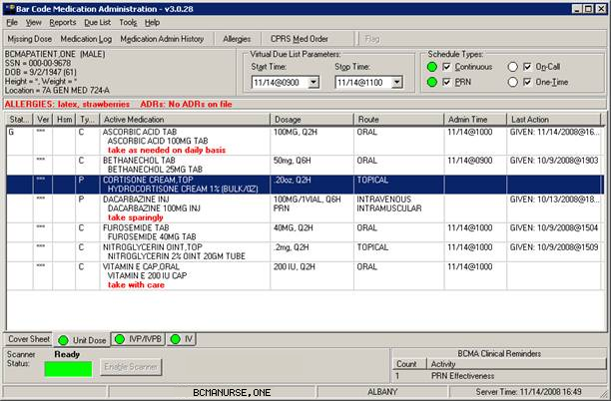
Menu
Bar
Schedule Type Indicator
Tool Bar
Column Headers
Medication Tabs
Status Bar
Scanner Status Indicator
Enable Scanner button, used to change Scanner Status to Ready.
BCMA Clinical Reminders Marquee identifies PRN medication orders needing effectiveness documentation.
Selected Administration
Taking a Quick Tour of BCMA
The VDL: In a Nutshell (cont.)  tip:  Check out the “Reports” and “Administering …” chapters to learn how the features listed here work  in BCMA. | Features of the VDL  Review this section to discover the many features (and benefits) that the BCMA VDL has to offer.  - Title Bar: Lists the name of the software application.  - Menu Bar: Provides options (commands) for accessing features and options within the BCMA VDL.  - Minimize Button: Shrinks the BCMA VDL to half its normal size.  - Maximize Button: Expands the BCMA VDL to its maximum size.  - Missing Dose Button: Requests a Missing Dose replacement from the Pharmacy.  - Allergies/ADR Bar: Describes food, drug, and “other” allergy and Adverse Drug Reaction (ADR) information about the patient, including whether the allergy or ADR was verified and observed. If this button is grayed out, no allergies or reactions were documented for the patient in the Allergy/Adverse Reaction Tracking (ART) package.  - CPRS Med Order Button: Also called the “Hot Button,”  provides a link to the Computerized Patient Record System (CPRS) package for electronically ordering, documenting, reviewing and signing verbal- and phone-type STAT and (One-Time) medication orders that you have already administered to patients.  - Flag Button: For the current patient record, displays a Patient Record Flag (PRF) Report for active PRFs. The button is disabled when there are no active PRFs associated with the current patient record.  - Tool Bar: Provides access to frequently used options within the BCMA VDL. (You can also access many of these options within the Menu Bar or by using the Right Click drop-down menu.)  - Patient Demographics Button: Displays personal, admission, eligibility, and appointment information about the patient whose orders are displayed on the BCMA VDL. This information was electronically documented when the patient was admitted to your medical center.  - Virtual Due List Parameters Area: Reflects the “Administration Time Window” defined as a site parameter for your site. This area of the BCMA VDL displays medications that need to be given within that Time Window. It corresponds to the Schedule Types selected on the BCMA VDL.
Taking a Quick Tour of BCMA
The VDL: In a Nutshell (cont.)  tip:  Check out the “Reports” and “Administering …” chapters to learn how the features listed here work  in BCMA.  tip:  You can automatically display PRN medication orders when the VDL is first opened by selecting the PRN check box in the “Include Schedule Types” area of the GUI BCMA Site Parameters application. | Features of the VDL (cont.)  - Schedule Types: Indicates when active medication orders exist for the selected timeframe, for each Schedule Type on the Unit Dose and IVP/IVPB Medication Tabs. These include Continuous, PRN, On-Call, and One-Time.  - Default in BCMA: The Schedule Types of Continuous, One-Time, and On-Call are already selected (checked) when you open a patient’s record. The PRN Schedule Type controls the default display of PRN medications on the BCMA VDL, and is based on the GUI BCMA Site Parameters entry for “Include Schedule Types.”  - Schedule Type Indicator: A GREEN “alert light” indicates that a medication order exists for the Schedule Type selected within the respective start/stop date and time selected on the BCMA VDL. If grayed out, none exist.  - Allergies/ADRs Bar: Alphabetically displays all food, drug, and “other” allergies and adverse drug reactions, in RED, that were documented for the patient in the ART package.  - Column Headers: Separates pertinent information about an active medication order. You can sort information alphabetically within each column by ascending or descending order.  - Order in Columns: Numeric information displays before alphabetic information. “Blank” columns display at the top of the BCMA VDL.  - Medication Order Display Area: Displays active medication orders for the VDL Parameters (Start and Stop Times), Schedule Types, and Medication Tab selected.  - Hold Orders: Includes orders placed “On Hold” (grayed out) by a provider using CPRS, or by Pharmacy using the Inpatient Medications V. 5 0 package.  - Scroll Bar: Available (not grayed out) when the number of medications that need displayed is greater than the Medication Order Display Area.
Taking a Quick Tour of BCMA
The VDL: In a Nutshell (cont.)  tip:  Check out the “Reports” and “Administering …” chapters to learn how the features listed here work  in BCMA. | Features of the VDL (cont.)  - Cover Sheet Tab: Its primary purpose is to provide users with four alternate user-selectable views of medication data related to the selected patient, and allow the user to drill down to view additional data. The Cover Sheet displays information by order, instead of by administration, as is displayed on the Medication Tabs, and does not allow the user to edit or take action against a patient record.  - Medication Tabs: Separates the different types of active medication orders that need to be administered to a patient. They include Unit Dose, IV Push, IV Piggyback, and large-volume IV orders. Medications that need to be administered will correspond to one of these Tabs. The Tab under which an order displays depends on how it was entered.  - Alert Light: Each Medication Tab provides an “alert light,” which turns GREEN only when the patient has active medication orders associated to them and (for Unit Dose and IVP/IVPB tabs) the admin time is within 12 hours before and 12 hours after NOW. When you click a “lit” Tab, BCMA displays the patient’s active medication orders on the BCMA VDL.  - Default in BCMA: The Unit Dose Medication Tab is selected when you open a patient’s record.  - Scanner Status Indicator: Indicates the status of your scanner. If indicator is RED and displays the “Not Ready”message, click the Enable Scanner button to activate the (GREEN) Ready Light and display the “Ready” message.
Taking a Quick Tour of BCMA
The VDL: In a Nutshell (cont.)  tip:  Check out the “Reports” and “Administering …” chapters to learn how the features listed here work  in BCMA. | Features of the VDL (cont.)  - BCMA Clinical Reminders Marquee: Identifies PRN medication orders needing effectiveness documentation. Based on the “PRN Documentation” site parameter, the setting applies to current admissions or to the site parameter timeframe (whichever is greater). Values can be set from 1-999, with 72 hours being the default setting.  - Partial List: “Mouse-over” on PRN Effectiveness Activity provides the four most recent PRN orders that need comments. This list is updated each time  a PRN Effectiveness is documented and the BCMA VDL is refreshed.  - Full List: Double clicking on the PRN Effectiveness Activity lets you document ALL PRN medication orders needing effectiveness comments.  - Status Bar: Includes the name of the clinician(s) administering medications, plus the name of the hospital and division, and the Server time (system time).  - Student Nurse Information: Will also include the name of a student nurse if logged on using the PSB STUDENT security key.

Getting Acquainted with the VDL
Accessing BCMA Features and Options  tip:  Check out the “Introducing BCMA V. 3.0” chapter to learn other ways to use the mouse/stylus with BCMA.  tip:  You can double click on the PRN Effectiveness Activity in the BCMA Clinical Reminders marquee to document ALL  PRN medication orders needing effectiveness documentation. | BCMA provides several ways to access features and options within the VDL. They include those listed in this section.  Menu Bar  BCMA includes five menus for accessing features and options (commands), plus a Help menu. They include: File, View, Reports, Due List, and Tools. You can access an option using shortcut keys, the Menu Bar, or the Right Click drop-down menu.  Note: The Tools menu is quite helpful for troubleshooting problems  with BCMA.  Tool Bar  The Tool Bar located at the top of the BCMA VDL provides buttons for accessing features in BCMA. They include: Missing Dose, Medication Log, Medication Admin History, Allergies, and CPRS Med Order. Several of these features can also be accessed from the Menu Bar.  Note: See the “Shortcut Keys” information on the next page to learn how to quickly access menu options on the BCMA VDL.  Mouse/Stylus  BCMA provides several ways to use the mouse and stylus with medication orders displayed on the BCMA VDL.  - Click: Use to select a medication order on the BCMA VDL, choose options (commands) from the Menu Bar, and select Buttons and Medication Tabs on the BCMA VDL.  - Double-click: When you double-click on a medication order on the VDL, the Display Order dialog box displays, with details of the order from Inpatient Medications V. 5.0.  - Right-click: With an active medication order selected on the BCMA VDL, click the right mouse button once to display a drop-down menu for accessing several BCMA options (commands). These options are also accessible from the Menu Bar or via the Buttons on the Tool Bar.  - shift+click: Use to select a range of medication orders, on the VDL, so you can mark them with the same administration status, or a range of patients when printing selected patients on a Ward, or a range of medications in the search results window of the Medication Therapy report.  - ctrl+click: Use to individually select multiple medication orders on the VDL, so you can mark them with the same administration status, to select multiple patients when printing selected patients on a Ward, or to select multiple medications in the search results window of the Medication Therapy report.
Getting Acquainted with the VDL
Accessing BCMA Features and Options (cont.) | Mouse/Stylus (cont.)  - ctrl+a: Use to select all patients listed on a selected Ward, in reports where you can print selected patients on a Ward, or to select all medications in the search results window of the Medication Therapy report.  Keyboard  BCMA provides several ways to use the keyboard with medication orders displayed on the BCMA VDL.  - Shortcut Keys: Let you access a few Menu options with a keyboard, instead of a mouse. In some cases, you can access an option by pressing one key; in other cases, you must use a combination of keys. See the table provided below for shortcut keys available in BCMA.  - You can also access options by pressing a letter on the keyboard that corresponds to the underlined “letter” in a menu name, directly with the alt key. Once the corresponding drop-down menu displays, press a letter on the keyboard that corresponds to the underlined letter for the option name. For example, to close a patient record, press alt+f [underlined letter of the menu name] to display the File menu. Then, at the File menu, press c on the keyboard to access the Close Patient Record option.
Example: Shortcut Keys Available in BCMA
Use This Shortcut: | To Make This Occur:
Ctrl+O | Depending on the mode, accesses the Scan Patient Wristband dialog box or the Patient Select dialog box (Read-Only, Limited Access, and after an Unable to Scan event) to open a Patient Record.
Ctrl+F | Display the Patient Record Flag report.
F1 | Access context-sensitive, on-line help for a command selected in the Menu Bar or Right Click drop-down menu, or for a button, feature, or option that you have “focused” on the VDL.
F4 | Display details of the selected medication order on the VDL, from Inpatient Medications V. 5.0.
F5 | Load active medication orders onto the VDL, and refresh the information in the Status and Last Action columns.
F9 | Display Cover Sheet Tab.
F10 | Display active medication orders under the Unit Dose Medication Tab.
F11 | Display active medication orders under the IVP/IVPB Medication Tab.
F12 | Display active medication orders under the IV Medication Tab.
Getting Acquainted with the VDL
Understanding the Columns on the VDL  tip:  This section describes the columns that display for the  Unit Dose and IVP/IVPB Medication Tabs. It also includes the differences among these Tabs and the IV Medication Tab, plus Exceptions.  tip:  An “Unknown” status can only be changed using the Edit Med Log option. | The Medication Order Display Area displays active medication orders for the Start/Stop Times, Schedule Types, and Medication Tab selected on the BCMA VDL. This “area” of the VDL is organized into columns, and described in this section.  - Status: Indicates the status of medications scanned for the Administration Time Window (Start/Stop Times) selected on the BCMA VDL. When a medication bar code is scanned, it is considered “Given,” and marked as such (with the letter “G”) in this column. You can change this status using the Due List menu or the Right Click drop-down menu. BCMA then “refreshes” (updates) information in this column and the Last Action column.  - If Blank: Indicates that no action was taken on the medication.  - “Unknown” Status: If an order created in BCMA CHUI Manual Medication Entry is not completed with a valid administration status, it will display as “U” (unknown) in the BCMA VDL Status column.  - Undo–Given Orders: Appear only in the Audit Trail section of the Medication Log Report (not on the BCMA VDL). The status is listed as “Not Given.”  - IV Medication Tab: Lists the status of the order with a word instead of a letter like the Unit Dose and IVP/IVPB Medication Tabs.  - Ver: An abbreviation for “Verified,” displays the initials of the nurse who verified the order using CPRS or the Inpatient Medications V. 5.0 package.  - Three Asterisks (***): Indicates that the order has not been verified by a nurse, but by a pharmacist.  - HSM: An abbreviation for “Hospital-supplied Self Medication,” indicates that the medication is supplied by your medical center’s Pharmacy, but administered by the patient.  - SM: An abbreviation for “Self Medication,” indicates that the patient is providing and administering the medication.  - If Blank: Indicates that your medical center’s Pharmacy is providing the medication, and that a nurse is administering the medication.  - IVP/IVPB Medication Tab: Column is not available for this Tab.  - IV Medication Tab: Column is not available for this Tab.
Getting Acquainted with the VDL
Understanding the Columns on the VDL (cont.) | This section describes the columns within the Medication Order Display Area of the BCMA VDL.  - Type: Displays the Schedule Type of a medication order. They include “C” (Continuous), “P” (PRN), “OC” (On-Call), and “O” (One-Time).  - Fill-on-Request Orders: These order types are grouped, based on whether their Schedule Type is Continuous or PRN. This depends on whether the schedule contains the characters “PRN.”  - IV Medication Tab: These order types are listed as Admixture, Chemotherapy, Hyperal, Piggyback, and Syringe.  - Active Medication: Lists the orderable item on the first line, and the dispensed drug name or medication (indented) on the second line.  - Special Instructions in RED: Display below the dispensed drug name or medication. Pharmacists enter Instructions using the Inpatient Medications V. 5.0 package. These codes expand to full text on the BCMA VDL.  - Special Instructions in a Pop-up Box: Display when you scan the medication bar code. You must acknowledge the message in the Pop-up Box before administering the medication.  - IVP/IVPB Medication Tab: Column is not available for this Tab.  - IV Medication Tab: Column is not available for this Tab.  - Dosage: Lists the total dosage and schedule information for the medication order.  - IVP/IVPB Medication Tab: This column is replaced by the Infusion Rate column.  - IV Medication Tab: This column is replaced by the Infusion Rate column.  - Route: Also called “Med Route,” indicates how a clinician will administer the medication to the patient. For example: Intravenous, Intramuscular, Intradermal, Subcutaneous.
Getting Acquainted with the VDL
Understanding the Columns on the VDL (cont.)  tip:  The Last Action column will not display a date/time if the medication was not administered before to the patient. | This section describes the columns within the Medication Order Display Area of the BCMA VDL.  - Admin Time: Indicates the Administration Date and Time entered for the medication by the Pharmacy, using the Inpatient Medications V. 5.0 package.  - Orders that Display on VDL: The administration time for an order must fall between the Start and Stop Time Parameters selected on the BCMA VDL, before the order will display on the VDL.  - Multiple Administration Times: If a Continous-type order has multiple administration times, each administration time appears as a separate line item on the BCMA VDL.  - IV Medication Tab: Column is not available for this Tab since IVs do not have administration times associated to them.  - Last Action: Describes the last action taken on the orderable item and the date/time of this action. When BCMA “refreshes,” it updates medication order information, plus this column and the Status column.  - Multiple Line Items: If multiple line items are displayed, the same last action time displays for each related item.  - Renewed Medications: Medications renewed during the Start/Stop Time Parameters selected on the BCMA VDL, display the last action and time of the preceding order.  - IV Medication Tab: Column is not available for this Tab.  - “Unknown” Status: If an order created in BCMA CHUI Manual Medication Entry is not completed with a valid administration status, it will display as “Unknown” in the Last Action column.  Exceptions  Besides the Medication Order Display Area, the IV Medication Tab also includes the IV Bag Chronology and the IV Bag Detail display areas. Each area is described below:  - IV Bag Chronology: Lists the action taken on each IV bag, whether the bag is available, the Unique Identifier Number, and the contents of each bag.  - IV Bag Detail: Provides a history of an IV bag, such as the date and time the medication was administered, the initials of the clinician who administered the medication, any actions taken on the medication, and any comments entered by a clinician.
Getting Acquainted with the VDL
Sorting the Contents of a Column  tip:  You can sort a column by clicking on a Column Header.  tip:  “Blank” columns display at the top of the VDL. | BCMA displays medication information in columns on the BCMA VDL. You can sort the contents of each column alphabetically, by ascending or descending order. You cannot change the order of the actual columns within the BCMA VDL.  Note: Information in columns is actually sorted numerically, then alphabetically in the columns.  To sort the contents of a column  - Select the Sort By command in the Due List menu. The Sort By drop-down menu displays.  Keyboard Shortcut: Press alt+d to display the Due List menu, and press s to display the Sort By drop-down menu.  Example: Sort By Drop-down Menu  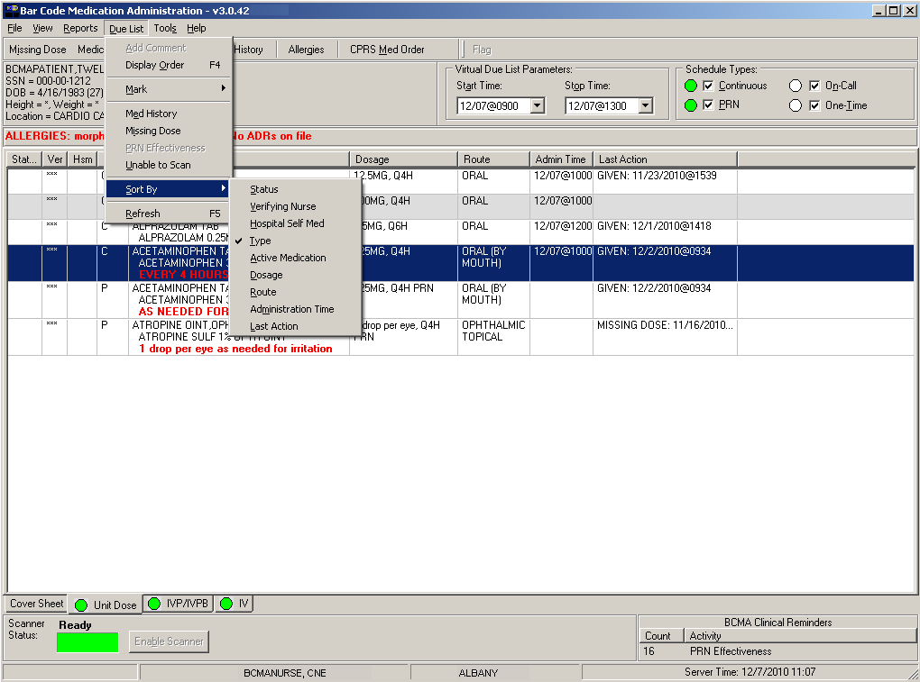  - Select the name of the column that you want to sort alphabetically on the BCMA VDL. The contents of the column changes accordingly.  Keyboard Shortcut: Use the arrow keys to select the desired column name, and press enter to sort the column alphabetically.
Getting Acquainted with the VDL
Resizing the Columns on the BCMA VDL  important:  Once you resize a column, you cannot “undo” it, unless you use the steps provided in this section. | You can quickly — and easily — resize the columns on the BCMA VDL. Here’s how.  To resize columns on the VDL  - Place the mouse pointer over the vertical border (line) of a Column Header. A crosshair displays.  Example: Crosshair Used to Resize a Column  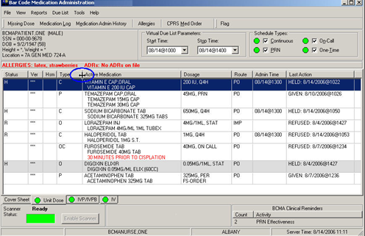  - Press and drag the crosshair to the right to increase the column width, or to the left to decrease the column width.  Note: There is a minimum size allowed for each column so you do not accidentally overlay one column onto another, and find yourself unable to access a column.
Getting Acquainted with the VDL
Refreshing the VDL  tip:  During your med pass, refresh BCMA periodically to check for new, active medication orders.  tip:  After a medication pass, press f5 to refresh the VDL with current medication order information, and to update the information in the Status and Last Action columns. | You can “refresh” the BCMA VDL to ensure that the medication order information displayed is the most current received from Inpatient Medications V. 5.0. When you use this feature, BCMA “loads” active medication orders onto the BCMA VDL, and refreshes the information in the Status and Last Action columns.  To refresh the VDL  - Select the Refresh command in the Due List menu. The BCMA VDL refreshes so you are receiving the most current medication order information. It also updates the information in the Status and Last Action columns.  Keyboard Shortcut: Press alt+d to display the Due List menu, and press r to select the Refresh command. The BCMA VDL “refreshes” with current medication order information, and also updates the Status and Last Action columns.  Example: Command Used to Refresh the VDL  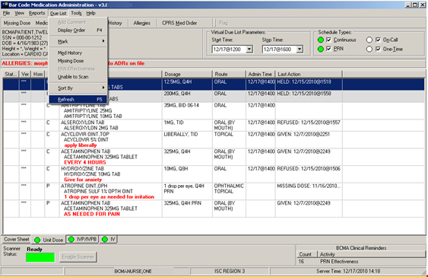  — THEN —  (SEE NEXT PAGE)
Getting Acquainted with the VDL
Refreshing the VDL (cont.)  tip:  During your med pass, refresh BCMA periodically to check for new, active medication orders. | To refresh the VDL (cont.)  Example: Message When VDL Refreshing  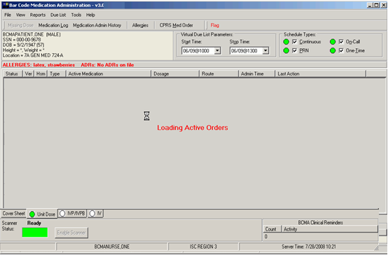  - Notice the message that displays when you refresh the BCMA VDL, and that the Status and Last Action columns are updated once this process is complete.

Getting Started
Signing on to BCMA  tip:  You can skip steps 2 and 3 by typing your Access Code, then your Verify Code, separated by a semi-colon in the Access Code field. Press ENTER after typing the codes.  tip:  Starting an administration session in BCMA is quite simple. Just double-click on the BCMA icon on your desktop, then enter information when prompted by the system. | Signing on to BCMA V. 3.0 may vary slightly, as a result of how site parameters are set for your division. For example, your medical center may require that you specify your division, enter an electronic signature code, or indicate if you are working with a nursing instructor. If so, you will receive all or just a few of the associated screens shown in this section when accessing BCMA V. 3.0.  To sign on to BCMA  - Double-click on the BCMA icon on your desktop. BCMA displays the BCMA Splash Screen and the VistA Sign-on dialog box.  Example: BCMA Splash Screen and  VistA Sign-on Dialog Box  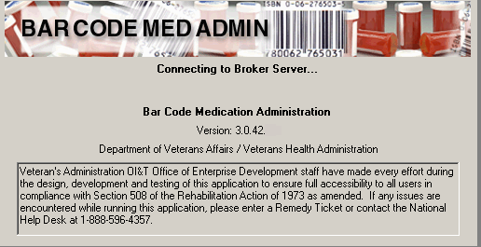  — THEN —  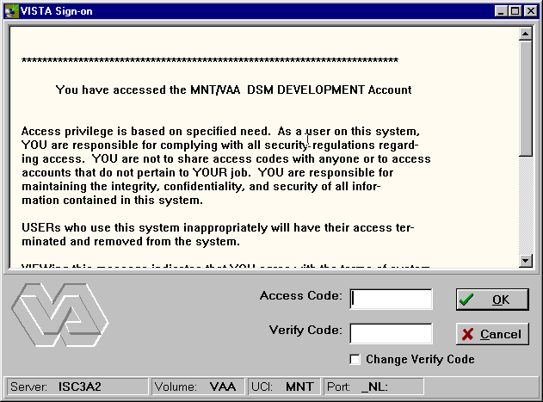
Getting Started
Signing on to BCMA (cont.)  tip:  You can skip steps 2 and 3 by typing your Access Code, then your Verify Code, separated by a semi-colon in the Access Code field. Press ENTER after typing the codes.  tip:  You can skip  steps 2 and 3 by typing your Access Code, then your Verify Code — separated by a semi-colon — in the Access Code field. Press ENTER after typing the codes. | To sign on to BCMA (cont.)  - In the Access Code field, type your Access Code, and press tab.  - If the “blinking” cursor does not display in this field, click once in the field to activate it.  - If you are a nursing student, enter your Access and Verify Codes. When you do, the system will verify that you have been assigned the PSB STUDENT security key. Your instructor should enter their Codes at the Instructor Sign-On dialog box that displays. In order to administer medications, you must exit Read-Only BCMA and sign on with your instructor.  - If you are a user requiring Read-Only access to BCMA, enter your Access and Verify Codes. The system will verify that you have been assigned the PSB READ ONLY security key. Upon login to Read-Only BCMA, “READ-ONLY” will display in the title bar, scanning of patient wristbands and medications is disabled, and only a subset of features will be available. Read-Only users are allowed access to the BCMA VDL to view data and run reports, but are not allowed to perform any actions against patient records.  Note: For more information on using Read-Only BCMA, please refer to Chapter 8, “Read-Only and Limited Access BCMA.”  Keyboard Shortcut: Press tab to move among the fields and buttons on the dialog box.  - In the Verify Code field, type your Verify Code, and click ok.  - If the “blinking” cursor does not display in this field, click once in the field to activate it.  - Medical centers with multiple divisions, see page 43.  - Divisions with nursing students, see page 44.  - Divisions requiring an Electronic Signature Code, see page 45.  Keyboard Shortcut: Press enter after typing your codes to begin the verification process.
Getting Started
Signing on to BCMA (cont.) | - For Medical Centers with Multiple Divisions  If your medical center has multiple divisions, the Select Division dialog box provided below displays.  To select a division  - Select a division that corresponds to your medical center, and click ok to continue with the sign-on process.  Keyboard Shortcut: Use the arrow keys to select your division name, and press enter. Press tab to activate the ok button, and press enter.  Example: Select Division Dialog Box  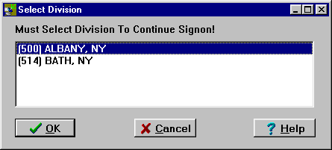  - Continue with the medication administration process.
Getting Started
Signing on to BCMA (cont.)  tip:  Student and instructor names display in the bottom left corner of the VDL Status Bar, as the medication administrators for this patient.  tip:  Student and instructor names display in the bottom left-hand corner of the VDL, on the Status Bar, as the medication administrators for  a patient.  tip:  The Sign On Button is grayed out until you click inside the Access Code field in the Instructor Sign-On dialog box. | - For Divisions with Nursing Students  If you are a nursing student, your nursing instructor must enter their Access and Verify Codes, at the Instructor Sign-On dialog box provided below, before you can have full access to the patient’s VDL. BCMA will then verify that the instructor has been assigned the PSB INSTRUCTOR security key, and is a recognized nursing instructor.  Note: If Instructor Codes are not entered, BCMA will automatically default to Read-Only mode (indicated by the “READ-ONLY” message in the title bar.) In order to administer medications, you must exit Read-Only BCMA and sign on with your instructor. For more information on using Read-Only BCMA, please refer to Chapter 8, “Read-Only and Limited Access BCMA.”  To enter nursing instructor codes  - Request that your nursing instructor enter their Access and Verify Codes in the Instructor Sign-On dialog box, and press sign on.  Keyboard Shortcut: Press tab to activate the Sign On button, and press enter.  Example: Instructor Sign-On Dialog Box  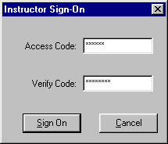  - Continue with the medication administration process.
Getting Started
Signing on to BCMA (cont.) | - For Divisions Requiring an Electronic Signature Code  The Electronic Signature dialog box provided below displays if your medical center has set its site parameters to require individuals to enter an Electronic Signature Code.  To enter an electronic signature code  - Enter your electronic signature code, and click ok.  Keyboard Shortcut: Press tab to activate the ok button, and press enter.  Example: Electronic Signature Code Dialog Box  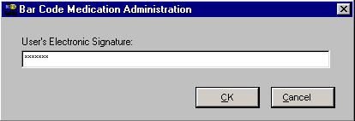  - Continue with the medication administration process.

Working with Patient Records
Opening a Patient Record  tip:  Press CTRL+O to display the Patient Lookup dialog box.  tip:  Press ctrl+o  to access a  patient record.  tip:  If the Scan Patient Wristband dialog is open, and your application focus changes to a program outside of BCMA, the Scanner Status will change to  Not Ready.  To regain focus and re-enable the scanner, click the Enable Scanner button, or click anywhere on the BCMA application window,  or press  alt-tab as many times as necessary to switch focus back to BCMA. | Before you can administer active medications to a patient, you must open the patient record (VDL). You can also open a patient record while an existing record is still open on the screen. BCMA may prompt you to confirm any active medication orders that have not been viewed, then proceeds to close the current record.  To open a patient record  - At the Scan Patient Wristband dialog box, perform one of the following actions:  - If the Scanner Status is “Ready,” scan the bar code on the patient’s wristband.  - If the Scanner Status is “Not Ready,” click the enable scanner button to enable the scanner. You are ready to scan when the Scanner Status indicator is GREEN and displays “Ready.”  Keyboard Shortcut: Press tab to activate the enable scanner button, press enter, or press alt-b to enable the scanner.  Example: Scan Patient Wristband Dialog Box  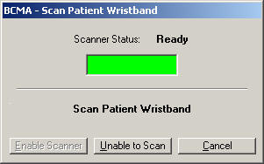  Note: Discharged and deceased patients cannot be opened via the Scan Patient Wristband dialog or Unable to Scan functionality. They can only be opened via Limited Access, Read-Only, and Edit Med Log.  - Click cancel to return to the VDL and access the Menu Bar — without opening a patient record — and do one of the following:  - Print all reports by ward, except for the Cumulative Vitals/Measurement Report. A patient’s file must be opened to access patient-specific reports. See Chapter 10, “Viewing and Printing BCMA Reports” for more information.
Working with Patient Records
Opening a Patient Record (cont.)  tip:  You can also enter the first letter of the last name and the last 4 of the SSN, e.g., B9678,. | To open a patient record (cont.)  - Edit the Medication Log to make changes to medication administration entries that have been created during the medication administration process. Access the Edit Med Log command from the File menu. See Chapter 7, “Editing the Medication Log” for more information.  - Open a patient record in Limited Access Mode. See Chapter 8, “Read-Only and Limited Access BCMA” for more information.  - If the scan is successful, skip to step #5. If you are unable to scan the patient wristband, click the unable to scan button, and perform the following actions at the Unable to Scan dialog box:  Keyboard Shortcut: Press tab to activate the unable to scan button, press enter, or press alt-u.  - Select a Reason (required) for scanning failure from the drop-down list.  - Enter a Comment (optional) that will aid your IRM staff in trouble-shooting the problem. The Comment field is limited to 150 characters.  - Click ok to complete the Unable to Scan event. The Patient Select dialog box displays. Proceed to Step#3  Example: Unable to Scan Patient Wristband  Dialog Box  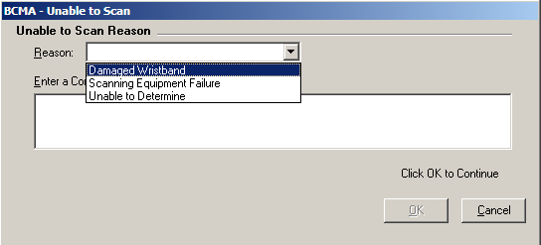  - At the BCMA – Patient Select dialog box, enter one of the following search criteria in the Patient Name field:  - Patient name (Last, First)  - Patient Social Security Number (SSN)  - Rm-Bed  - Ward
Working with Patient Records
Opening a Patient Record (cont.)  tip:  To broaden your search, you can enter partial search criteria for Last Name, SSN, Rm-Bed, or Ward in the BCMA – Patient Select dialog box.  tip:  You can double-click on the patient name to quickly open the record on the VDL. | To open a patient record (cont.)  Note: BCMA automatically searches for the patient record(s) that match the criteria - as you are typing. You must enter at least 2 characters to initiate the search. There is no need to press ENTER. Note that the search is not case sensitive.  Example: Patient Select Dialog Box  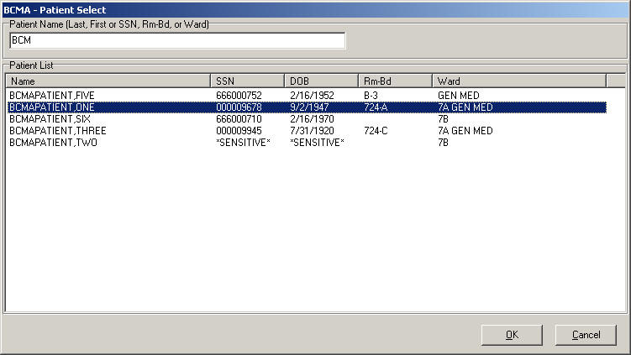  - Perform one of the following actions:  - If the patient you are requesting is displayed in the Patient List, click on the patient record you want to access, and click ok to access the patient’s VDL. Proceed to Step #5.  Keyboard Shortcut: Press tab to go to the Patient List. If multiple records are displayed, use the arrow keys to select the patient record. Press tab to activate the ok button, and press enter to access the patient’s VDL in Read-Only mode.  - If the patient you are requesting is not displayed in the Patient List:  - If more records are retrieved than can be displayed in the Patient List, scroll bars will appear to allow you to scroll through the data. Scroll to the patient record, click on the patient record you want to access, and click ok to access the patient’s VDL in Read-Only mode.  - If records are retrieved, but you do not see the intended patient record, re-enter your patient search criteria, as indicated in step #3 above.  - If you see a “No patients matching…” message, re-enter your patient search criteria, as indicated in step #4 above.
Working with Patient Records
Opening a Patient Record (cont.) | To open a patient record (cont.)  - If you see a “Too many patients matching…” message, the system found more than 100 records that matched your criteria. Re-enter more specific patient criteria, as indicated in step #2 above.  - The Patient Confirmation dialog box displays after a successful scan, or upon selecting a patient after documenting an Unable to Scan event. The patient’s personal data displays, such as name, SSN, date of birth, ward, room-bed, allergies, ADRs, and Patient Record Flag (PRF) assignments, if applicable.  Example: Patient Confirmation Dialog Box  (After Successful Scan)  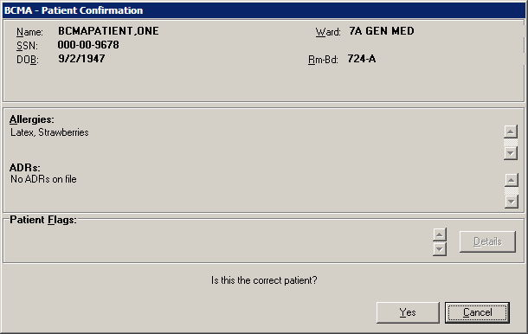  Example: Patient Confirmation Dialog Box  (After Unable to Scan Event)  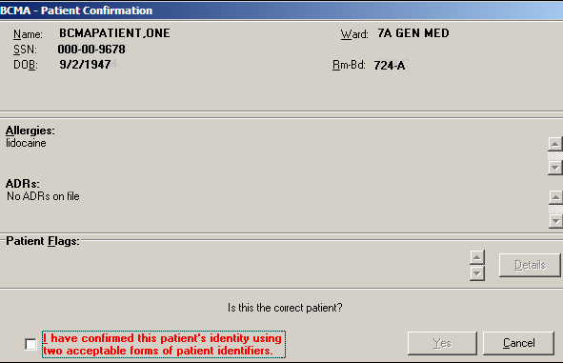
Working with Patient Records
Opening a Patient Record (cont.) | To open a patient record (cont.)  - Verify the information provided on the BCMA – Patient Confirmation dialog box with the information on the patient’s wristband.  Note: If the patient’s record is marked as “Sensitive,” the SSN and DOB fields will be blocked out. See the section “If Patient’s Record Marked as Sensitive” for reviewing information on a sensitive record.  Note: If any active PRF assignments exist for this patient, the details button will be enabled in the Patient Flags section of the dialog box. It is strongly recommended that you click the details button to view the Patient Record Flag report, especially for behavioral flags, to view information which may be critical to patient and employee safety.  - Perform one of the following actions:  - If the information matches the data printed on the patient’s wristband:  - If a confirmation checkbox displays as a result of a Unable to Scan event, check the box and confirm that you have used two acceptable forms of patient identifiers.  - Click YES to access their VDL and to begin administering active medications to the patient.  - If the patient record is Sensitive:  - If a confirmation checkbox displays as a result of an Unable to Scan event, check the box and confirm that you have used two acceptable forms of patient identifiers.  - Click ACCEPT then YES to access their VDL and to begin administering active medications to the patient. An entry is created automatically in a log for your Information Security Officer.  - If this information does not match the data on the patient’s wristband, click cancel, and verify the patient’s identity against the information on their wristband.  Keyboard Shortcut: Press tab to activate the yes, accept, or cancel button, and press enter to access the patient’s VDL.
Working with Patient Records
Opening a Patient Record (cont.)  tip:  The information in a “Sensitive Record” is considered extremely confidential and should be treated as such.  tip:  If the Details button is enabled in the Patient Confirmation dialog box, it indicates that this “Sensitive” patient also has active PRF assignments. Click the Details button to display the Patient Record Flag report. | - If Patient’s Record Marked as “Sensitive”  BCMA uses the standard Patient Lookup. If a patient record is marked as “Sensitive,” you may (or may not) receive a Restricted Record Warning message. This will depend on whether you hold the security key for this type of patient record. A “Sensitive Patient” is one for whom a record exists in the DG SECURITY LOG file (#38.1) with a SECURITY LEVEL field (#2) marked as “Sensitive.”  Example: Sensitive Patient Confirmation Dialog Box  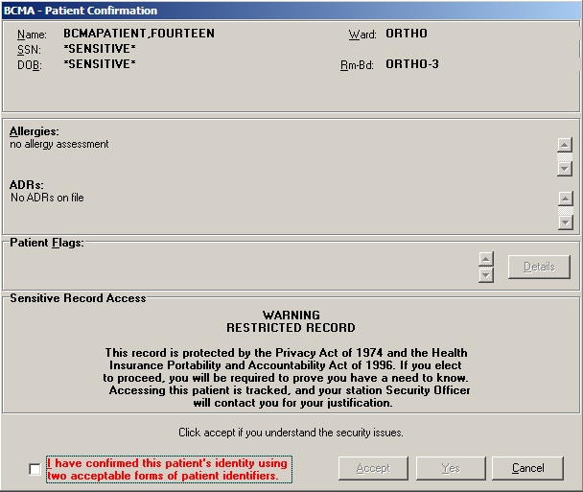  Note: Every time a “Sensitive” patient record is accessed, an entry is created in a log for the Information Security Officer at your medical center. The log lists the individual who accessed the record, how they accessed the record, and for what length of time. That way, the Security Officer can monitor the patient’s privacy and make sure that “need to know” information is disseminated accordingly.  Note: For opening Sensitive patients during an Unable to Scan event, the checkbox must be checked to enable the Accept button. Click ACCEPT to enable the Yes button. Click YES to open the patient’s record.  To review information for a sensitive record  - Review the Warning message, and click accept, which acknowledges your understanding of the security warning, Click yes to access the patient’s VDL and begin administering active medications to the patient.  Keyboard Shortcut: Press tab to activate the yes button, and press enter to display the patient’s VDL.  - Continue with the medication administration process.
Working with Patient Records
Opening a Patient Record (cont.)  tip:  The Patient Transfer Notification message will only display once per Medication Tab (i.e. Unit Dose or IVP/IVPB), while the patient’s record is open. | - If Patient Transfer Notification Message Displays  BCMA displays the Patient Transfer Notification message if the patient has had a movement type (i.e., usually a transfer) within the site-definable parameter, and the last action for the medication occurred before the movement, but still within the defined timeframe. You can define this parameter, the Patient Transfer Notification Timeframe, on the BCMA Site Parameters Tab of the BCMA GUI Site Parameters application.  Note: The display of the message is dependent on the last action displayed in the “Last Action” column of the BCMA VDL. BCMA evaluates the last action performed each time the Unit Dose or IVP/IVPB Medication Tabs are refreshed.  To review Patient Transfer Notification message  - Review the Patient Transfer Notification message, and click ok to return to the patient’s VDL and begin administering active medications to the patient. BCMA will determine each last action that falls within the site-specified Notification “window” and display the patient’s movement in the “Last Action” column, along with the existing last action.  Keyboard Shortcut: Press tab to activate the ok button, and press enter to display the patient’s VDL.  Example: Patient Transfer Notification Message  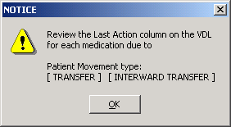  - Continue with the medication administration process.
Working with Patient Records
Closing a Patient Record  tip:  It is not necessary, or required, to close a patient record before opening another, although it is advised if you are leaving the patient’s room  for awhile. | Once you finish administering active medications to your patient, you can close their patient record (VDL), and open another patient record. This feature is particularly useful when you need to leave the patient’s room for a few minutes, and do not want to leave their record open on your computer.  tip:  BCMA displays an Information message to verify if you want to view active orders on other Medication Tabs before closing the patient’s record.  To close a patient record  - Select the Close Patient Record command from the File menu. The Information message displays.  Keyboard Shortcut: Press alt+f to display the File menu, and press c to display the Information message.  Example: Information Message  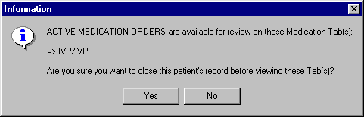  Note: The Information message, provided above, displays only for  IV Piggyback medications since you automatically view Unit Dose orders when the BCMA VDL opens. The message lets you verify if you want to view active orders under the IVP/IVPB Medication Tab before closing the patient’s record.  - Perform one of the following actions:  - Click yes to close the current record without viewing medication orders, for the patient, on other Medication Tabs. The Patient Lookup dialog box displays.  - Click no to view active medication orders under the Medication Tab listed in the Information message.  Keyboard Shortcut: Press tab to activate the yes button, and press enter to continue.  Note: BCMA provides the “BCMA Idle Timeout” site parameter for defining the number of minutes that an idle BCMA session can stay open. Once the allowable time-out has been reached, BCMA will close. If the BCMA session displays a prompt, it will not time-out until the prompt is answered. The allowable entry for this parameter is 1 to 1440 minutes/day. The default is 30 minutes.

Working with Unit Dose Medications
Benefits of this Chapter | Use this chapter when you need to administer active Unit Dose medications to patients on your ward. The options and features available within the BCMA VDL apply specifically to active Unit Dose medication orders only.
Preparing to Administer Unit Dose Medications  tip:  You can skip steps 2 and 3 by typing your Access Code, then your Verify Code, separated by a semi-colon in the Access Code field. Press ENTER after typing the codes.  tip:  A medication displays on the VDL if it has an “active” status  and the patient has a status and location of “inpatient.”  tip:  The PRN Schedule Type controls the default display of PRN medications on the VDL, and is based on the GUI BCMA Site Parameters entry for “Include Schedule Types.” | Before administering any active Unit Dose medications to a patient, review this section to learn more about the Schedule Types for Unit Dose medications that you can administer, including medication orders that display on the BCMA VDL, and how BCMA indicates “actions” taken on medications displayed on the VDL.  Then you will be ready to define the administration Start and Stop Times and Schedule Types of the medications that you want to display on the BCMA VDL, and to administer active Unit Dose medications to your patients.  Schedule Types that You Can Administer  You can administer medications for active Unit Dose medication orders with the Schedule Types listed below.  - Continuous: A medication given continuously to a patient for the life of the order, as defined by the order Start and Stop Date/Time. Includes Fill-on-Request orders.  - Fill-on-Request Orders: These are grouped, based on whether their Schedule Type is Continuous or PRN. This depends on whether the schedule contains the characters “PRN.” If BCMA does not find these characters, it looks for administration times, and places the order accordingly on the BCMA VDL.  - PRN: A medication dosage given to a patient on an “as needed” basis. Includes Fill-on-Request orders.  - On-Call: A specific order or action dependent upon another order or action taking place before it is carried out.  - One-Time: A medication order given one time to a patient such as a STAT or a NOW order. This order type displays for a fixed length of time on the BCMA VDL, as defined by the order Start and Stop Date/Time.  Note: Each time that you open a BCMA VDL (i.e., patient record), BCMA defaults to the Unit Dose Medication Tab and the Schedule Types of Continuous, One-Time, and On-Call already selected. This occurs even if you change the Schedule Types or Medication Tab during a medication pass.
Working with Unit Dose Medications
Preparing to Administer Unit Dose Medications (cont.)  tip:  The administration time of an active order must fall within the Start and Stop Date/Times selected on the VDL before the order will display. | Medication Orders that Display on the VDL  Once a Unit Dose medication order becomes “active,” it displays on the BCMA VDL under the Unit Dose Medication Tab for the Start and Stop Date/Times and Schedule Types selected on the BCMA VDL. This status occurs once a pharmacist or nurse verifies a medication order using Inpatient Medications V. 5.0 or CPRS. This includes orders on “Hold” and any orders entered through the Unit Dose or IV package. Orders placed “On Hold” by a provider display grayed out on the BCMA VDL. You can only mark these order types as “Held,” although it is not necessary that you do so.  Active Unit Dose orders display under the Unit Dose Medication Tab, except for orders entered with a Medication Route of IV PUSH or IV Piggyback. (These order types display under the IVP/IVPB Medication Tab.)  BCMA determines when to display an order on the BCMA VDL by subtracting the information in the “Before Scheduled Admin Time” site parameter field from the Start Date/Time of the medication order. You can define this parameter using the Parameters Tab in the GUI BCMA Site Parameters application.  Medications Available for Scanning  Administering Unit Dose medications to a patient involves the scanning of the patient’s medication (drug) bar code. BCMA recognizes the following number on the Unit Dose Medication Tab:  - Internal Entry Number (IEN): Drug numbers provided  on medication bar codes are considered a unique drug identifier by the Pharmacy. BCMA validates the bar code scanned against the IEN of DRUG file (#50) and/or the SYNONYM field (#.01) of the DRUG file (#50), to ensure that a valid number exists for the dispensed drug and strength scheduled for administration. BCMA also recognizes National Drug Code (NDC) unique identifier product numbers found on manufacturer bar code labels, which are also stored in the SYNONYM field (#.01) of the DRUG file (#50).
Working with Unit Dose Medications
Preparing to Administer Unit Dose Medications (cont.)  tip:  You can only change a “Given” status to “Not Given” by using the “Undo – Given” option.” This status does not display on the VDL; it only appears in the Audit Trail section of the Medication Log Report.  tip:  If the Scanner Status Indicator is RED, click in the Indicator field to activate the GREEN Ready Light before manually entering the Drug IEN Code or Unique Identifier Number.  tip:  You can scan any Unique Identifier Number listed in the Information message.  tip:  An “Unknown” status can only be changed to Given, Not Given, Held, or Refused–using the Edit Med Log option.  tip:  When the patient’s VDL uses the Status column to sort orders, BCMA displays medications with no status at the top of the VDL. It then displays all other medications in alphabetical order by the Status code. | Marking the Order Status/Last Action Column  When you administer a Unit Dose medication to a patient, BCMA electronically documents the “action” taken on the medication by displaying a letter, for example a “G” (for “Given”), in the Status column of the BCMA VDL. This information also displays on the Medication Log Report and the MAH Report.  The Last Action column lists the “last action” taken on an orderable item and the date/time of this action, so the nurse will know when the patient last received any dose of a medication regardless of the Schedule Type selected. This information helps to prevent the same medication from being given to the patient from another order or schedule type.  - If the orderable item is the same, the Last Action column lists the last administration action.  - If the patient has two different orders, for the same orderable item, the last administration of either of these orders displays in the Last Action column for both orders. You can view the MAH Report to determine from which order the medication was given on the BCMA VDL.  - If a medication was not administered before to the patient, the Last Action column will not list a date/time.  Understanding the Status of a Medication Order  Once you scan and mark a medication as Given, you cannot scan it again for the same administration time. If you do, you will receive an Error message. You can, however, change the status from “Given” to “Not Given” by using the “Undo–Given” option — provided you are the individual who originally marked it as “Given,” or you have been assigned the PSB MANAGER security key.  You can mark a Unit Dose medication with the following status:  - Given to Not Given  - Removed to Given  - Held or Refused to Given  - Missing to Given, Held, or Refused  Note: A patch marked as “Given,” displays on the BCMA VDL each time BCMA is opened — until it is marked as “Removed” — even if the order is discontinued or expires, or the patient is discharged or  re-admitted to your medical center. The patch will fall off the display after the order’s stop date if the “Patch Display Duration” site parameter value is set between 7 and 14 days.
Working with Unit Dose Medications
Preparing to Administer Unit Dose Medications (cont.) | Information Stored by BCMA  BCMA stores the following information each time you administer an active Unit Dose medication to a patient:  - Patient  - Location of the patient (i.e., bed, ward, or division)  - Clinician administering the medication  - Clinician who created the Medication Log Entry  - Entered date and time  - Audit information (i.e., clinician, text, date and time)  - Administration date and time  - Status of the administration, such as Given, Held, Refused, Missing, or Removed (in the case of a patch)  - Orders changed using the “Undo–Given” option do not display a code (letter) in the Status column of the BCMA VDL. This status appears only in the Audit Trail section of the Medication Log Report, not on the BCMA VDL.  - “Cancelled” administrations are not stored in the Medication Log.  - “Unknown” Status: If an order created in BCMA CHUI Manual Medication Entry is not completed with a valid administration status, the Admin Status will be stored as null (blank), but will display as “U” (unknown) in the BCMA VDL Status column and “Unknown” in the Last Action column.  - Number of minutes that the dose was given too Early or too Late to the patient  - Reason that a PRN medication was administered and the medication effectiveness  - Medication, dosage, and/or number of units given  - Any comments associated with the drug administration dose  - Injection site for medications that must be injected
Working with Unit Dose Medications
How BCMA Validates Patient and Medication Information  tip:  After a medication pass, press F5 to refresh the VDL, then  note that the Last Action column lists an administration as the most  recent one. | When used as intended, BCMA serves as an excellent check-and-balance system for patients and VAMCs. The chances for errors increase when the scanning process is circumvented — entered manually — during the medication administration process. In short, here is the validation process completed by BCMA V. 3.0.  First Validation By BCMA  When you scan the bar code on a patient’s wristband, BCMA automatically verifies/validates the patient’s identity and provides important clinical information via a Confirmation dialog box and the patient’s VDL.  Second Validation By BCMA  The second validation by BCMA occurs when you scan the bar code on the patient’s medication or when you use the Unable to Scan feature. During this validation process, BCMA verifies whether the medication is located in the DRUG file (#50), if the patient has an active order entered into Inpatient Medications V. 5.0 for the medication scanned, and if the dosage is correct and timely for the medication ordered. The lookup is restricted to the IEN and SYNONYM field (#.01) of the DRUG file (#50).  A variety of dialog boxes will display for each patient, depending on the medications scheduled for administration. (See the descriptions provided below to learn when a dialog will display on the VDL.) If the administration is successful, the patient’s VDL displays the letter “G” (for “Given) in the Status column to document that the patient received the medication as required.  - If the order is active, and includes more than one unit per dose, a dialog box displays so you can select and scan each unit dose scheduled for administration.  - If a patient has more than one active order for the same medication, with different schedule types, both orders display on the BCMA VDL.  - If you give the medication outside the medication administration window — Early or Late — (as defined by a site parameter), the Medication Log dialog box displays, requiring that you complete the Comments field. The order is then logged as Early or Late in the Medication Variance Log.  - If a medication is scanned and marked as “Given,” you cannot scan it again for the same administration time.  - If you scan a medication twice for the same administration time, you will receive an Error message.
Working with Unit Dose Medications
How BCMA Validates Patient and Medication Information (cont.) | Unable to Scan Medication  If you experience a medication scanning failure, you can select the Unable to Scan feature to administer the medication and inform your support staff of the failure, After entering a reason for the failure and an optional comment, the Medication Verification dialog displays, where you can choose one of the following options:  - Verify Medication: This (default) option provides an entry field in which the user types the number from the bar code label on the medication or IV bag to verify the medication being administered to the patient. BCMA validates the entry against the order and displays the matching dispense drug or bag components. Best practice dictates that you always attempt to verify the medication first. You may retry if your entry does not result in a match.  - Verify Five Rights: This option provides a method for administering a medication in the event that Verify Medication failed, or, for example, when the number on the bar code label is not readable, or there is no label. You must confirm that each of the five rights of medication administration have been physically verifed (right patient, right medication, right dose, right route, right time) before you can continue the administration process.  Note: Refer to your BCMA Coordinator and site policy for guidance on the use of the Verify Five Rights option.  Note: The Verify Five Rights option is only available if the Five Rights Override Parameters are enabled for Unit Dose and IV medications in the BCMA Site Parameters application. If the Five Rights Override Parameter is turned off, the option will be grayed out and you will not be able to administer the medication. Refer to your site policies regarding how to contact pharmacy to address the problem.

Administering a Patient’s Unit Dose Medications
Preparing to Administer Unit Dose Medications  tip:  If the number  of medications that need to be administered is greater than the VDL can display, use the Scroll Bar to view  all of them.  tip:  Each time you open a patient record, BCMA defaults to the Unit Dose Medication Tab. | The instructions listed in this section describe how to change the Virtual Due List Parameters (Start and Stop Date/Time) and Schedule Types on the patient’s VDL, along with the process for scanning the patient’s active Unit Dose medications.  Viewing a Patient’s Active Unit Dose Medications  The “view” or active window shown below, displays the first time that you open BCMA and display medications under the Unit Dose Medication Tab.  Each time that you open a VDL (i.e., patient record), BCMA defaults to the Unit Dose Medication Tab and the Schedule Types of Continuous, One-Time, and On-Call already selected. This occurs even if you change the Schedule Types or Medication Tab during a medication pass. The PRN Schedule Type controls the default display of PRN medications on the BCMA VDL, and is based on the GUI BCMA Site Parameters entry for “Include Schedule Types.”  Using the Unit Dose Medication Tab  The Unit Dose Medication Tab provides an “alert light” which turns GREEN only when the patient has active medication orders associated to them and the admin time is within 12 hours before and 12 hours after NOW. When you click a “lit” Tab, BCMA displays the patient’s active medication orders on the BCMA VDL for your selected timeframe. This safeguard is provided, along with the Missed Medications Report, to ensure that all Unit Dose medications that are due are given to the patient in the correct dosage and on time.  Example: BCMA VDL for  Active Unit Dose Medications  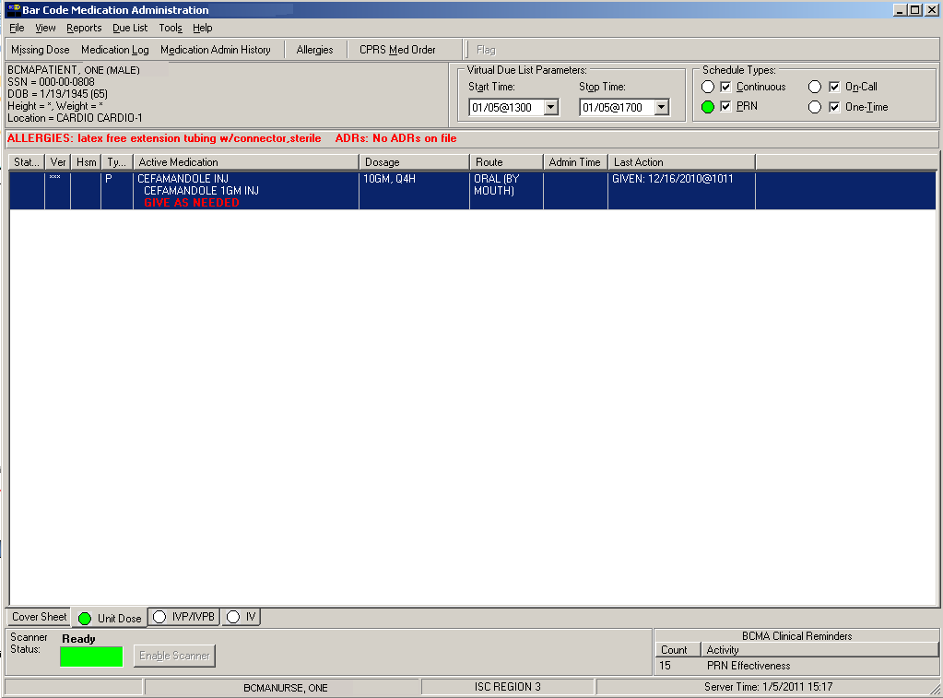
Administering a Patient’s Unit Dose Medications
Preparing to Administer Unit Dose Medications (cont.)  tip:  The Start and Stop Time Parameters are set to the “Default Times from ” settings in the GUI BCMA Site Parameters application.  tip:  You can expand (or restrict) the number of active Unit Dose medications, that display on the VDL, by changing the default Start and Stop Times in the Virtual Due List Parameters area. | Changing the Virtual Due List Parameters  The Virtual Due List Parameters is the functional timeframe during which you can administer medications to a patient before or after the scheduled administration time. For many medical centers, this timeframe is defined as two hours.  Once you use BCMA, these Parameters become your default settings. For example, when you change the default settings for certain fields (i.e., Start and Stop Times, and Column Sort Selection) on the BCMA VDL, these settings are retained in your user parameters and become the default settings each time you log on to BCMA. You can reset these user-selected parameters to site-defined parameters using the Reset User Parameters [PSB USER PARAM RESET] option in CHUI BCMA.  Note: The BCMA VDL Start and Stop Times display in one-hour increments, from the top of the nearest hour. For example, 1:15 displays as 1:00 and 1:45 displays as 2:00. You can expand the time range 12 hours before and 12 hours after NOW.  To change the Virtual Due List Parameters  - In the patient’s VDL, select the Start and Stop Times in the Virtual Due List Parameters area. The BCMA VDL automatically refreshes and displays active medications for the newly selected administration window.  Keyboard Shortcut: Press tab to access the Virtual Due List Parameters area and to move among the Time fields.  Example: Virtual Due List Parameters Area on VDL  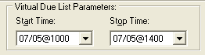  - Now you are ready to select the Schedule Types of Unit Dose medications that you want to display on the BCMA VDL.
Administering a Patient’s Unit Dose Medications
Preparing to Administer Unit  Dose Medications (cont.)  tip:  If a checkbox is selected for an order, that you do not want displayed on the VDL, click on it to deselect it.  tip:  If the Scanner Status Indicator is red, click in the Indicator field to activate the green Ready Light before scanning a medication bar code.  C  tip:  If the Scanner Status Indicator is RED, click in the Indicator field to activate the GREEN Ready Light before manually entering the Drug IEN Code or Unique Identifier Number.  tip:  You can scan any Unique Identifier Number listed in the Information message.  tip:  If the Scanner Status Indicator is RED, click in the Indicator field to activate the GREEN Ready Light before manually entering the Drug IEN Code or Unique Identifier Number.  tip:  You can scan any Unique Identifier Number listed in the Information message.  tip:  If the Scanner Status Indicator is RED, click in the Indicator field to activate the GREEN Ready Light before manually entering the Drug IEN Code or Unique Identifier Number.  Status Indicator is RED, click in the Indicator field to activate the GREEN Ready Light before manually entering the Drug IEN Code or Unique Identifier Number.  tip:  You can quickly look up the Drug IEN Code or Unique Identifier Number for a medication by selecting the medication on the VDL, and then selecting the related command from the Right Click drop-down menu.  tip:  If the Scanner Status Indicator is RED, click in the Indicator field to activate the GREEN Ready Light before manually entering the Drug IEN Code or Unique Identifier Number.  tip:  You can scan any Unique Identifier Number listed in the Information message.  tip:  You can quickly look up the Drug IEN Code or Unique Identifier Number for a medication by selecting the medication on the VDL, and then selecting the related command from the Right Click drop-down menu.  tip:  You can scan any Unique Identifier Number listed in the Information message.  tip:  You can scan any Unique Identifier Number listed in the Information message.  tip:  If the Scanner Status Indicator is RED, click in the Indicator field to activate the GREEN Ready Light before manually entering the Drug IEN Code or Unique Identifier Number.  tip:  You can scan any Unique Identifier Number listed in the Information message.  tip:  If the Scanner Status Indicator is RED, click in the Indicator field to activate the GREEN Ready Light before manually entering the Drug IEN Code or Unique Identifier Number.  tip:  You can scan any Unique Identifier Number listed in the Information message.  tip:  If the Scanner Status Indicator is RED, click in the Indicator field to activate the GREEN Ready Light before manually entering the Drug IEN Code or Unique Identifier Number.  Status Indicator is RED, click in the Indicator field to activate the GREEN Ready Light before manually entering the Drug IEN Code or Unique Identifier Number.  tip:  You can quickly look up the Drug IEN Code or Unique Identifier Number for a medication by selecting the medication on the VDL, and then selecting the related command from the Right Click drop-down menu.  tip:  If the Scanner Status Indicator is RED, click in the Indicator field to activate the GREEN Ready Light before manually entering the Drug IEN Code or Unique Identifier Number.  tip:  You can scan any Unique Identifier Number listed in the Information message.  tip:  You can quickly look up the Drug IEN Code or Unique Identifier Number for a medication by selecting the medication on the VDL, and then selecting the related command from the Right Click drop-down menu.  tip:  You can scan any Unique Identifier Number listed in the Information message.  tip:  You can scan any Unique Identifier Number listed in the Information message.  tip:  If the Scanner Status Indicator is RED, click in the Indicator field to activate the GREEN Ready Light before manually entering the Drug IEN Code or Unique Identifier Number.  tip:  You can scan any Unique Identifier Number listed in the Information message.  tip:  If the Scanner Status Indicator is RED, click in the Indicator field to activate the GREEN Ready Light before manually entering the Drug IEN Code or Unique Identifier Number.  tip:  You can scan any Unique Identifier Number listed in the Information message.  tip:  If the Scanner Status Indicator is RED, click in the Indicator field to activate the GREEN Ready Light before manually entering the Drug IEN Code or Unique Identifier Number.  Status Indicator is RED, click in the Indicator field to activate the GREEN Ready Light before manually entering the Drug IEN Code or Unique Identifier Number.  tip:  You can quickly look up the Drug IEN Code or Unique Identifier Number for a medication by selecting the medication on the VDL, and then selecting the related command from the Right Click drop-down menu.  tip:  If the Scanner Status Indicator is RED, click in the Indicator field to activate the GREEN Ready Light before manually entering the Drug IEN Code or Unique Identifier Number.  tip:  You can scan any Unique Identifier Number listed in the Information message.  tip:  You can quickly look up the Drug IEN Code or Unique Identifier Number for a medication by selecting the medication on the VDL, and then selecting the related command from the Right Click drop-down menu.  tip:  You can scan any Unique Identifier Number listed in the Information message.  tip:  You can scan any Unique Identifier Number listed in the Information message.  tip:  If the Scanner Status Indicator is RED, click in the Indicator field to activate the GREEN Ready Light before manually entering the Drug IEN Code or Unique Identifier Number.  tip:  You can scan any Unique Identifier Number listed in the Information message.  tip:  If the Scanner Status Indicator is RED, click in the Indicator field to activate the GREEN Ready Light before manually entering the Drug IEN Code or Unique Identifier Number.  tip:  You can scan any Unique Identifier Number listed in the Information message.  tip:  If the Scanner Status Indicator is RED, click in the Indicator field to activate the GREEN Ready Light before manually entering the Drug IEN Code or Unique Identifier Number.  Status Indicator is RED, click in the Indicator field to activate the GREEN Ready Light before manually entering the Drug IEN Code or Unique Identifier Number.  tip:  A GREEN “alert light” indicates that a medication order exists for the Schedule Type selected within  the respective start/stop date  and time.  If grayed out,  then none exist.  tip:  You can automatically display PRN medication orders when the VDL is first opened by selecting the PRN check box in the “Include Schedule Types” area of the GUI BCMA Site Parameters application. | Changing Schedule Types on the VDL  You are ready to select the Schedule Types of the active Unit Dose medications that you want to display on the BCMA VDL. You can choose all Schedule Types available or just specific ones.  The abbreviation for each Schedule Type is listed as follows in the Type column of the BCMA VDL:  - C (for Continuous)  - P (for PRN)  - OC (for On-Call)  - O (for One-Time)  Note: Each time that you open a VDL (i.e., patient record), BCMA defaults to the Unit Dose Medication Tab and the Schedule Types of Continuous, One-Time, and On-Call already selected. This occurs even if you change the Schedule Types or Medication Tab during a medication pass. The PRN Schedule Type controls the default display of PRN medications on the BCMA VDL, and is based on the GUI BCMA Site Parameters entry for “Include Schedule Types.”  To select Schedule Types that display on the VDL  - In the Schedule Types area of the BCMA VDL, select the check boxes that apply to the types of medication orders that you want to display on the BCMA VDL for the patient. You may select all of the check boxes or just specific ones.  - If a checkbox is selected for a Schedule Type that you do not want displayed, click on it to deselect it.  Keyboard Shortcut: Press tab to access the Schedule Types area and the arrow keys to move among the Schedule Types. Use the spacebar to select a Schedule Type.  Example: Schedule Types Area of VDL  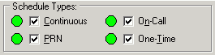  - Now you are ready to scan the patient’s active Unit Dose medications.
Administering a Patient’s Unit Dose Medications
Scanning and Verifying Medication Information  tip:  You do not have to select an active Unit Dose medication on the VDL before scanning the medication bar code. | Now you are ready to scan (and verify) the patient’s active Unit Dose medications and to officially begin the medication administration process.  To scan and verify medication information  - At the patient’s VDL, first check the status of the scanner at the lower left corner of the VDL.  - If the Scanner Status is “Ready” and GREEN, scan the bar code on the medication.  - If the Scanner Status is “Not Ready” and RED, click the enable scanner button to enable the scanner, and scan the bar code on the medication.  Keyboard Shortcut: Press alt-b to enable the scanner.  Example: Scanner Status and Enable Scanner button  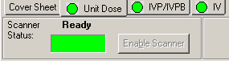  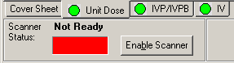  - If you are unable to scan the medication bar code for any reason, right-click on the administration, and select the Unable to Scan option from the right click or Due List menu. Proceed to the section “Unable to Scan Unit Dose Medication” on page 71.  Example: Unable to Scan  Right-Click Option  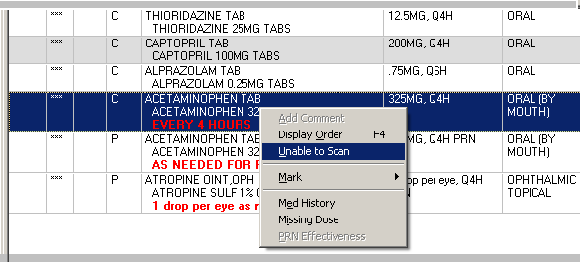
Administering a Patient’s Unit Dose Medications
Scanning and Verifying Medication Information (cont.)  tip:  If the Scanner Status Indicator is red, click in the Indicator field to activate the green Ready Light before scanning a medication bar code. | To scan and verify medication information (cont.)  - Continue with the medication administration process for the patient’s active Unit Dose medications.  - If an Error message indicates that the Drug Bar Code was not found in the DRUG file (#50), see page 66.  - If an Error message indicates that the medication has already been given or it’s not time to give it yet, see page 67.  - If an Error message indicates that no order exists for the medication that you just scanned, see page 68.  - If an Information message indicates that you attempted to take action on an administration with an unknown action status, see page 69.  - If an Information message indicates that you attempted to take action on an order that contains an administration with an unknown action status, see page 70.
Administering a Patient’s Unit Dose Medications
Scanning and Verifying Medication Information (cont.)  tip:  If the Scanner Status Indicator is red, click in the Indicator field to activate the green Ready Light before scanning a medication bar code. | - If Drug IEN Code Not Found in DRUG file (#50)  The Error message provided below displays when BCMA does not locate the medication Drug IEN Code or synonym in the DRUG file (#50). This occurs if the DRUG file (#50) contains two entries for the same Drug IEN Code, or the code is invalid.  This error message also displays during an Unable to Scan event, whenever the Drug IEN Code or synonym entered at the Medication Verification dialog does not match the medication on the order.  Note: If you receive this Error message more than once, contact the Pharmacy directly about the problem.  - Review the Error message, and click ok to return to the patient’s VDL.  Keyboard Shortcut: Press tab to activate the ok button, and press enter to display the patient’s VDL.  Example: Error Message When  Drug IEN Code Not Found  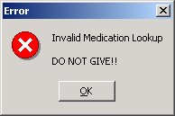  - Select a medication order on the patient’s VDL.

Administering a Patient’s Unit Dose Medications
Scanning and Verifying Medication Information (cont.)  tip:  If the Scanner Status Indicator is red, click in the Indicator field to activate the green Ready Light before scanning a medication bar code. | - If Medication Already Given or Not Time To Give Yet  The Error message, provided below, displays if a patient has an order, BUT the medication has already been given to them, or it’s not time yet to give the medication to them.  To review the Error message  - Review the Error message, and then click ok to return to the patient’s VDL.  Keyboard Shortcut: Press tab to activate the ok button, and then press enter to return to the patient’s VDL.  Example: Error Message When Medication Already Given or It’s Not Time to Give Yet  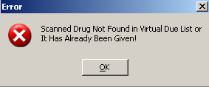  - Continue administering active Unit Dose medications to the patient.
Administering a Patient’s Unit Dose Medications
Scanning and Verifying Medication Information (cont.)  tip:  If the Scanner Status Indicator is red, click in the Indicator field to activate the green Ready Light before scanning a medication bar code. | - If No Order Exists for Medication Scanned  The Error message, provided below, displays if the patient does not have an order for the medication that you just scanned.  To review the Error message  - Review the Error message, and then click ok to return to the patient’s VDL.  Keyboard Shortcut: Press tab to activate the ok button, and then press enter to return to the patient’s VDL.  Example: Error Message When No Order Exists  for Medication Scanned  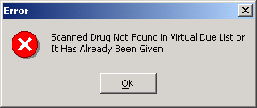  - Continue administering active Unit Dose medications to the patient.
Administering a Patient’s Unit Dose Medications
Scanning and Verifying Medication Information (cont.) | - If User Attempts to Take Action on an Administration with an Unknown Action Status  The Informational message, provided below, displays if the user attempts to administer or take action on an administration whose status is “Unknown.” The user must confirm the message by clicking OK, but the action will be cancelled. Users are required to resolve the status of the administration using the Edit Med Log option.  To review the Error message  - Review the Error message, and click ok to return to the patient’s VDL.  Keyboard Shortcut: Press tab to activate the ok button, and press enter to return to the patient’s VDL.  Example: Information Message for Unknown Action Status -- Administration Cancelled  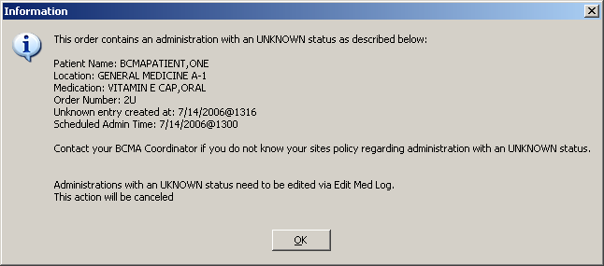  - Proceed to the Edit Med Log option to resolve the status of the administration.  Note: For information on using the Edit Med Log option, please refer to Chapter 7, “Editing the Medication Log.”
Administering a Patient’s Unit Dose Medications
Scanning and Verifying Medication Information (cont.) | - If User Attempts to Take Action on an Order that Contains an Administration with an Unknown Action Status  The Informational message, provided below, displays if the user starts to administer or take action on an order in which one of the administration associated with that order has an “Unknown” status. The user can choose to acknowledge the message and proceed with the administration or cancel the action.  To review the Error message  - Review the Error message, and perform one of the following actions:  - To continue with the administration, click ok.  - To cancel the administration without saving, click cancel. To resolve the status of the associated administration, use the Edit Med Log option.  Keyboard Shortcut: Press tab to activate the ok or cancel button, and press enter to access the patient’s VDL.  Note: For information on using the Edit Med Log option, please refer to Chapter 7, “Editing the Medication Log.”  Example: Information Message for Unknown Action Status with Option to Continue Administration  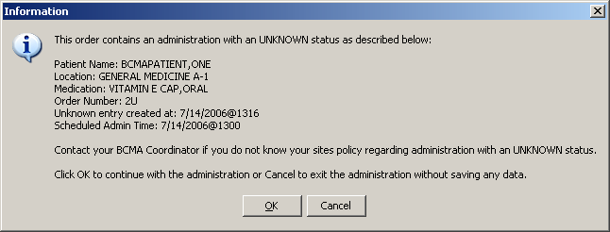  - Continue administering active Unit Dose medications to the patient.

Administering a Patient’s Unit Dose Medications
Unable to Scan  Unit Dose Medication  tip:  You can report scanning failures without interrupting the medication administration process. | Medication scanning failures may be due to several reasons. The barcode may be illegible, it may be damaged, it may be absent, the equipment may be faulty, the drug may be invalid, there may be a dose discrepancy, or the synonym may not be in our drug file. Whatever the reason, the user can select the Unable to Scan feature to document the administration as well as inform their IRM/Pharmacy staff of the problem.  To administer a unit dose medication using Unable to Scan  - From the Unit Dose tab, select an administration for a unit dose order. Then select the Unable to Scan command from the right-click or the Due List menu.  Example: Unable to Scan Right Click Option  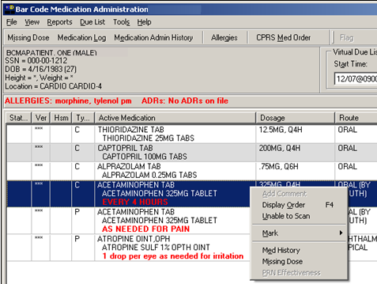  - If the early/late medication log displays, enter a comment describing why the administration is early or late.  - If it is a PRN order, the PRN Medicaion Log dialog box displays before the Unable to Scan dialog box if it is too soon to give the PRN medication.  - If the selected administration has multiple dispense drugs, or a unit per dose does not equal to one, continue the existing workflow as if the drug had been scanned until the Multiple Dose or Multiple/Fractional Dose dialog box displays. For orders with multiple dispense drugs or units per dose not equal to one, refer to the sections on “Administering a Multiple Dose Order” and “Administering a Fractional Dose Order.”
Administering a Patient’s Unit Dose Medications
Unable to Scan  Unit Dose Medication (cont.)  tip:  If the Scanning failure is not an equipment problem, you can scan the problematic bar code directly into the Comment field. This may help your IRM and Pharmacy staff zero in on the source of problem more quickly. | To administer a unit dose medication using Unable to Scan (cont.)  - At the Unable to Scan dialog box, verify the administration information displayed at the top of the Unable to Scan dialog box including: Medication, Scheduled Admin Time, Schedule Type, Dosage/Infusion Rate, Units Per Dose, Last Action, Bag ID, Medication Route, Special Instructions, and Dispensed Drugs/Medications/Solutions.  Example: Unable to Scan Dialog Box  for Unit Dose Administration  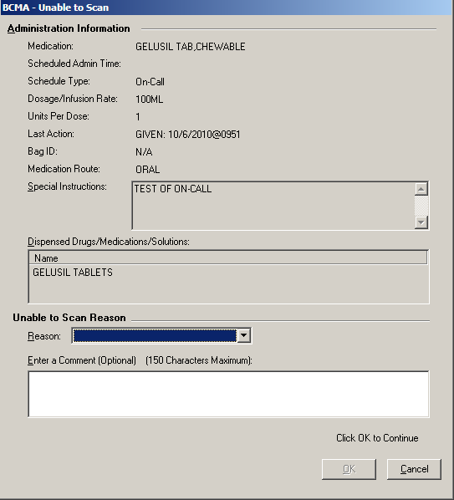  - Select an “Unable to Scan Reason” from the drop-down list box. Selections include: Damaged Medication Label, Dose Discrepancy, No Bar Code, Scanning Equipment Failure, and Unable to Determine.  Example: Unable to Scan Medication Reasons  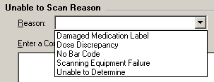
Administering a Patient’s Unit Dose Medications
Unable to Scan  Unit Dose Medication (cont.) | To administer a unit dose medication using Unable to Scan (cont.)  Note: If you click Cancel at any point in the Unable to Scan process, the Unable to Scan event is not logged, an email is not sent, and the “Order Administration Cancelled” message displays.  - You may enter an optional text comment. Click OK. The Medication Verification dialog box displays.  Example: Medication Verification Dialog Box  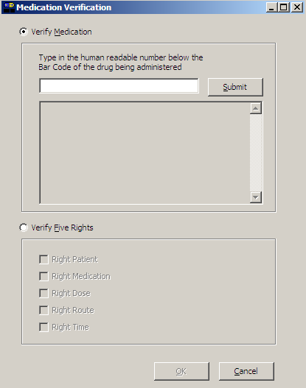  - Notice the Verify Medication option is selected by default. To verify the medication being administered, enter the Drug IEN or National Drug Code from the medication package in the entry field. Click Submit.  - If the number entered matches the dispense drug being administered for the selected order, the the medication, dosage, units, route and special instructions will display. Verify that the information displayed matches the order.  Note: When entering a bar code number, remember that no letters, spaces or punctuation marks are allowed.
Administering a Patient’s Unit Dose Medications
Unable to Scan  Unit Dose Medication (cont.) | To administer a unit dose medication using Unable to Scan (cont.)  Example: Medication Verification Dialog Box  (Verify Medication Option)  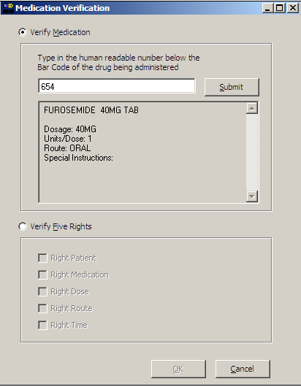  - If the number entered does not match the dispense drug being administered for the selected order:  - An “Invalid Medication – Do not Give”error message displays.  Example: Error Message When  Drug IEN Code Not Found
Administering a Patient’s Unit Dose Medications
Unable to Scan  Unit Dose Medication (cont.) | To administer a unit dose medication using Unable to Scan (cont.)  - If the number entered does not match, or the bar code number is not readable, or there is no label, you may select the Verify Five Rights option. Place a checkmark in each of the five checkboxes to document that the five rights of medication administration have been physically verified (right patient, right medication, right dose, right route, right time) and continue administering the medication without entering a matching bar code number.  Note: This option is only available if the Five Rights Override Parameter is enabled for unit dose medications in the BCMA Site Parameters application. If the Five Rights Override Parameter is turned off, you will not be able to administer the medication. Refer to your site policies regarding how to contact pharmacy to address the problem.  Example: Medication Verification Dialog Box  (Five Rights Override Option)  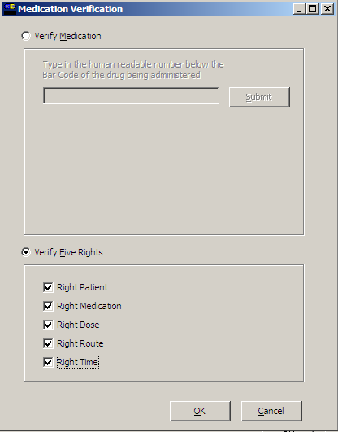  - Review the contents of the Medication Verification dialog box and perform one of the following actions:
Administering a Patient’s Unit Dose Medications
Unable to Scan  Unit Dose Medication (cont.)  tip:  Email messages will be sent to the Unable to Scan email group that is defined in the BCMA Site Parameters application. | To administer a unit dose medication using Unable to Scan (cont.)  - Click OK to complete the Unable to Scan process and continue with the administration. Upon completing the administration you will return to the VDL. BCMA processes the information and displays the letter “G” (for “Given”) in the Status column to document that you administered the medication to the patient. The Unable to Scan event is recorded, and a Mailman message is sent notifying IRM/Pharmacy staff of the medication bar code sanning failure.  - Click the Cancel button to cancel the Unable to Scan process without documenting the administration. The Unable to Scan event will not be recorded, nor will a MailMan message be sent.  MailMan Message Sent After Medication Bar Code Scanning Failure  When you create a medication scanning failure entry, a MailMan message will be sent to the mail group you specified. The subject line of the message will indicate a medication scanning failure. The body of the message will contain the following information:  - User: Last name, First Name (for identifying system issues only/educational needs)  - Date/Time of event  - Patient: Last Name, First Name, and last four digits of patient’s Social Security Number.  - Order Number  - Ward Location/Room  - Type of Bar Code issue: Medication  - Medication  - Unit Dose orders will display dispense drug; drug IEN; dosage ordered  - IV Orders will display: unique ID (Bag ID typed by User or Wardstock); orderable item.  - Reason for scan failure  - User’s comment  Note: Inclusion of the last four digits of the patient’s SSN is currently allowed in VistA clinical alert messaging. If there are changes to this policy due to a future VHA directive, the format of this field is subject to change.
Administering a Patient’s Unit Dose Medications
Administering a Multiple Dose Order  tip:  This functionality  is also available on the IVP/IVPB Medication Tab. | The Multiple Dose dialog box, provided below, displays when the patient’s order includes a single dispensed drug with multiple doses (variable doses) that need to be administered to the patient. The Multiple Dose dialog box provided on the next page displays when the patient has multiple dispensed drugs that need to be administered to them. You can add comments about the medication administration process to either dialog box.  To administer a multiple dose order  - Scan each dosage or dispensed drug for the medication that you want to administer to the patient.  - If you did not scan once for each unit listed in the Multiple Dose dialog box, the Confirmation dialog box displays. Proceed to step #2.  - If you are unable to scan one of the units, click the Unable to Scan button next to the unit and proceed with the Unable to Scan Unit Dose Medication process, as described on page 71.  Note: The Multiple Dose dialog box closes automatically if you are scanning the last dosage for the medication.  Example: Multiple Dose Dialog Box  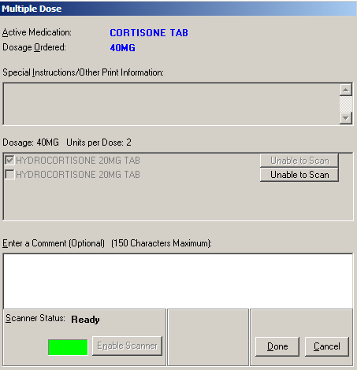  — OR —  (See Next Page)
Administering a Patient’s Unit Dose Medications
Administering a Multiple Dose Order (cont.)  tip:  The Multiple Dose  dialog box displays  the dosage and units per dose for orders that contain only one dispensed drug. However, orders that contain more than one dispensed drug will display the heading “***Multiple Dispensed Drugs:” instead. | To administer a multiple dose order (cont.)  Example: Multiple/Fractional Dose Dialog Box  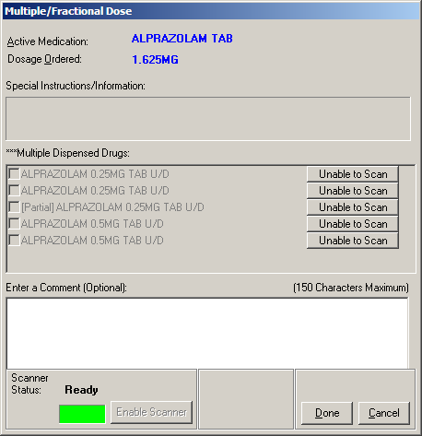  — OR —  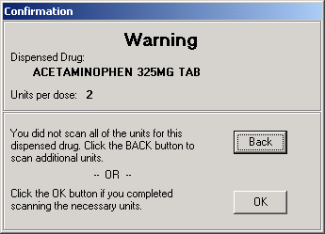  - At the Confirmation dialog box, click back to scan additional units. The Multiple Dose dialog box re-displays, retaining the data entered before you clicked the done button.  - Click done after you scan all multiple dosages or multiple dispensed drugs needed. BCMA processes the information, and then displays the letter “G” (for “Given”) in the Status column to document that you administered the medication to the patient.  - Continue administering active Unit Dose medications.  Keyboard Shortcut: Press tab to activate the done button, and press enter to display the patient’s VDL.
Administering a Patient’s Unit Dose Medications
Administering a Fractional Dose Order  tip:  The Fractional  Dose dialog box  lets you document the administration of fractional unit doses that are  less than 1.0.  tip:  This functionality  is also available on the IVP/IVPB Medication Tab. | The Fractional Dose functionality is designed to alert you when dispensed drug dosages need to be administered to a patient in “fractional” doses, and to allow you to provide comments about this order type once administered. In short, the related dialog boxes let you document the units and the fractional portion of a dose administered to a patient.  Note: The Fractional Dose dialog box displays when the units per dose is fractional and less than 1.0. The Multiple/Fractional Dose dialog box displays when the units per dose is greater than 1.0. If you do not scan once for each unit listed in the Multiple/Fractional Dose dialog box, the Confirmation dialog box displays, requesting that you confirm the actual total units administered to the patient.  To administer a fractional dose order  - Scan the medication that you want to administer to the patient.  Note: The dialog box that displays depends on the amount of the fractional dose (i.e., less than or greater than 1.0) to be administered to the patient.  Example: Fractional Dose Dialog Box  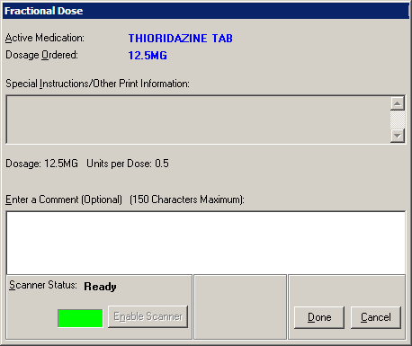

Administering a Patient’s Unit Dose Medications
Administering a Fractional Dose Order (cont.)  tip:  The Multiple/  Fractional  Dose dialog box  lets you document the administration of fractional unit doses that are greater than 1.0. | To administer a fractional dose order (cont.)  Example: Multiple/Fractional Dose Dialog Box  - Perform one of the following actions, which are related to the fractional dose administered to the patient.  - If the fractional dose is less than 1.0, enter any comments about the administration (if desired), and click done. BCMA processes the information and displays the letter “G” (for “Given”) in the Status column to document that you administered the medication to the patient.  - If the fractional dose is greater than 1.0, scan all units that you’re administering to the patient, enter any comments about the administration (if desired), and click done. If all units are scanned, BCMA processes the information, and displays the letter “G” (for “Given”) in the Status column to document that you administered the medication to the patient.  - If you did not scan once for each unit listed in the Multiple/Fractional Dose dialog box, the Confirmation dialog box displays. Proceed to step #3.  - If you are unable to scan one of the units, click the Unable to Scan button next to the unit and proceed with the Unable to Scan Unit Dose Medication process, as described on page 71.  Keyboard Shortcut: Press tab to activate the done button, and press enter to display the patient’s VDL.
Administering a Patient’s Unit Dose Medications
Administering a Fractional Dose Order (cont.)  tip:  The Confirmation  dialog box  displays if you do not scan once  for each unit  listed in the Multiple/Fractional Dose dialog box. | To administer a fractional dose order (cont.)  Example: Confirmation Dialog Box  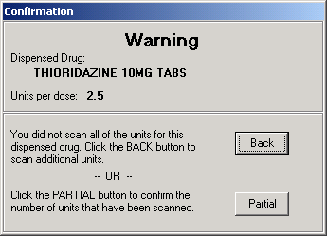  - At the Confirmation dialog box, perform one of the following actions, which are related to the fractional dose administered to the patient.  - Click back to scan additional units, if you did not scan all of the units for this dispensed drug. The Multiple/Fractional Dose dialog box re-displays, retaining the data entered before you clicked the done button. If the fractional dose is greater than 1.0, perform step #2 again.  - Click the partial button to confirm the number of units that have been scanned. The Confirmation dialog box expands for you to select the number of units that have been scanned. Proceed to step #4.

Administering a Patient’s Unit Dose Medications
Administering a Fractional Dose Order (cont.)  tip:  The Confirmation  dialog box  expands when you click the partial button, allowing you to select the number of units scanned that will be recorded in BCMA. | To administer a fractional dose order (cont.)  Example: Confirmation Dialog Box (Expanded)  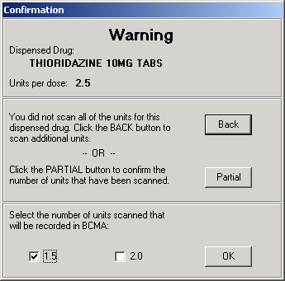  - Select the number of units scanned that will be recorded in BCMA.  Note: Since BCMA cannot determine if one of the units scanned was the fractional unit (i.e., the split tablet), the following choices are provided in the example above, where only two scans were performed.  - Selecting 1.5 indicates that 1.5 units were administered to the patient.  - Selecting 2.0 indicates that 2.0 units were administered to the patient.  - Click ok after making your selection. BCMA processes the information, records the number of units selected, and displays the letter “G” (for “Given”) in the Status column to document that you administered the medication to the patient.  - Continue administering active medications to the patient.
Administering a Patient’s Unit Dose Medications
Administering an Order with Multiple Admin Times | The Multiple Orders for Scanned Drug dialog box, provided below, displays only if the patient’s order has multiple administration times for the medication that you scanned — using the Start and Stop time setting on the BCMA VDL.  To administer an order with multiple administration times  - Select the order containing the administration time that you need, and click ok. BCMA processes the information, and displays the letter “G” (for “Given) in the Status column to document that you administered the medication to the patient.  Keyboard Shortcut: Use the arrow keys to select an order. Press tab to activate the ok button, and press enter to accept the selection and display the patient’s VDL.  Example: Multiple Orders for Scanned Drug Dialog Box  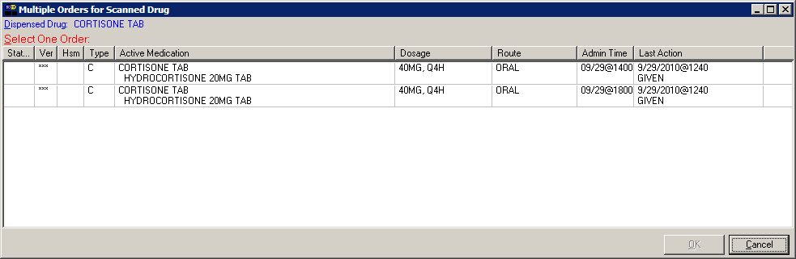  - Continue administering active Unit Dose medications to the patient.
Administering a Patient’s Unit Dose Medications
Administering an Order with Special Instructions  tip:  Special Instructions help to ensure that the patient receives the medication dosage required by the provider. | Information messages, like the ones provided below, display when the Pharmacy answers “YES” to a question in Inpatient Medications V. 5.0 about including Special Instructions in a Pop-up box after a nurse scans a medication. If the Pharmacy answers “NO” to the question, the Special Instructions only display in RED below the dispensed drug name in the Medication Order Display Area. You must acknowledge the message before administering the medication.  The Special Instructions may include those provided below, or they could even include the sliding scale range written by the provider. That way, you know how much insulin to administer to the patient, based on the patient’s blood sugar level.  To review Special Instructions from the Pharmacy  - Review the Information message from the Pharmacy, and click ok to return to the patient’s VDL.  Keyboard Shortcut: Press tab to activate the ok button, and press enter to continue the medication administration process.  Example: Special Instructions Pop-up Boxes  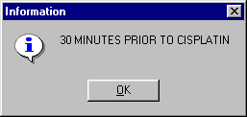  — OR —  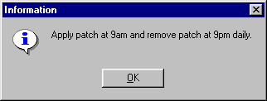  - Continue administering active Unit Dose medications to the patient.
Administering a Patient’s Unit Dose Medications
Specifying the Medication Quantity and Units Given  tip:  You may be required to  specify the quantity and units given for cc’s, milliliters, grams, milliequivalants, milligrams, millimoles, and units. | To specify medication quantity and units given to patient  - Enter the quantity and units of the medication that you are administering to the patient, and click ok. The maximum character length is 40. BCMA processes the information, and displays the letter “G” (for “Given”) in the Status column to document that you administered the medication to the patient.  Keyboard Shortcut: Press tab to activate the ok button, and press enter to continue.  Example: Quantity and Units Dialog Box  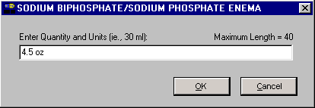  - Continue administering active Unit Dose medications to the patient.
Administering a Patient’s Unit Dose Medications
Specifying the Injection Site for the Medication | The Injection Site Selection dialog box, provided below, displays when a Unit Dose medication is injectable and has a Med Route of Intravenous, Intravenous Push, Intramuscular, Intradermal, or Subcutaneous. (Other routes do not have this requirement.) When this occurs, BCMA requires that you enter the quantity/units and location on the patient (the site/location) where you are injecting the medication — before proceeding with the administration process.  To specify an injection site for the medication  - In the Injection Site Selection drop-down list box, select the location where you are injecting the medication into the patient, and click ok. BCMA processes the information and displays the letter “G” (for “Given”) in the Status column to document that you administered the medication to the patient.  Keyboard Shortcut: Use the arrow keys to select an injection “site” in the drop-down list box. Press tab to activate the ok button, and press enter to continue.  Example: Injection Site Dialog Box  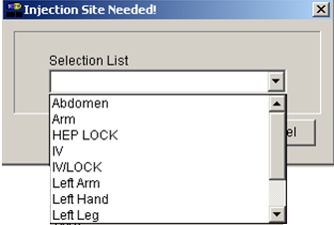  - Continue administering active Unit Dose medications to the patient.
Administering a Patient’s Unit Dose Medications
Marking a Patch  As Removed  tip:  You can quickly mark a patch as “Removed” by selecting a medication  on the VDL, then selecting the Mark command from the Right Click drop-down menu. | BCMA lets you document when you “remove” a patch (i.e., Nitroglycerin, Fentanyl, or Nicotine) from a patient. Once marked, the letters “RM” (for “Removed”) display in the Status column of the BCMA VDL.  A patch marked as “Given” displays on the BCMA VDL each time BCMA is opened — until it is marked as “Removed” — even if the order is discontinued or expires, or the patient is discharged or  re-admitted to your medical center. The patch will fall off the display after the order’s stop date if the “Patch Display Duration” site parameter value is set between 7 and 14 days. If an order (except a one-time order) has either Expired or been Discontinued and the patch has not been marked as “Removed,” an alert displays and continues to pop up until the patch is marked as “Removed.”  Note: The action of marking an administration “Not Given” has been replaced by “Undo,” which is applicable only to a patch marked as “Given” or “Removed.” The wording opposite the Undo status will change, depending on the current status of the patient’s medication. For example, changing a medication marked as Given to Undo will display as “Undo–Given” in the Mark drop-down menu.  To mark a patch as Removed  - Select a “patch” medication that you want to mark as “Removed” on the BCMA VDL.  Note: You cannot administer another patch to a patient, from the same order, until the previous one is marked as “Removed.” This requirement applies to all orderable items with a dosage form of Patch.  - Select the Mark command from the Right Click or Due List menu. The Mark drop-down menu displays with the “actions” available for this medication (patch).  Keyboard Shortcut: Press alt+d to display the Due List menu, and press m to display the Mark command in the drop-down menu.  - Select the Removed command from the drop-down menu. BCMA processes the information, and displays the letters “RM” (for “Removed”) in the Status column of the BCMA VDL to document the action taken on the medication.  Keyboard Shortcut: Use the arrow keys to select the Removed command.  - Continue administering active Unit Dose medications to the patient.

Administering a Patient’s Unit Dose Medications
“Given” Patch that is Expired or Discontinued | When a patch marked as Given is Expired or Discontinued  When a patch has been “Given” and the order (except a one-time order) then expires or is discontinued, and the patch has not been marked as “Removed,” an alert displays.  Example: Given Patches that are Expired or Discontinued Alert  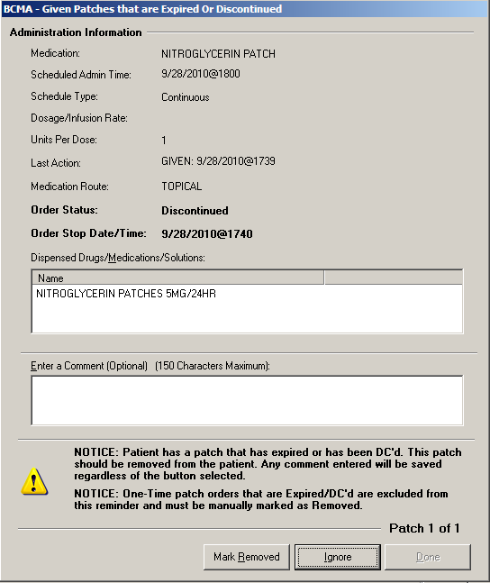  To automatically mark a patch as Removed  - To automatically mark the patch as “Removed,” click the mark removed button.  - Enter comments as needed.  Note: If the ignore button is clicked, the status of the patch administration will remain “Given,” and the alert will continue to pop up until the patch is marked as “Removed.”  - Select one of the following options:  - Next: The Next button is enabled when there is more than one “Given” patch order that is expired or discontinued. You will see “Patch 1 of N,” where N is the total number of “Given” patches that are discontinued or expired for this patient. Select the Next button to display the next “Given” patch order that is expired or discontinued.
Administering a Patient’s Unit Dose Medications
“Given” Patch that is Expired or Discontinued (cont.) | To automatically mark a patch as Removed (cont.)  - Done: The Done button is enabled when all “Given” patches that are discontinued or expired have been either “Marked Removed” or “Ignored.” Click Done to return to the VDL.  Note: You can manually mark a patch as “Removed” from the VDL. Select a patch medication on the VDL, and then select the Mark command from the Right Click drop-down menu, then select Removed.
Administering a Patient’s Unit Dose Medications
Administering a PRN Order  tip:  The Med History button displays the Medication History Report for the orderable item listed in the  dialog box.  tip:  If no administration times are listed in the Medication Log dialog box, the patient has not received any previous doses. | The Medication Log dialog box, provided below, displays when you administer a PRN medication to a patient. BCMA checks for an active order and displays the last four “actions” for the same orderable item (not the medication), the date/time of each action, the schedule type, the reasons that the selected PRN medication was administered to the patient, and the number of units given to the patient.  If you are administering a PRN medication using the Unable to Scan feature, the Medication Log dialog box for PRN administrations will display before the Unable to Scan dialog box, allowing you to determine whether it’s too soon to give the PRN medication before continuing with the Unable to Scan process.  The dialog box also includes the Vitals area, which can display the four previous vitals entries for each of the Vital signs listed in the area. The “+” (plus) sign, to the left of a Vital sign, expands the row to reveal additional entries. The “–” (minus) sign collapses the row to hide all but the most recent entry.  To administer a PRN order  - In the Select a Reason drop-down list box, select a site-defined reason that indicates why you are administering the PRN medication to the patient.  Keyboard Shortcut: Use the arrow keys to locate and select a Reason in the drop-down list box.  Example: Medication Log Dialog Box  for PRN Administration  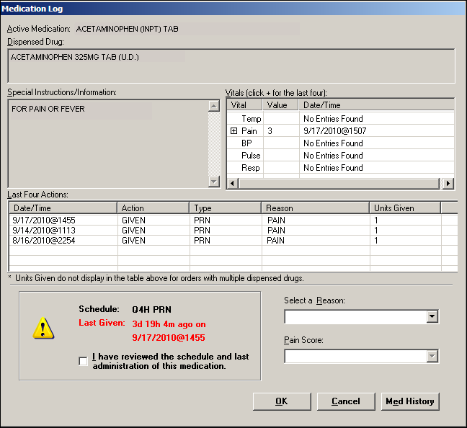
Administering a Patient’s Unit Dose Medications
Administering a PRN Order (cont.)  tip:  The “G” disappears from the Status column after you refresh the VDL, or close the VDL after administering a PRN medication to the patient. | To administer a PRN order (cont.)  - In the Pain Score drop-down list box, select the patient’s pain score, between 0 and 10 or 99, with “0” being No Pain, “10” the Worst Imaginable, and “99” for “Unable to Respond.”  Note: You are prompted to enter a pain score only if your site has selected this requirement for the “Reason Medication Given PRN Answer Lists” in the GUI BCMA Site Parameters application.  - In the Schedule area, select the check box to acknowledge that you, as the person administering the medication, have reviewed the schedule and last administration for the medication.  Note: To continue, you must check the box.  - Click ok to accept your selection and return to the patient’s VDL. BCMA processes the information, and displays the letter “G” (for “Given”) in the Status column to document that you administered the medication to the patient.  Keyboard Shortcut: Press tab to activate the ok button, and press enter to continue.  - Continue administering active Unit Dose medications to the patient.
Administering a Patient’s Unit Dose Medications
Recording the Effectiveness of a PRN Medication  tip:  You can quickly access the PRN Effectiveness Log by selecting a medication  on the VDL, and then selecting the PRN Effectiveness command from the Right Click drop-down menu.  tip:  You can double click on the PRN Effectiveness Activity in the BCMA Clinical Reminders marquee to document ALL PRN medication orders needing effectiveness documentation. | After administering a PRN medication to a patient, you can record the effectiveness of the medication for the patient and view the related information on the PRN Effectiveness List Report.  The PRN Effectiveness Log dialog box lists the orderable item, units given, administration date/time, reason the PRN medication was given, medication administrator, and the patient’s location in the hospital. The Vitals area can display the four previous vitals entries for each of the Vital signs listed in the area. The “+” (plus) sign, to the left of a Vital sign, expands the row to reveal additional entries. The “–” (minus) sign collapses the row to hide all, but the most recent entry.  To record the effectiveness of a PRN medication  - Select the PRN medication on the BCMA VDL for which you want to record Effectiveness comments.  Note: You can enter the Effectiveness for a PRN medication only if an administration has a status of “G” (for Given).  - Select the PRN Effectiveness command from the Right Click or Due List menu. The PRN Effectiveness Log dialog box displays with the patient’s medication information listed at the top of the box, under the Selected Administration area, and all PRN medication administrations displayed in the PRN List table.  Keyboard Shortcut: Press alt+d to display the Due List menu, and press p to select the PRN Effectiveness command.  - Under the PRN List table, select the medication for which you want to enter an Effectiveness comment. The “Selected Administration” area of the dialog box populates with administration information.  Keyboard Shortcut: Use the arrow keys to locate and select a PRN medication in the list box.
Administering a Patient’s Unit Dose Medications
Recording the Effectivness of a PRN Medication (cont.)  tip:  The Med History button displays  the Medication History Report for the orderable item listed in the  ”Selected Administration” area of the  dialog box.  tip:  After you submit the pain score, date/time, and comments and the BCMA VDL is refreshed, BCMA updates the count for the PRN Effectiveness Activity in the BCMA Clinical Reminders marquee. | To record the effectiveness of a PRN medication (cont.)  - Under the PRN Effectiveness Comment area, enter the effectiveness of the medication given to the patient, up to 150 characters in length. If a pain score is entered, the comment is optional.  Example: Entering an Effectiveness Comment  for a Selected PRN Medication  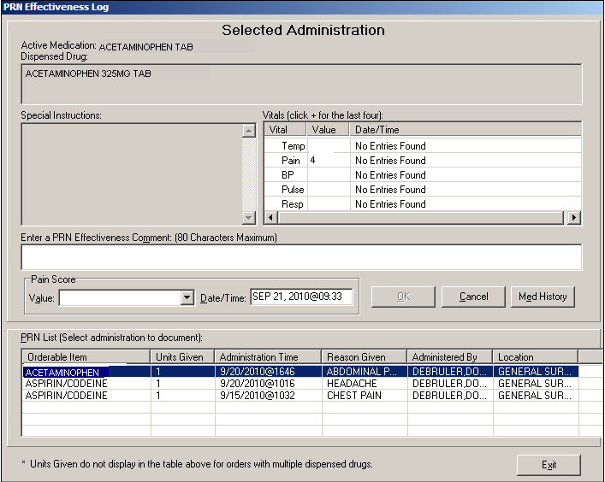  - In the Pain Score drop-down list box, select the patient’s pain score, between 0 and 10 or 99, with “0” being No Pain, “10” the Worst Imaginable, and “99” for “Unable to Respond.”  Note: You are prompted to enter a pain score only if your site has selected this requirement for the “Reason Medication Given PRN Answer Lists” in the GUI BCMA Site Parameters application.  - In the Date/Time drop-down list box, define the date/time that the pain score was taken. This information cannot be before the administration time or after the current system time.  - Click ok to file your comments, or click exit to submit your comments and pain score information and return to the patient’s VDL. If you entered a pain score, the text “Pain Score entered in Vitals via BCMA taken at [date/time]” and your comments will display on the Medication Log.  Keyboard Shortcut: Press tab to activate the ok button, and press enter to continue.
Administering a Patient’s Unit Dose Medications
Administering a Medication Early  tip:  Medications logged as “Early” are noted in the Medication Variance Log, along with the time scanned, and the reason the medication was administered early.  tip:  BCMA will not mark the medication as Given (with a “G”), in the Status column of the VDL, until you enter a “Comment” in the Medication Log dialog box. | The Medication Log dialog box, provided below, is designed to “alert” you that you are administering the medication to the patient before the scheduled administration time. The dialog box includes the number of minutes that you are administering the medication, “before the scheduled administration time” listed on the BCMA VDL. You can add a “Comment” (free text), up to 150 characters in length.  To administer a medication early to a patient  - In the Comments area of the Medication Log dialog box, specify the reason that you are administering the medication early to the patient, and click ok. BCMA processes the information, and displays the letter “G” (for “Given”) in the Status column to document that you administered the medication to the patient.  Keyboard Shortcut: Press tab to activate the ok button, and press enter to continue.  Example: Medication Log Dialog Box for Early Dose  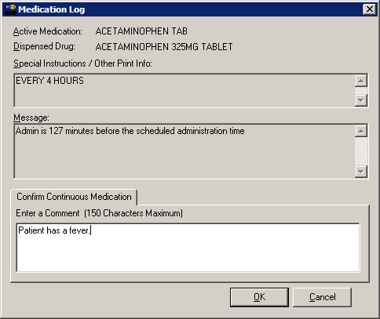  - Continue administering active Unit Dose medications to the patient.
Administering a Patient’s Unit Dose Medications
Administering a Medication Late  tip:  Medications logged as “Late” are noted in the Medication Variance Log, along with the time scanned, and the reason the medication was administered late.  tip:  BCMA will not mark the medication as “Given”  (with a “G”), in the Status column of the VDL, until you enter a “Comment” in the Medication Log dialog box. | The Medication Log dialog box, provided below, is designed to “alert” you that you are administering the medication to the patient after the scheduled administration time. The dialog box includes the number of minutes that you are administering the medication, “after the scheduled administration time” listed on the BCMA VDL. You can add a “Comment” (free text), up to 150 characters in length.  To administer a medication late to a patient  - In the Comments area of the Medication Log dialog box, specify the reason that you are administering the medication late to the patient, and click ok. BCMA processes the information, and displays the letter “G” (for “Given”) in the Status column to document that you administered the medication to the patient.  Keyboard Shortcut: Press tab to activate the ok button, and press enter to continue.  Example: Medication Log Dialog Box for Late Dose  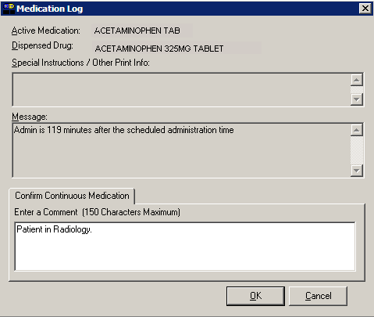  - Continue administering active Unit Dose medications to the patient.
Administering a Patient’s Unit Dose Medications
Marking Multiple Medications  on the VDL  tip:  You can quickly mark multiple medications selected on the VDL, with the same “action,” by selecting the Mark command from the Right Click drop-down menu. | As requested, you can select and mark multiple medications, for the patient, as “Held” or “Refused” on the BCMA VDL. This feature is particularly helpful when a patient is temporarily off their ward, or if they refuse to take their medications.  To mark multiple medications on the VDL  - Perform one of the following actions:  - Using shift+click, select a range of medication orders that you want to mark with the same status on the BCMA VDL.  - Using ctrl+click, individually select several medication orders that you want to mark with the same status on the BCMA VDL.  Note: If you do not “select” orders on the BCMA VDL, the Mark options will be grayed out and not accessible to you. The options available to you will depend on the current Status of the medication order.  - Select the Mark command from the Right Click or Due List menu. The Mark drop-down menu displays with the “actions” available for these medications.  Keyboard Shortcut: Press alt+d to display the Due List menu, and press m to display the Mark drop-down menu.  - Select the command that represents the “action” that you want to take on the medications selected on the BCMA VDL. BCMA processes the information and displays a letter in the Status column of the BCMA VDL to document the action taken on the medications.  Keyboard Shortcut: Use the arrow keys to select the command that represents the “action” that you want to take on the medications selected on the BCMA VDL.  - Continue administering active Unit Dose medications to the patient.
Administering a Patient’s Unit Dose Medications
Changing the Status of a Unit Dose Medication  tip:  You can mark the status of a medication placed “On Hold” to “Held,” although it is not necessary that you do so unless required by your medical center.  tip:  You can quickly change the status of a Unit Dose medication by selecting the Mark command from the Right Click drop-down menu.  tip:  An “Unknown” status can only be changed to Given, Not Given, Held, or Refused–using the Edit Med Log option. | Use this section when you need to change the status of a patient’s medication.  Once you scan and mark a medication as “Given,” you cannot scan it again for the same administration time. If you do, you will receive an Error message. You can, however, change the status from “Given” to “Not Given” by using the “Undo–Given” option – provided you are the individual who originally marked it as “Given,” or you have been assigned the PSB MANAGER security key.  You can change a medication with the following status:  - Given to Not Given  - Removed to Given  - Held or Refused to Given  - Missing to Given, Held, or Refused  Note: A patch marked as “Given,” displays on the BCMA VDL each time BCMA is opened — until it is marked as “Removed” — even if the order is discontinued or expires, or the patient is discharged or  re-admitted to your medical center. The patch will fall off the display after the order’s stop date if the “Patch Display Duration” site parameter value is set between 7 and 14 days.  To change the status of a Unit Dose medication  - Select the medication on the BCMA VDL for which you want to change the status.  - Select the Mark command from the Right Click or Due List menu. The Mark drop-down menu displays with the “actions” available for this medication.  Note: The Mark options available to you will depend on the current Status of the medication order.  Keyboard Shortcut: Press alt+d to display the Due List menu, and press m to display the Mark drop-down menu.  - Select the command that represents the “action” that you want to take on the medication selected on the BCMA VDL. BCMA processes the information and displays a letter in the Status column of the BCMA VDL to document the action taken on the medication.  Keyboard Shortcut: Use the arrow keys to select the command that represents the “action” that you want to take on the medication selected on the BCMA VDL.  - Continue administering active Unit Dose medications to the patient.
Administering a Patient’s Unit Dose Medications
Adding Comments to a Patient’s Medication Record  tip:  You can quickly add comments to a patient’s medication by selecting the medication on the VDL, and then selecting the  Add Comment command from the Right Click drop-down menu. | You can add a comment (free text), up to 150 characters in length, to a patient’s medication marked as “G “(Given), “H” (Held), or  “R” (for “Refused”) in the Status column of the BCMA VDL. Your comments will also display in the Medication Log Report.  To add comments to a patient’s medication record  - Select the medication on the BCMA VDL that you want to add Comments.  - Select the Add Comment command from the Right Click or Due List menu. The Medication Log dialog box displays.  Keyboard Shortcut: Press alt+d to display the Due List menu, and press a to display the Medication Log dialog box.  - In the Add Comment area, enter the comments that you want to associate with the medication selected on the patient’s VDL.  Example: Adding Comments to a Patient’s  Medication Record  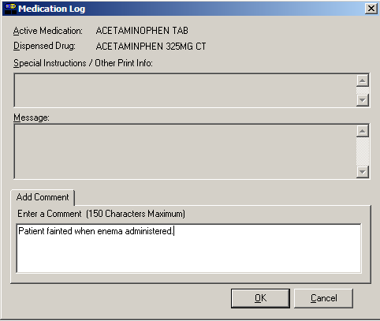  - Click ok once you’ve read your entry and are satisfied with it.  Keyboard Shortcut: Press tab to activate the ok button, and press enter to continue.
Administering a Patient’s Unit Dose Medications
Adding Comments to a Patient’s Medication Record (cont.)  tip:  BCMA automatically wraps words  in the  Comments  area. | To add comments to a patient’s medication record (cont.)  - Verify that your comments were entered in the patient’s record by clicking the Med Log button in the Tool Bar to access the Medication Log Report.  Example: Medication Log with Comments Entered  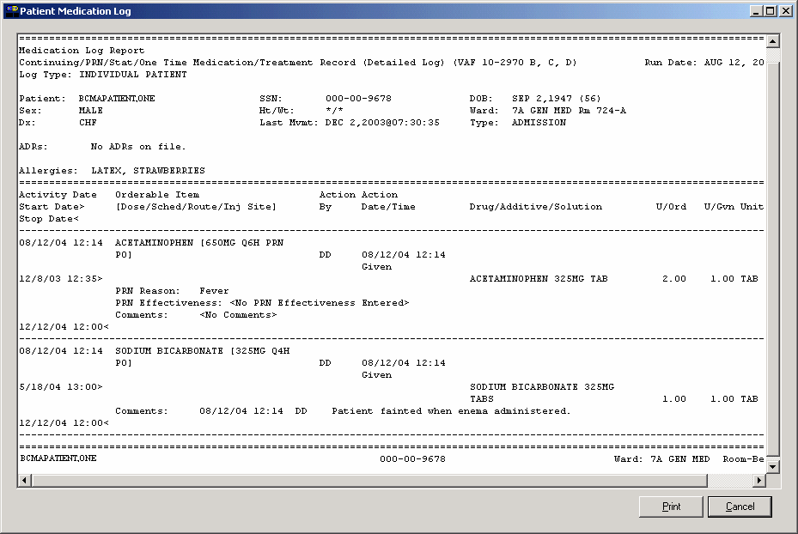  Comments entered by a clinician.  Note: You can view comments on the Medication Log Report if you select the “Audits” check box in the Include area of the Patient Medication Log dialog box. See Chapter 10, “Viewing and Printing BCMA Reports” for more information.
Administering a Patient’s Unit Dose Medications
Submitting a Missing Dose Request  tip:  You cannot submit a Missing Dose Request for a medication marked as “Given” on the VDL. You can, however, change the status from Missing to Held, Refused,  or Given.  tip:  You can quickly submit a Missing Dose Request by selecting a medication on the VDL, and then clicking once on the Missing Dose button in the  Tool Bar at the top  of the VDL. | You can use the Missing Dose command or the Missing Dose button on the Tool Bar to send Missing Dose Requests directly to the Pharmacy. Your request will automatically print on a dedicated printer in the Pharmacy that your site predefined using the GUI BCMA Site Parameters application. BCMA will also send a MailMan message to a predefined mail group. If both are predefined, both will be notified.  BCMA V. 3.0 displays an “M” in the Status column of the BCMA VDL after you submit a Missing Dose Request to the Pharmacy. The Last Action column includes this status information after you refresh the BCMA VDL. This functionality will benefit the Pharmacy by identifying requests that have already been submitted, and by reducing the number of duplicate submissions that they receive on a daily basis.  Note: You can mark a Missing Dose medication as “Held,” “Refused,” or “Given.” If you miss the “administration window,” you can use the Manual Med Entry [PSB MED LOG NEW ENTRY] option in CHUI BCMA to mark it as “Given.”  To submit a Missing Dose Request  - Select a medication on the BCMA VDL that is considered “Missing.”  - Select the Missing Dose command from the Right Click or Due List menu. The Missing Dose Request dialog box displays.  Keyboard Shortcut: Press alt+d to display the Due List menu, and press i (not “L”) to display the Missing Dose Request dialog box.  - Verify the patient’s name on the Tab at the top of the dialog box, and their location and medication information within the dialog box.  Example: Submitting a Missing Dose Request  to the Pharmacy  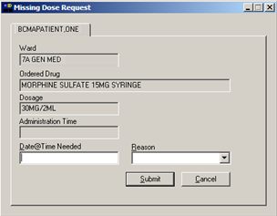
Administering a Patient’s Unit Dose Medications
Submitting a Missing Dose Request (cont.)  tip:  When you select the Missing Dose option, BCMA automatically populates the fields in the Missing Dose Request dialog box. You must complete all fields before submitting the request to the Pharmacy.  tip:  Enter “N” (for NOW ) if you want BCMA to automatically enter the current date and time in the dialog box for you when you move to the Reason drop-down list box. | To submit a Missing Dose Request (cont.)  - In the Date@Time Needed field, enter the day and time when you need the medication for the patient using the VA FileMan Date/Time formatting guidelines listed below. You can use a date in the future or the past.  Date Formatting  - May 1, 2010, 01 MAY 10, 5/01/10, 050110  - N (for NOW)  - T (for Today)  Time Formatting  - 00:00 (For example, 14:00 for 2:00 p.m.)  Keyboard Shortcut: Press tab to move among the fields on the dialog box.  Note: If the year is omitted, the computer uses the current year. A two-digit year assumes no more than 20 years in the future, or 80 years in the past.  - In the Reason field, click once on the drop-down arrow to display pre-defined reasons why you are sending this request to the Pharmacy.  Keyboard Shortcut: Use the arrow keys to locate and select a Reason in the drop-down list box.  Example: Selecting Reason for Submitting  a Missing Dose Request  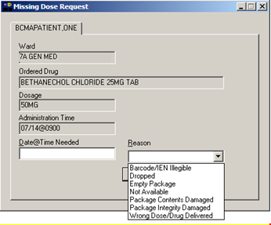
Administering a Patient’s Unit Dose Medications
Submitting a Missing Dose Request (cont.) | To submit a Missing Dose Request (cont.)  tip:  When you “refresh” the VDL, the Last Action column reflects the action taken on the Missing Dose.  - Verify the information in the dialog box, and click submit to send the request to the Pharmacy, where it prints on a predefined printer. An Information message displays. A MailMan message will also be sent to a mail group if predefined using the GUI BCMA Site Parameters application.  Keyboard Shortcut: Press tab to activate the submit button, and press enter to display the Information message.  - Read the Information message, and click ok. BCMA processes the request and displays the letter “M” (for “Missing”) in the Status column.  Note: A “Missing Dose Request” displays on the Missed Medications Report.  Example: Missing Dose Submission Message  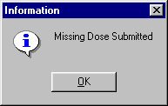

Working with IVP/IVPB Medications
Benefits of this Chapter | Use this chapter when you need to administer active IV Piggyback and intermittent syringe, and any Unit Dose medication with a route of IVP or IV PUSH to patients on your ward. The options and features available within the BCMA VDL apply specifically to active orders only.
Preparing to Administer IVP or IVPB Medications  tip:  You can skip steps 2 and 3 by typing your Access Code, then your Verify Code, separated by a semi-colon in the Access Code field. Press ENTER after typing the codes.  tip:  A medication displays on the VDL if it has an “active” status  and the patient has a status and location of “inpatient.”  tip:  The PRN Schedule Type controls the default display of PRN medications on the VDL, and is based on the GUI BCMA Site Parameters entry for “Include Schedule Types.” | Before administering any active IV Push or IV Piggyback medications to a patient, review this section to learn more about the Schedule Types for the medications that you can administer, including medication orders that display on the BCMA VDL, and how BCMA indicates “actions” taken on medications displayed on the BCMA VDL.  Then you will be ready to define the administration Start and Stop Times and Schedule Types of the medications that you want to display on the BCMA VDL, and to administer active IVP and IVPB medications to your patients.  Schedule Types that You Can Administer  You can administer medications for active IV Push, IV Piggyback, and intermittent syringe medication orders with the Schedule Types below.  - Continuous: A medication given continuously to a patient for the life of the order, as defined by the order Start and Stop Date/Time. Includes Fill-on-Request orders.  - Fill-on-Request Orders: These are grouped, based on whether their Schedule Type is Continuous or PRN. This depends on whether the schedule contains the characters “PRN.” If BCMA does not find these characters, it looks for administration times, and places the order accordingly on the BCMA VDL.  - PRN: A medication dosage given to a patient on an “as needed” basis. Includes Fill-on-Request orders.  - On-Call: A specific order or action dependent upon another order or action taking place before it is carried out.  - One-Time: A medication order given one time to a patient such as a STAT or a NOW order. This order type displays for a fixed length of time on the VDL, as defined by the order Start and Stop Date/Time.  Note: Each time that you open a VDL (i.e., patient record), BCMA defaults to the Unit Dose Medication Tab and the Schedule Types of Continuous, One-Time, and On-Call already selected. This occurs even if you change the Schedule Types or Medication Tab during a medication pass.
Working with IVP/IVPB Medications
Preparing to Administer IVP or IVPB Medications (cont.)  tip:  The administration time of an active order must fall within the Start and Stop Date/Times selected on the VDL before the order will display. | Medication Orders that Display on the VDL  In order for active IV Push or IV Piggyback medication orders to display on the IVP/IVPB Medication Tab, all medication routes associated with these orders must have the option “DSPLY ON IVP/IVPB TAB IN BCMA?” specified as “YES” in the MEDICATION ROUTES file (#51.2). BCMA then displays the orders that fall within the Start and Stop Date/Times and Schedule Types selected on the VDL.  Orders that typically display on the IVP/IVPB tab include active Unit Dose orders with a medication route of IV PUSH, and the IV order types listed below:  - “Piggyback”  - “Syringe,” with the “INTERMITTENT SYRINGE?” prompt set to “YES”  - “Chemotherapy,” with the “CHEMOTHERAPY TYPE:” prompt set to “Piggyback” or “Syringe” and the “INTERMITTENT SYRINGE?” prompt set to “YES”  An “active” status occurs once a pharmacist or a nurse verifies a medication order using Inpatient Medications V. 5.0 or CPRS. This includes orders on “Hold” and any orders entered through the Unit Dose or IV package. Orders placed “On Hold” by a provider display grayed out on the BCMA VDL. You can only mark these order types as “Held,” although it is not necessary that you do so.  BCMA determines when to display an order on the BCMA VDL by subtracting the information in the “Before Scheduled Admin Time” site parameter field from the Start Date/Time of the medication order. You can define this parameter using the Parameters Tab in the GUI BCMA Site Parameters application.
Working with IVP/IVPB Medications
Preparing to Administer IVP or IVPB Medications (cont.)  tip:  IV Piggyback medications include a Unique Identifier Number, with a “V,” which is generated when the Pharmacy prints a bar code label  for an IV bag. | Medications Available for Scanning  Administering IV Push and IV Piggyback medications to a patient involves the scanning of the patient’s medication (drug) bar code, which was applied by the Pharmacy. BCMA recognizes the following numbers on the IVP/IVPB Medication Tab.  - Internal Entry Number (IEN): Drug numbers provided  on medication bar codes are considered a unique drug identifier by the Pharmacy. BCMA validates the bar code scanned against the IEN of DRUG file (#50) and/or the SYNONYM field (#.01) of the DRUG file (#50), to ensure that a valid number exists for the dispensed drug and strength scheduled for administration. A drug entry may contain multiple synonyms, which may include National Drug Code (NDC) and manufacturer bar code numbers.  - Unique Identifer Number: This number is generated when the Pharmacy prints a bar code label for an IV bag. It is designed to communicate which IVs have been manufactured by the Pharmacy. This number displays in the IV Bag Chronology display area of the BCMA VDL.  - Ward Stock Number: This number is generated when you use a “Ward Stock” item to complete an IV medication order because the IV bag is not available from the Pharmacy (with a Unique Identifier Number). When you scan the Bar Code number on the bag, BCMA generates a Ward Stock number (with a “WS”) that also displays on the Medication Log. You must scan every Additive and Solution for the Ward Stock item. When you do, BCMA then seaches for a match to the Bar Code number in any of the active IV orders displayed on the BCMA VDL.  Note: If an IV bag is administered using Unable to Scan – Create WS, or Unable to Scan – Five Rights Override, BCMA generates a Ward Stock Number for the bag.  Note: Most Pharmacies use a combination of bar codes to identify drug products at the point of administration.
Working with IVP/IVPB Medications
Preparing to Administer IVP or IVPB Medications (cont.)  tip:  You can only change a “Given” status to “Not Given” by using the “Undo–Given option.” This status does not display on the VDL; it only appears in the Audit Trail section of the Medication Log Report.  tip:  When the patient’s VDL uses the Status column to sort orders, BCMA displays medications with no status at the top of the VDL. It then displays all other medications in alphabetical order by the Status code. | Marking the Order Status/Last Action Column  When you administer an IV Push or IV Piggyback medication to a patient, BCMA electronically documents the “action” taken on the medication by displaying a letter, for example, a “G” (for “Given”) in the Status column of the BCMA VDL. This information also displays on the Medication Log Report and the MAH Report.  The Last Action column lists the “last action” taken on an orderable item (not the medication), and the date/time of this action, so the nurse will know when the patient last received any dose of a medication regardless of the Schedule Type selected. This information helps to prevent the same medication from being given to the patient from another order or schedule type.  - If the orderable item is the same, the Last Action column lists the last administration action.  - If the patient has two different orders for the same orderable item, the last administration of either of these orders displays in the Last Action column for both orders. You can view the MAH Report to determine which order the medication was given from on the BCMA VDL.  - If a medication was not administered before to the patient, the Last Action column will not list a date/time.  Understanding the Status of a Medication Order  Once you scan and mark a medication as “Given,” you cannot scan it again for the same administration time. If you do, you will receive an Error message. You can, however, change the status from “Given” to “Not Given” by using the “Undo–Given” option – provided you are the individual who originally marked it as “Given,” or you have been assigned the PSB MANAGER security key.  You can mark an IV Push or IV Piggyback medication with the following status:  - Given to Not Given  - Held or Refused to Given  - Missing to Given, Held, or Refused
Working with IVP/IVPB Medications
Preparing to Administer IVP or IVPB Medications (cont.) | Information Stored by BCMA  BCMA stores the following information each time you administer an active IV Push or IV Piggyback medication to a patient:  - Patient  - Location of the patient (i.e., bed, ward, and division)  - Clinician administering the medication  - Clinician who created the Medication Log Entry  - Entered date and time  - Audit information (i.e., clinician, text, date and time)  - Administration date and time  - Status of the administration, such as Given, Held, Refused, or Missing  - Orders changed using the “Undo–Given” option do not display a code (letter) in the Status column of the BCMA VDL. This status appears only in the Audit Trail section of the Medication Log Report, not on the BCMA VDL.  - “Cancelled” administrations are not stored in the Medication Log.  - “Unknown” Status: If an order created in BCMA CHUI Manual Medication Entry is not completed with a valid administration status, the Admin Status will be stored as null (blank), but will display as “U” (unknown) in the BCMA VDL Status column and “Unknown” in the Last Action column.  - IV Additive (strength), IV Solution (volume), and/or number of units given  - Number of minutes that the dose was given too Early or too Late to the patient  - Reason that a PRN medication was administered and the medication effectiveness  - Medication, dosage, and/or number of units given  - Any comments associated with the drug administration dose  - Injection site for medications that must be injected
Working with IVP/IVPB Medications
How BCMA Validates Patient and Medication Information  tip:  After a medication pass, press F5 to refresh the VDL, then  note that the Last Action column lists an administration as the most  recent one. | When used as intended, BCMA serves as an excellent check-and-balance system for patients and VAMCs. The chances for errors increase when the scanning process is circumvented — entered manually — during the medication administration process. In short, here is the validation process completed by BCMA V. 3.0.  First Validation By BCMA  When you scan the bar code on a patient’s wristband, BCMA automatically verifies/validates the patient’s identity, and provides important clinical information via a Confirmation dialog box and the patient’s VDL.  If you experience a wristband scanning failure, you can select the Unable to Scan feature at the Scan Patient Wristband dialog box. After entering a reason for the failure and an optional comment, you can perform a patient lookup and confirm their identity on the Confirmation dialog box before opening the patient’s VDL.  Second Validation By BCMA  The second validation by BCMA occurs when you scan the bar code on the patient’s medication or when you use the Unable to Scan medication feature. During this validation process, BCMA verifies whether the medication IEN Code is located in the DRUG file (#50) or has a valid Unique Identifier Number, if the patient has an active order entered into Inpatient Medications V. 5.0 for the medication scanned, and if the dosage is correct and timely for the medication ordered. The lookup is restricted to the Unique Identifier Number only in Inpatient Medications V. 5.0.  A variety of dialog boxes will display for each patient, depending on the medications scheduled for administration. (See the examples provided below.) If the administration is successful, the patient’s VDL displays the letter “G” (for “Given”) in the Status column to document that the patient received the medication as required.  - If a patient has more than one active order for the same medication, with different schedule types, both orders display on the BCMA VDL.  - If you give the medication outside the medication administration window — Early or Late — (as defined by a site parameter), the Medication Log dialog box displays, requiring that you complete the Comments field. The order is then logged as Early or Late in the Medication Variance Log.  - If a medication is scanned and marked as “Given,” you cannot scan it again for the same administration time.  - If you scan a medication twice for the same administration time, you will receive an Error message.
Working with IVP/IVPB Medications
How BCMA Validates Patient and Medication Information (cont.) | Unable to Scan Medication  If you experience a medication scanning failure, you can select the Unable to Scan feature to administer the medication and inform your support staff of the failure, After entering a reason for the failure and an optional comment, the Medication Verification dialog displays, where you can choose one of the following options:  - Verify Medication: This (default) option provides an entry field in which the user types the number from the bar code label on the medication or IV bag to verify the medication being administered to the patient. BCMA validates the entry against the order and displays the matching dispense drug or bag components. Best practice dictates that you always attempt to verify the medication first. You may retry if your entry does not result in a match.  - Verify Five Rights: This option provides a method for administering a medication in the event that Verify Medication failed, or, for example, when the number on the bar code label is not readable, or there is no label. You must confirm that each of the five rights of medication administration have been physically verifed (right patient, right medication, right dose, right route, right time) before you can continue the administration process.  Note: Refer to your BCMA Coordinator and site policy for guidance on the use of the Verify Five Rights option.  Note: The Verify Five Rights option is only available if the Five Rights Override Parameters are enabled for Unit Dose and IV medications in the BCMA Site Parameters application. If the Five Rights Override Parameter is turned off, the option will be grayed out and you will not be able to administer the medication. Refer to your site policies regarding how to contact pharmacy to address the problem.

Administering a Patient’s IVP/IVPB Medications
Preparing to Administer IVP or IVPB Medications  tip:  If the number  of medications that need to be administered is greater than the VDL can display, use the Scroll Bar to view  all of them.  tip:  Press f10 or click the IVP/IVPB Medication Tab  to display active medication orders under this Tab. | The instructions listed in this section describe how to change the Virtual Due List Parameters (Start and Stop Date/Time) and Schedule Types on the patient’s VDL, along with the process for scanning the patient’s active IV Push, IV Piggyback, and intermittent syringe medications.  Viewing a Patient’s Active IVP/IVPB Medications  The “view” or active window shown below, displays when you select the IVP/IVPB Medication Tab on the BCMA VDL.  Each time that you open a VDL (i.e., patient record), BCMA defaults to the Unit Dose Medication Tab and the Schedule Types of Continuous, One-Time, and On-Call already selected. This occurs even if you change the Schedule Types or Medication Tab during a medication pass. The PRN Schedule Type controls the default display of PRN medications on the BCMA VDL, and is based on the GUI BCMA Site Parameters entry for “Include Schedule Types.”  Note: The IVP/IVPB Medication Tab provides an “alert light” which turns GREEN only when the patient has active medication orders associated to them and the admin time is within 12 hours before and 12 hours after NOW. When you click a “lit” Tab, BCMA displays the patient’s active medication orders on the BCMA VDL — for the selected timeframe only. This safeguard is provided, along with the Missed Medications Report, to ensure that all IV Push, IV Piggyback, and intermittent syringe medications that are due are given to the patient in the correct dosage and on time.  Example: BCMA VDL  for Active IV Push and IV Piggyback Medications  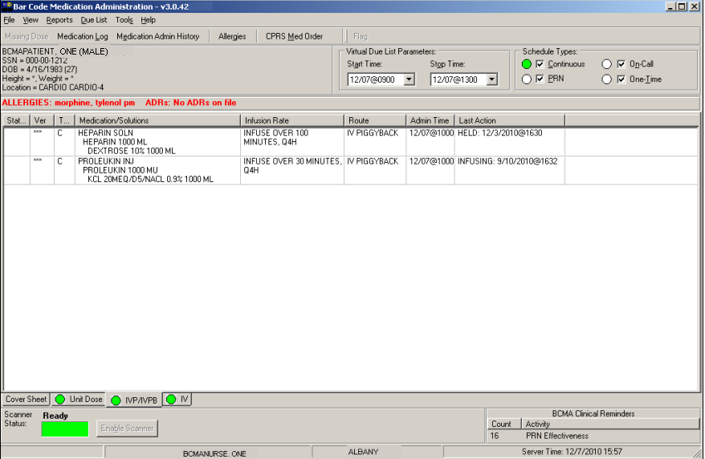  Note: The Medication Order Display Area includes the Medication/Solutions and Infusion Rate columns.
Administering a Patient’s IVP/IVPB Medications
Preparing to Administer IVP or IVPB Medications (cont.)  tip:  The Start and Stop Time Parameters are set to the “Default Times from ” settings in the GUI BCMA Site Parameters application.  tip:  You can expand (or restrict) the number of active IVP/IVPB medications, that display on the VDL, by changing the default Start and Stop Times in the Virtual Due List Parameters area. | Changing the Virtual Due List Parameters  The BCMA VDL Parameters is the functional timeframe during which you can administer medications to a patient before or after the scheduled administration time. For many medical centers, this timeframe is defined as two hours.  Once you use BCMA, these Parameters become your default settings. For example, when you change the default settings for certain fields (i.e., Start and Stop Times, and Column Sort Selection) on the BCMA VDL, these settings are retained in your user parameters and become the default settings each time you log on to BCMA. You can reset these user-selected parameters to site-defined parameters using the Reset User Parameters [PSB USER PARAM RESET] option in CHUI BCMA.  Note: The BCMA VDL Start and Stop Times display in one-hour increments, from the top of the nearest hour. For example, 1:15 displays as 1:00 and 1:45 displays as 2:00. You can expand the time range 12 hours before and 12 hours after NOW.  To change the Virtual Due List Parameters  - In the patient’s VDL, select the Start and Stop Times in the Virtual Due List Parameters area. The BCMA VDL automatically refreshes and displays active medications for the newly selected administration window.  Keyboard Shortcut: Press tab to access the Virtual Due List Parameters area and to move among the Time fields.  Example: VDL Parameters Area on VDL  - Now you are ready to select the Schedule Types of IV Push or IV Piggyback medications that you want to display on the BCMA VDL.
Administering a Patient’s IVP/IVPB Medications
Preparing to Administer IVP or IVPB Medications (cont.)  tip:  If a checkbox is selected for an order, that you do not want displayed on the VDL, click on it to deselect it.  tip:  If the Scanner Status Indicator is red, click in the Indicator field to activate the green Ready Light before scanning a medication bar code.  tip:  The PRN Schedule Type controls the default display of PRN medications on the VDL, and is based on the GUI BCMA Site Parameters entry for “Include Schedule Types.”  tip:  A GREEN “alert light” indicates that a medication order exists for the Schedule Type selected within  the respective start/stop date  and time selected on the BCMA VDL. If grayed out,  then none exist. | Changing Schedule Types on the VDL  You are ready to select the Schedule Types of the active IV Push or IV Piggyback medications that you want to display on the BCMA VDL. You can choose all Schedule Types available, or just specific ones.  The abbreviation for each Schedule Type is listed as follows in the Type column of the BCMA VDL:  - C (for Continuous)  - P (for PRN)  - OC (for On-Call)  - O (for One-Time)  Each time that you open a VDL (i.e., patient record), BCMA defaults to the Unit Dose Medication Tab and the Schedule Types of Continuous, One-Time, and On-Call already selected. This occurs even if you change the Schedule Types or Medication Tab during a medication pass.  To select Schedule Types that display on the VDL  - In the Schedule Types area of the BCMA VDL, select the check boxes that apply to the types of medication orders that you want to display on the BCMA VDL for the patient. You may select all of the check boxes or just specific ones.  - If a checkbox is selected for a Schedule Type that you do not want displayed, click on it to deselect it.  Note: You can turn off the automatic display of PRN medication orders when the BCMA VDL is first opened by deselecting the PRN check box in the “Include Schedule Types” area of the GUI BCMA Site Parameters application.  Keyboard Shortcut: Press tab to access the Schedule Types area and the arrow keys to move among the Schedule Types. Use the Spacebar to select a Schedule Type.  Example: Schedule Types Area of VDL  - Now you are ready to scan the patient’s active IV Push or  IV Piggyback medications.
Administering a Patient’s IVP/IVPB Medications
Scanning and Verifying Medication Information  tip:  If the Scanner Status Indicator is RED, click in the Indicator field to activate the GREEN Ready Light before scanning a medication bar code.  tip:  You do not have to select an active IVP or IVPB medication order on the VDL before scanning the Drug IEN Code or the Unique Identifier Number. | Now you are ready to scan (and verify) the patient’s active IV Push and IV Piggyback medications and to officially begin the medication administration process.  To scan and verify medication information  - At the patient’s VDL, scan the bar code on the patient’s medication. BCMA processes the scan, and displays screens related to the medication order. If unable to scan, see the Unable to Scan IVP/IVPB Medication section on page 121.  Note: If the medication bar code is missing or unreadable, right-click on the medication to select the Drug IEN Code command or the Available Bags command from the Right Click drop-down menu, and to display the IEN Code or Unique Identifier Number.  - Continue with the medication administration process for the patient’s active IV Push or IV Piggyback medication.  - If an Error message indicates that the Drug IEN Code was not found in the DRUG file (#50) or the Unique Identifer number was not located, see page 66.  - If an Error message indicates that the medication has already been given, or it’s not time to give it yet, see page 67.  - If an Error message indicates that no order exists for the medication that you just scanned, see page 68.  - If no bags are available for the medication displayed on the BCMA VDL, see page 116.  - If IV Parameters fields set to “Warning” and a field is edited in Inpatient Medications V. 5.0, see page 117.  - If the “OTHER PRINT INFO:” prompt is edited in Inpatient Medications V. 5.0, see page 118.  - If the user attempts to take action on an IVP/IVPB administration with an Unknown Action status, see page 119.
Administering a Patient’s IVP/IVPB Medications
Scanning and Verifying Medication Information (cont.)  tip:  If the Scanner Status Indicator is red, click in the Indicator field to activate the green Ready Light before scanning a medication bar code. | - If Drug IEN Code Not Found in DRUG file (#50) or Unique Identifier Number Not Located  The Error message, provided below, displays when BCMA does not locate the Drug IEN Code in the DRUG file (#50), or the Unique Identifier Number is not located. This occurs if the DRUG file contains two entries for the same Drug IEN Code, or the code/number is invalid.  Note: If you receive this Error message more than once, contact the Pharmacy directly about the problem.  - Review the Error message, and click ok to return to the patient’s VDL.  Keyboard Shortcut: Press tab to activate the ok button, and press enter to return to the patient’s VDL.  Example: Error Message When Drug IEN Code  or Unique Identifier Number Not Located  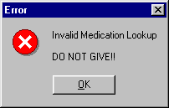  - Select a medication order on the patient’s VDL.

Administering a Patient’s IVP/IVPB Medications
Scanning and Verifying Medication Information (cont.) | - If No Bags Available for Medication Displayed  on the VDL  The Information message, provided below, displays if the scanned bag number does not match one of the available bags on the order.  To review the Information message  - Review the Information message, and click ok to return to the patient’s VDL.  Keyboard Shortcut: Press tab to activate the ok button, and press enter to return to the patient’s VDL.  Example: Information Message When  No Bags Available for Medication Displayed on VDL  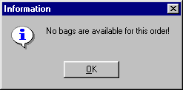  - Continue administering active IV Push or IV Piggyback medications to the patient.
Administering a Patient’s IVP/IVPB Medications
Scanning and Verifying Medication Information (cont.) | - If IV Parameters Fields Set to “Warning” and Field Edited in Inpatient Medications V. 5.0  The Warning message, provided below, displays when the IV Parameters fields in the GUI BCMA Site Parameters application are set to “Warning” and an IV field is edited in Inpatient Medications V. 5.0. This message indicates that the Infusion Rate has changed.  To acknowledge IV Parameters Warning message  - Review the Warning message, and click ok to return to the patient’s VDL.  Keyboard Shortcut: Press tab to activate the ok button, and press enter to return to the patient’s VDL.  Example: Warning Message When IV Field Edited in Inpatient Medications V. 5.0  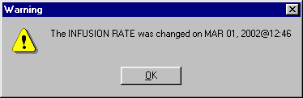  - Continue administering active IV Push or IV Piggyback medications to the patient.

Administering a Patient’s IVP/IVPB Medications
Scanning and Verifying Medication Information (cont.) | - If “OTHER PRINT INFO:” Prompt Edited  The Warning message, provided below, displays when the “OTHER PRINT INFO:” prompt in Inpatient Medications V. 5.0 is edited for a medication order displayed on the BCMA VDL.  To acknowledge changes when “OTHER PRINT INFO:”  prompt edited  - Review the Warning message, and click ok to return to the patient’s VDL.  Keyboard Shortcut: Press tab to activate the ok button, and press enter to return to the patient’s VDL.  Example: Warning Message When  Other PRINT INFO Field Edited  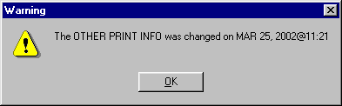  - Continue administering active IV Push or IV Piggyback medications to the patient.
Administering a Patient’s IVP/IVPB Medications
Scanning and Verifying Medication Information (cont.) | - If User Attempts to Take Action on an Administration with an Unknown Action Status  The Informational message, provided below, displays if the user attempts to administer or take action on an administration whose status is “Unknown.” The user must confirm the message by clicking OK, but the action will be cancelled. Users are required to resolve the status of the administration using the Edit Med Log option.  To review the Error message  - Review the Error message, and click ok to return to the patient’s VDL.  Keyboard Shortcut: Press tab to activate the ok button, and press enter to return to the patient’s VDL.  Example: Information Message for Unknown Action Status -- Administration Cancelled  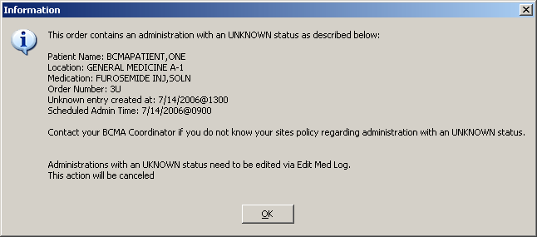  - Proceed to the Edit Med Log option to resolve the status of the administration.  Note: For information on using the Edit Med Log option, please refer to Chapter 7, “Editing the Medication Log.”
Administering a Patient’s IVP/IVPB Medications
Scanning and Verifying Medication Information (cont.) | - If User Attempts to Take Action on an Order that Contains an Administration with an Unknown Action Status  The Informational message, provided below, displays if the user starts to administer or take action on an order in which one of the administration associated with that order has an “Unknown” status. The user can choose to acknowledge the message and proceed with the administration or cancel the action.  To review the Error message  - Review the Error message, and perform one of the following actions:  - To continue with the administration, click ok.  - To cancel the administration without saving, click cancel. To resolve the status of the associated administration, use the Edit Med Log option.  Keyboard Shortcut: Press tab to activate the ok or cancel button, and press enter to access the patient’s VDL.  Note: For information on using the Edit Med Log option, please refer to Chapter 7, “Editing the Medication Log.”  Example: Information Message for Unknown Action Status with Option to Continue Administration  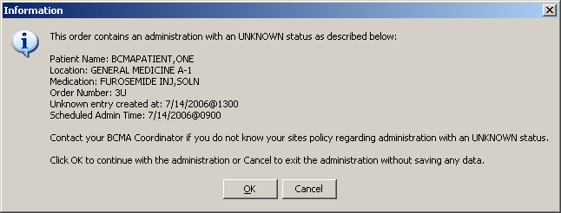  - Continue administering active IV Push or IV Piggyback medications to the patient.
Administering a Patient’s IVP/IVPB Medications
Unable to Scan IVP/IVPB Medication  tip:  You can report scanning failures without interrupting the medication administration process.. | In the event of a medication scanning failure, you can use the Unable to Scan feature to administer IV Push and IV Piggyback medications. Since IV Push orders that display on the IVP/IVPB tab are treated as unit dose orders, the Unable to Scan IVP medication process is essentially the same as for unit dose medications. IV Piggyback orders displayed on the IVP/IVPB tab may be administered through the Unable to Scan option if the bags are labeled and sent from Pharmacy, or via the Unable to Scan – Create WS option if the bag is to be administered as a Ward Stock.  To administer an IVP/IVPB medication using Unable to Scan  - From the IVP/IVPB tab, select an administration for an IVP/IVPB order. Then select the Unable to Scan command from the right-click or the Due List menu.  Note: The Unable to Scan – Create WS is disabled and not applicable to IVP orders.  Example: Unable to Scan Right Click Option  for IV Push Administration  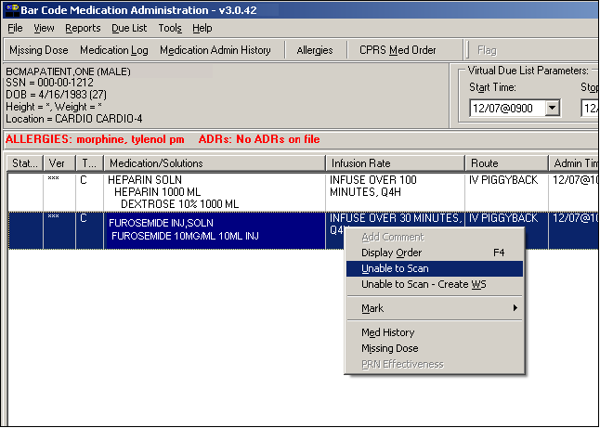  - If there are several orders for the same medication, the Multiple Orders for Scanned Drug dialog box will display. Select the appropriate order.
Administering a Patient’s IVP/IVPB Medications
Unable to Scan IVP/IVPB Medication (cont.)  tip:  If the Scanning failure is not an equipment problem, you can scan the problematic bar code directly into the Comment field. This may help your IRM and Pharmacy staff zero in on the source of problem more quickly. | To administer an IVP/IVPB medication using Unable to Scan (cont.)  - From the Unable to Scan dialog box, verify the administration information displayed at the top of the Unable to Scan dialog box including: Medication, Scheduled Admin Time, Schedule Type, Dosage/Infusion rate, units Per Dose, Last Action, Bag ID, Medication Route, and Dispensed Drugs/Medications/Solutions.  Example: Unable to Scan Dialog Box  for IV Push Administration  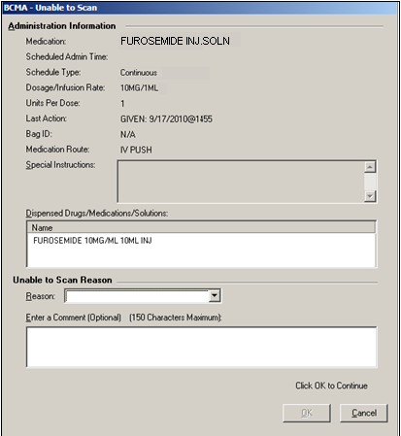  - Select an “Unable to Scan Reason” from the drop-down list box. Selections include: Damaged Medication Label, Dose Discrepancy, No Bar Code, Scanning Equipment Failure, and Unable to Determine.

Administering a Patient’s IVP/IVPB Medications
Unable to Scan IVP/IVPB Medication (cont.) | To administer an IVP/IVPB medication using Unable to Scan (cont.)  Example: Unable to Scan Medication Reasons  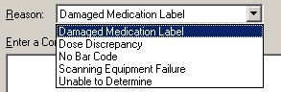  Note: If you click Cancel at any point in the Unable to Scan process, the Unable to Scan event is not logged, an email is not sent, and the “Order Administration Cancelled” message displays. Click ok to return to the VDL  - You may enter an optional text comment. Click OK. The Medication Verification dialog box displays with the Verify Medication option selected by default.  Example: Medication Verification Dialog Box (Verify Medication Option)  - Perform one of the following actions:  - To verify the IVP medication being administered, enter the Drug IEN or the National Drug Code from the medication package into the entry field.  - To verify the IVPB medication being administered, enter the bag number that is printed on the label into the entry field.  Note: When entering the IEN or NDC number, remember that no letters, spaces, or punctuation marks are allowed.
Administering a Patient’s IVP/IVPB Medications
Unable to Scan IVP/IVPB Medication (cont.) | To administer an IVP/IVPB medication using Unable to Scan (cont.)  - Click Submit.  - If the number entered matches the dispense drug being administered for the selected order, the medication, dosage, units, route and special instructions will display. Verify that the information displayed matches the order. For IVPB orders, the IV bag components Confirmation dialog box displays, confirming the additives and solutions.  Example: Medication Verification Dialog Box  (Verify Medication Option)  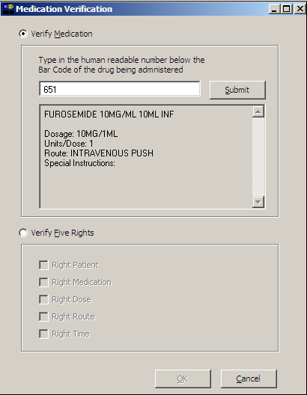  - If the number entered does not match the dispense drug being administered for the selected order:  - An “Invalid Medication – Do not Give” error message displays. Click OK to return to the Medication Verification dialog box. You may reenter the bar code number to try again.
Administering a Patient’s IVP/IVPB Medications
Unable to Scan IVP/IVPB Medication (cont.) | To administer an IVP/IVPB medication using Unable to Scan (cont.)  Example: Error Message When  Drug IEN Code Not Found  - If the number entered does not match, or the bar code number is not readable, or there is no label, you may select the Verify Five Rights option. Place a checkmark in each of the five checkboxes to document that the five rights of medication administration have been physically verified (right patient, right medication, right dose, right route, right time) and continue with the medication administration without entering a matching bar code number for the medication.  Note: This option is only available if the Five Rights Override Parameter is enabled for unit dose medications in the BCMA Site Parameters application. If the Five Rights Override Parameter is turned off, you will not be able to administer the medication. Refer to your site policies regarding how to contact pharmacy to address the problem.  Example: Medication Verification Dialog Box  (Verify Five Rights Option) )
Administering a Patient’s IVP/IVPB Medications
Unable to Scan IVP/IVPB Medication (cont.) | To administer an IVP/IVPB medication using Unable to Scan (cont.)  - Review the contents of the Medication Verification dialog box and perform one of the following actions:  - Click OK to continue with the administration. The Quantity and Units dialog box displays for IVP orders.  - Click the Cancel button to cancel the Unable to Scan process without documenting the administration. The Unable to Scan event will not be recorded, nor will a MailMan message be sent.  Example: Quantity and Units Dialog Box  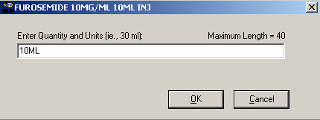  - If applicable, enter the quantity and units of the medication that you are administering to the patient and click OK. The Injection Site Selection dialog box displays.  Example: Injection Site Selection Dialog Box  - In the Injection Site Selection drop-down list box, select the location where you are injecting the medication into the patient.
Administering a Patient’s IVP/IVPB Medications
Unable to Scan IVP/IVPB Medication (cont.)  tip:  Email messages will be sent to the Unable to Scan email group that is defined in the BCMA Site Parameters application. | To administer an IVP/IVPB medication using Unable to Scan (cont.)  - Click OK to complete the Unable to Scan process and return to the VDL. BCMA processes the information and displays the letter “G” (for Given”) in the Status column to document that you administered the medication to the patient. The Unable to Scan event is recorded, and a MailMan message is sent notifying IRM/Pharmacy staff of the medication bar code scanning failure.  MailMan Message Sent After Medication Bar Code Scanning Failure  When you create a medication scanning failure entry, a MailMan message will be sent to the mail group you specified. The subject line of the message will indicate a medication scanning failure. The body of the message will contain the following information:  - User: Last name, First Name (for identifying system issues only/educational needs)  - Date/Time of event  - Patient: Last Name, First Name, and last four digits of patient’s Social Security Number.  - Order Number  - Ward Location/Room  - Type of Bar Code issue: Medication  - Medication  - Unit Dose orders will display dispense drug; drug IEN; dosage ordered  - IV Orders will display: unique ID (Bag ID typed by User or Wardstock); orderable item.  - Reason for scan failure  - User’s comment  Note: Inclusion of the last four digits of the patient’s SSN is currently allowed in VistA clinical alert messaging. If there are changes to this policy due to a future VHA directive, the format of this field is subject to change.
Administering a Patient’s IVP/IVPB Medications
Unable to Scan IVP/IVPB Medication (cont.)  tip:  You can report scanning failures without interrupting the medication administration process. | If you experience a medication scanning failure while trying to administer a Ward Stock IV Piggyback medication, use the Unable to Scan – Create WS feature.  To administer an IVPB medication using Unable to Scan – Create WS  - From the IVP/IVPB tab, select an administration for an IV Piggyback order. Then select the Unable to Scan – Create WS command from either the right click or the Due List menu.  Example: Unable to Scan – Create WS  Right Click Option  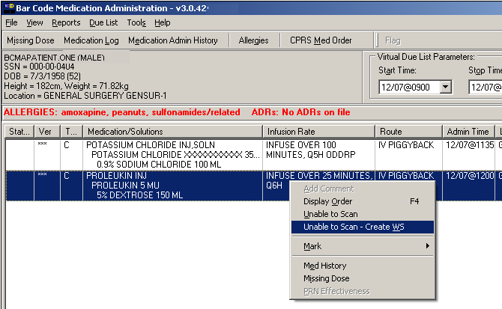  - From the Unable to Scan dialog box, verify the administration information displayed at the top of the Unable to Scan dialog box including: Medication, Scheduled Admin Time, Schedule Type, Dosage/Infusion rate, units Per Dose, Last Action, Bag ID, Medication Route, and Dispensed Drugs/Medications/Solutions.
Administering a Patient’s IVP/IVPB Medications
Unable to Scan IVP/IVPB Medication (cont.)  tip:  If the Scanning failure is not an equipment problem, you can scan the problematic bar code directly into the Comment field. This may help your IRM and Pharmacy staff zero in on the source of problem more quickly. | To administer an IVPB medication using Unable to Scan – Create WS (cont.)  Example: Unable to Scan Dialog Box  for an IV Piggyback Order  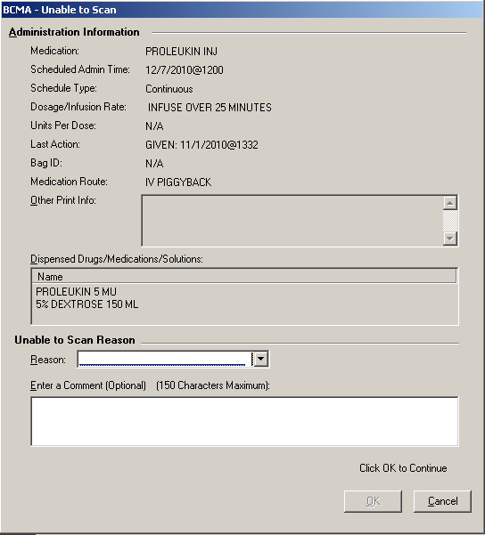  - Select an “Unable to Scan Reason” from the drop-down list box. Selections include: Damaged Medication Label, Dose Discrepancy No Bar Code, Scanning Equipment Failure, and Unable to Determine.  Example: Unable to Scan Medication Reasons  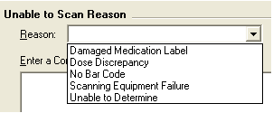
Administering a Patient’s IVP/IVPB Medications
Unable to Scan IVP/IVPB Medication (cont.) | To administer an IVPB medication using Unable to Scan – Create WS (cont.)  Note: If you click Cancel at any point in the Unable to Scan process, the Unable to Scan event is not logged, an email is not sent, and the “Order Administration Cancelled” message displays.  - You may enter an optional text comment. Click OK. The Ward Stock dialog box displays.  Example: Ward Stock Dialog Box  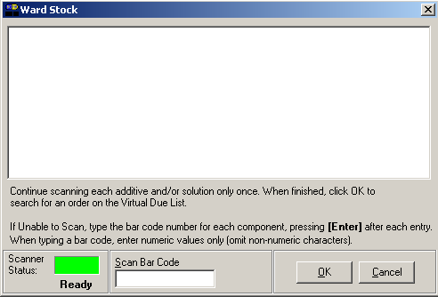  - Enter the Drug IEN or the National Drug Code from the medication package for each Additive and Solution in the order in the Scan Bar Code field. Press Enter after each entry.  Note: When entering a bar code number, remember that no letters, spaces or punctuation marks are allowed.  Example: Ward Stock Dialog Box  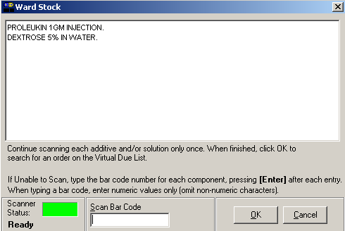
Administering a Patient’s IVP/IVPB Medications
Unable to Scan IVP/IVPB Medication (cont.) | To administer an IVPB medication using Unable to Scan – Create WS (cont.)  - Verify the information in the Ward Stock dialog box. It should contain the all of the correct additives and solutions for the selected order. Click OK. The Injection Site Selection dialog box displays.  Example: Injection Site Selection Dialog Box  - In the Injection Site Selection drop-down list box, select the location where you are injecting the medication into the patient.  - Perform one of the following actions:  - Click OK to complete the Unable to Scan process and continue with the administration. Upon completing the administration you will return to the VDL. BCMA processes the information and displays the letter “G” (for “Given”) in the Status column to document that you administered the medication to the patient. The Unable to Scan event is recorded, and a MailMan message is sent notifying IRM/Pharmacy staff of the medication bar code scanning failure.  - Click the Cancel button to cancel the Unable to Scan process without documenting the administration. The Unable to Scan event will not be recorded nor will a MailMan message be sent.
Administering a Patient’s IVP/IVPB Medications
Unable to Scan IVP/IVPB Medication (cont.)  tip:  Email messages will be sent to the Unable to Scan email group that is defined in the BCMA Site Parameters application. | To document an IVPB medication using Unable to Scan – create WS (cont.)  MailMan Message Sent After Medication Bar Code Scanning Failure  When you create a medication scanning failure entry, a MailMan message will be sent to the mail group you specified. The subject line of the message will indicate a medication scanning failure. The body of the message will contain the following information:  - User: Last name, First Name (for identifying system issues only/educational needs)  - Date/Time of event  - Patient: Last Name, First Name, and last four digits of patient’s Social Security Number  - Order Number  - Ward Location/Room  - Type of Bar Code issue: Medication  - Medication  - Unit Dose orders will display dispense drug; drug IEN; dosage ordered  - IV Orders will display: unique ID (Bag ID typed by User or Wardstock); orderable item  - Reason for scan failure.  - User’s comment  Note: Inclusion of the last four digits of the patient’s SSN is currently allowed in VistA clinical alert messaging. If there are changes to this policy due to a future VHA directive, the format of this field is subject to change.
Administering a Patient’s IVP/IVPB Medications
Administering an Order with Multiple Admin Times | The Multiple Orders for Scanned Drug dialog box, provided below, displays only if the patient’s order has multiple administration times for the medication that you scanned — using the Start and Stop time setting on the BCMA VDL.  To administer an order with multiple administration times  - Select the order containing the administration time that you need, and click ok. BCMA processes the information, and displays the letter “G” (for “Given”) in the Status column to document that you administered the medication to the patient.  Keyboard Shortcut: Use the arrow keys to select an order. Press tab to activate the ok button, and press enter to accept the selection and display the patient’s VDL.  Example: Multiple Orders for Scanned Drug Dialog Box  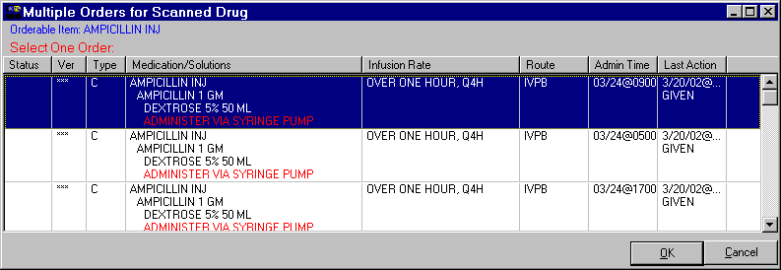  - Continue administering active IV Push or IV Piggyback medications to the patient.
Administering a Patient’s IVP/IVPB Medications
Administering an Order with Special Instructions  tip:  Special Instructions help to ensure that the patient receives the medication dosage required by the provider. | Information messages, like the ones provided below, display when the Pharmacy answers “YES” to a question in Inpatient Medications V. 5.0 about including Special Instructions in a Pop-up box after a nurse scans a medication. If the Pharmacy answers “NO” to the question, the Special Instructions only display in RED below the dispensed drug name in the Medication Order Display Area. You must acknowledge the message before administering the medication.  The Special Instructions may include those provided below, or they could even include the sliding scale range written by the provider. That way, you know how much insulin to administer to the patient, based on the patient’s blood sugar level.  To review Special Instructions from the Pharmacy  - Review the Information message from the Pharmacy, and click ok to return to the patient’s VDL.  Keyboard Shortcut: Press tab to activate the ok button, and press enter to continue the medication administration process.  Example: Special Instructions Pop-up Boxes  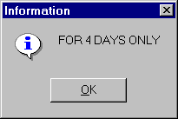  — OR —  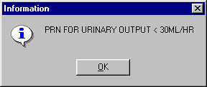  - Continue administering active IV Push or IV Piggyback medications to the patient.
Administering a Patient’s IVP/IVPB Medications
Specifying the Medication Quantity and Units Given  tip:  You may be required to  specify the quantity and units given for cc’s, milliliters, grams, miliquivelants, milligrams, milimoles, and units. | The Quantity and Units dialog box, provided below, displays when the medication order does not include the words “CAP” or “TAB” in the “DOSAGE ORDERED:” prompt of the patient’s order from Inpatient Medications V. 5.0.  To specify medication quantity and units given to patient  - Enter the quantity and units of the medication that you are administering to the patient, and click ok. The maximum character length is 40. BCMA processes the information and displays the letter “G” (for “Given”) in the Status column to document that you administered the medication to the patient.  Keyboard Shortcut: Press tab to activate the ok button, and press enter to continue.  Example: Quantity and Units Dialog Box  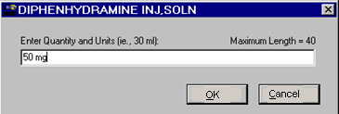  - Continue administering active IV Push or IV Piggyback medications to the patient.
Administering a Patient’s IVP/IVPB Medications
Specifying the Injection Site for the Medication | The Injection Site Selection dialog box, provided below, displays when an IV Push or IV Piggyback medication is injectable and when “PROMPT FOR INJ. SITE IN BCMA” is specified as “YES” in the MEDICATION ROUTES file (#51.2) for a particular route. Medication route examples for IVP/IVPB administrations include Intravenous, Intravenous Push, Intramuscular, Intradermal, or Subcutaneous. When prompted for the injection site, BCMA requires that you enter the location on the patient (the site/location) where you are injecting the medication — before proceeding with the administration process.  To specify an injection site for the medication  - In the Injection Site Selection drop-down list box, select the location where you are injecting the medication into the patient, and click ok. BCMA processes the information, and displays the letter “G” (for “Given”) in the Status column to document that you administered the medication to the patient.  Keyboard Shortcut: Use the arrow keys to select an injection “site” in the drop-down list box. Press tab to activate the ok button, and press enter to continue.  Example: Injection Site Selection Dialog Box  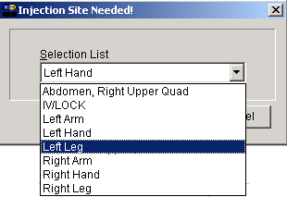  - Continue administering active IV Push or IV Piggyback medications to the patient.
Administering a Patient’s IVP/IVPB Medications
Administering a PRN Order  tip:  If no administration times are listed in the Medication Log dialog box, the patient has not received any previous doses.  tip:  If no administration times are listed in the Medication Log dialog box, the patient has not received any previous doses.  tip:  The Med History button displays the Medication History Report for the orderable item listed in the  dialog box. | The Medication Log dialog box, provided below, displays when you administer a PRN medication to a patient. BCMA checks for an active order, and displays the last four “actions” for the same orderable item (not the medication), the date/time of each action, the schedule type, the reasons that the selected PRN medication was administered to the patient, and the number of units given to the patient.  The dialog box also includes the Vitals area, which can display the four previous vitals entries for each of the Vital signs listed in the area. The “+” sign, to the left of a Vital sign, expands the row to reveal additional entries. The “-” sign collapses the row to hide all but the most recent entry.  To administer a PRN order  - In the Select a Reason drop-down list box, select a site-defined reason that indicates why you are administering the PRN medication to the patient.  Keyboard Shortcut: Use the arrow keys to locate and select a Reason in the drop-down list box.  Example: Medication Log Dialog Box  for PRN Administration  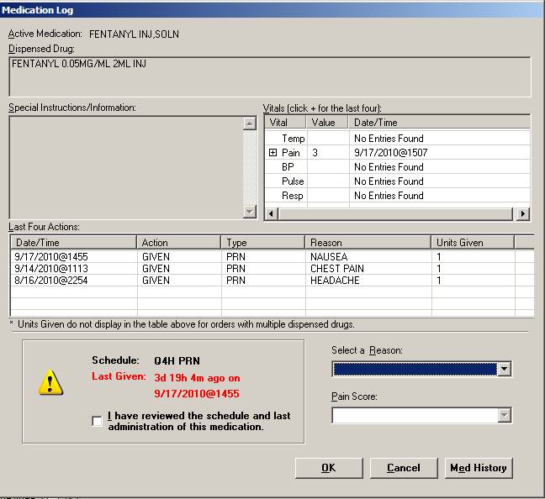
Administering a Patient’s IVP/IVPB Medications
Administering a PRN Order (cont.)  tip:  The “G” disappears from the Status column after you refresh the VDL, or close the VDL after administering a PRN medication to the patient. | To administer a PRN order (cont.)  - In the Pain Score drop-down list box, select the patient’s pain score, between 0 and 10 or 99, with “0” being No Pain, “10” the Worst Imaginable, and “99” for “Unable to Respond.”  Note: You are prompted to enter a pain score only if your site has selected this requirement for the “Reason Medication Given PRN Answer Lists” in the GUI BCMA Site Parameters application.  - Click ok to accept your selection and return to the patient’s VDL. BCMA processes the information, and displays the letter “G” (for “Given”) in the Status column to document that you administered the medication to the patient.  Keyboard Shortcut: Press tab to activate the ok button, and press enter to continue.  - Continue administering active IV Push or IV Piggyback medications to the patient.
Administering a Patient’s IVP/IVPB Medications
Recording the Effectiveness of a PRN Medication  tip:  You can quickly access the PRN Effectiveness Log by selecting a medication  on the VDL, and then selecting the PRN Effectiveness command from the Right Click drop-down menu.  tip:  You can double click on the PRN Effectiveness Activity in the BCMA Clinical Reminders marquee to document ALL PRN medication orders needing effectiveness documentation. | After administering a PRN medication to a patient, you can record the effectiveness of the medication for the patient and view the related information on the PRN Effectiveness List Report.  The PRN Effectiveness Log dialog box lists the orderable item, units given, administration date/time, reason the PRN medication was given, medication administrator, and the patient’s location in the hospital. The Vitals area can display the four previous vitals entries for each of the Vital signs listed in the area. The “+” sign, to the left of a Vital sign, expands the row to reveal additional entries. The “-” sign collapses the row to hide all but the most recent entry.  To record the effectiveness of a PRN medication  - Select the PRN medication on the BCMA VDL for which you want to record Effectiveness comments.  - Select the PRN Effectiveness command from the Due List menu. The PRN Effectiveness Log dialog box displays with the patient’s medication information listed at the top of the box, under the Selected Administration area, and all PRN medication administrations displayed in the PRN List table.  Keyboard Shortcut: Press alt+d to display the Due List menu, and press p to select the PRN Effectiveness command.  Note: Double-click on the PRN Effectiveness Activity to document ALL PRN medication orders needing effectiveness comments.  - Under the PRN List table, select the medication for which you want to enter an Effectiveness comment. The “Selected Administration” area of the dialog box populates with administration information.  Keyboard Shortcut: Use the arrow keys to locate and select a PRN medication in the list box.
Administering a Patient’s IVP/IVPB Medications
Recording the Effectivness of a PRN Medication (cont.)  tip:  The Med History button displays  the Medication History Report for the orderable item listed in the  ”Selected Administration” section of the dialog box.  tip:  After you submit the pain score, date/time, and comments and the BCMA VDL is refreshed, BCMA updates the count for the PRN Effectiveness Activity in the BCMA Clinical Reminders marquee. | To record the effectiveness of a PRN medication (cont.)  - Under the PRN Effectiveness Comment area, enter the effectiveness of the medication given to the patient, up to 150 characters in length. If a pain score is entered, the comment is optional.  Example: Entering an Effectiveness Comment  for a Selected PRN Medication  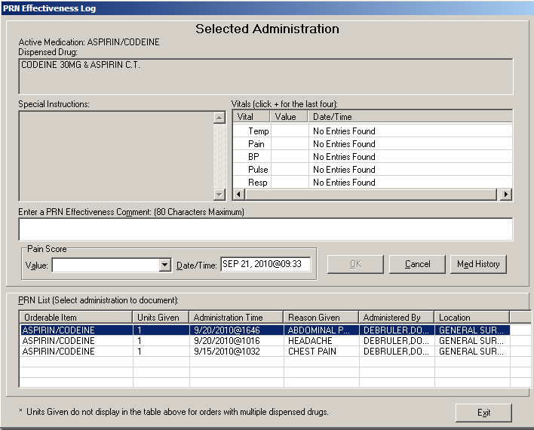  - In the Pain Score drop-down list box, select the patient’s pain score, between 0 and 10 or 99, with “0” being No Pain, “10” the Worst Imaginable, and “99” for “Unable to Respond.”  Note: You are prompted to enter a pain score only if your site has selected this requirement for the “Reason Medication Given PRN Answer Lists” in the GUI BCMA Site Parameters application.  - In the Date/Time drop-down list box, define the date/time that the pain score was taken. The information cannot be before the administration time or after the current system time.  - Click ok to file your comments or click exit to submit your comments and pain score information and return to the patient’s VDL. If you entered a pain score, the text “Pain Score entered in Vitals via BCMA taken at [date/time]” and your comments will display on the Medication Log.  Keyboard Shortcut: Press tab to activate the ok button, and press enter to continue.
Administering a Patient’s IVP/IVPB Medications
Administering a Medication Early  tip:  Medications logged as “Early” are noted in the Medication Variance Log, along with the time scanned, and the reason the medication was administered early.  tip:  BCMA will not mark the medication as Given (with a “G”), in the Status column of the VDL, until you enter a “Comment” in the Medication Log dialog box. | The Medication Log dialog box, provided below, is designed to “alert” you that you are administering the medication to the patient before the scheduled administration time. The dialog box includes the number of minutes that you are administering the medication, “before the scheduled administration time” listed on the BCMA VDL. You can add a “Comment” (free text), up to 150 characters in length.  To administer a medication early to a patient  - In the Comments area of the Message Log dialog box, specify the reason that you are administering the medication early to the patient, and click ok. BCMA processes the information and displays the letter “G” (for “Given”) in the Status column to document that you administered the medication to the patient.  Keyboard Shortcut: Press tab to activate the ok button, and press enter to continue.  Example: Medication Log Dialog Box for Early Dose  - Continue administering active IV Push or IV Piggyback medications to the patient.
Administering a Patient’s IVP/IVPB Medications
Administering a Medication Late  tip:  Medications logged as “Late” are noted in the Medication Variance Log, along with the time scanned, and the reason the medication was administered late.  tip:  BCMA will not mark the medication as Given (with a “G”), in the Status column of the VDL, until you enter a “Comment” in the Medication Log dialog box. | The Medication Log dialog box, provided below, is designed to “alert” you that you are administering the medication to the patient after the scheduled administration time. The dialog box includes the number of minutes that you are administering the medication, “after the scheduled administration time” listed on the BCMA VDL. You can add a “Comment”(free text), up to 150 characters in length.  To administer a medication late to a patient  - In the Comments area of the Medication Log dialog box, specify the reason that you are administering the medication late to the patient, and click ok. BCMA processes the information, and displays the letter “G” (for “Given”) in the Status column to document that you administered the medication to the patient.  Keyboard Shortcut: Press tab to activate the ok button, and press enter to continue.  Example: Medication Log Dialog Box for Late Dose  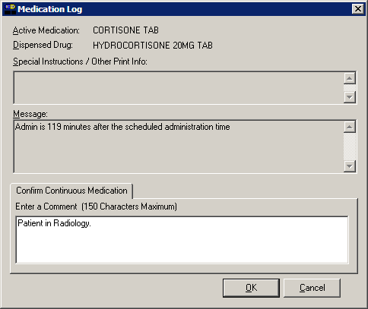  - Continue administering active IV Push or IV Piggyback medications to the patient.
Administering a Patient’s IVP/IVPB Medications
Marking Multiple Medications  on the VDL  tip:  You can quickly mark multiple medications selected on the VDL, with the same “action,” by selecting the Mark command from the Right Click drop-down menu. | As requested, you can select and mark multiple medications, for the patient, as “Held” or “Refused” on the BCMA VDL. This feature is particularly helpful when a patient is temporarily off their ward, or if they refuse to take their medications.  To mark multiple medications on the VDL  - Perform one of the following actions:  - Using shift+click, select a range of medication orders that you want to mark with the same status on the BCMA VDL.  - Using ctrl+click, individually select several medication orders that you want to mark with the same status on the BCMA VDL.  Note: If you do not “select” orders on the BCMA VDL, the Mark options will be grayed out and not accessible to you. The options available to you will depend on the current Status of the medication order.  - Select the Mark command from the Right Click or Due List menu. The Mark drop-down menu displays with the “actions” available for these medications.  Keyboard Shortcut: Press alt+d to display the Due List menu, and press m to display the Mark drop-down menu.  - Select the command that represents the “action” that you want to take on the medications selected on the BCMA VDL. BCMA processes the information and displays a letter in the Status column of the BCMA VDL to document the action taken on the medications.  Keyboard Shortcut: Use the arrow keys to select the command that represents the “action” that you want to take on the medications selected on the BCMA VDL.  - Continue administering active Unit Dose medications to the patient.
Administering a Patient’s IVP/IVPB Medications
Changing the Status of an IVP or IVPB Medication  tip:  You can change the status of a medication on “Hold” to “Held,” although it is not necessary that you do so unless required by your medical center.  tip:  You can quickly change the status of an IVP/IVPB medication by selecting the Mark command from the Right Click drop-down menu.  tip:  An “Unknown” status can only be changed to Given, Not Given, Held, or Refused–using the Edit Med Log option. | Use this section when you need to “mark” (change) the status of a patient’s medication.  Once you scan and mark a medication as “Given,” you cannot scan it again for the same administration time. If you do, you will receive an Error message. You can, however, change the status from “Given” to “Not Given” by using the “Undo–Given” option – provided you are the individual who originally marked it as “Given,” or you have been assigned the PSB MANAGER security key.  You can mark a medication with the following status:  - Given to Not Given  - Held or Refused to Given  - Missing to Given, Held, or Refused  To change the status of an IVP or IVPB medication  - Select the medication on the BCMA VDL for which you want to change the status (take an action on).  - Select the Mark command from the Right Click or Due List menu. The Mark drop-down menu displays with the “actions” available for this medication.  Note: Held and Refused IV bags as well as IV bags marked as Missing Dose can be set to the infusing state via scanning and via the Unable to Scan process.  Keyboard Shortcut: Press alt+d to display the Due List menu, and press m to display the Mark drop-down menu.  Note: The Mark options available to you will depend on the current Status of the medication order.  - Select the command that represents the “action” that you want to take on the medication selected on the BCMA VDL. BCMA processes the information and displays a letter in the Status column of the BCMA VDL to document the action taken on the medication.  Keyboard Shortcut: Use the arrow keys to select the command that represents the “action” that you want to take on the medication selected on the BCMA VDL.  - Continue administering active IV Push or IV Piggyback medications to the patient.
Administering a Patient’s IVP/IVPB Medications
Adding Comments to a Patient’s Medication Record  tip:  You can quickly add comments  to a patient’s medication by selecting the medication on the VDL, and then selecting the  Add Comment command from the Right Click drop-down menu. | You can add a comment (free text), up to 150 characters in length, to a patient’s medication marked as “G” (Given), “H” (Held), or  “R” (Refused) in the Status column of the BCMA VDL. Your comments will also display in the Medication Log Report.  To add comments to a patient’s medication record  - Select the medication on the BCMA VDL that you want to add Comments.  - Select the Add Comment command from the Right Click or Due List menu. The Medication Log dialog box displays.  Keyboard Shortcut: Press alt+d to display the Due List menu, and press a to display the Medication Log dialog box.  - In the Add Comment area, enter the comments that you want to associate with the medication selected on the patient’s VDL.  Example: Medication Log Dialog Box  - Click ok once you’ve read your entry and are satisfied with it.  Keyboard Shortcut: Press tab to activate the ok button, and press enter to continue.
Administering a Patient’s IVP/IVPB Medications
Adding Comments to a Patient’s Medication Record (cont.)  tip:  BCMA automatically wraps words  in the  Comments  section. | To add comments to a patient’s medication record (cont.)  - Verify that your comments were entered in the patient’s record by clicking the Med Log button in the Tool Bar to access the Medication Log Report.  Example: Medication Log with Comments Entered  Comments entered by a clinician.  Note: You can view comments on the Medication Log Report if you select the “Comments” check box in the Include area of the Patient Medication Log dialog box. See Chapter 10, “Viewing and Printing BCMA Reports” for more information.
Administering a Patient’s IVP/IVPB Medications
Submitting a Missing Dose Request  tip:  You cannot submit a Missing Dose Request for a medication marked as “Given” on the VDL. You can, however, change the status from Missing to Held, Refused, or Given.  tip:  You can quickly submit a Missing Dose Request by selecting a medication on the VDL, and then clicking once on the Missing Dose button in the  Tool Bar at the top of the VDL. | You can use the Missing Dose command or the Missing Dose button on the Tool Bar to send Missing Dose Requests directly to the Pharmacy. Your request will automatically print on a dedicated printer in the Pharmacy that your medical center predefined using the GUI BCMA Site Parameters application. BCMA will also send a MailMan message to a predefined mail group. If both are predefined, both will be notified.  BCMA V. 3.0 displays an “M” in the Status column of the BCMA VDL after you submit a Missing Dose Request to the Pharmacy. The Last Action column includes this status information after you refresh the BCMA VDL. This functionality will benefit the Pharmacy by identifying requests that have already been submitted, and by reducing the number of duplicate submissions that they receive on a daily basis.  Note: You can mark a Missing Dose medication as “Held," “Refused,” or “Given.” If you miss the “administration window,” you can use the Manual Med Entry [PSB MED LOG NEW ENTRY] option in CHUI BCMA to mark it as “Given.”  To submit a Missing Dose Request  - Select a medication on the BCMA VDL that is considered “Missing.”  - Select the Missing Dose command from the Right Click or Due List menu. The Missing Dose Request dialog box displays.  Keyboard Shortcut: Press alt+d to display the Due List menu, and press i (not “L”) to display the Missing Dose Request dialog box.  - Verify the patient’s name on the Tab at the top of the dialog box, and their location and medication information within the dialog box.
Administering a Patient’s IVP/IVPB Medications
Submitting a Missing Dose Request (cont.)  tip:  When you select the Missing Dose option, BCMA automatically populates the fields in the Missing Dose Request dialog box. You must complete all fields before submitting the request to the Pharmacy.  tip:  Enter “N” (for NOW) if you want BCMA to automatically  enter the current date and time in the dialog box for you when you move to the Reason drop-down list box. | To submit a Missing Dose Request (cont.)  Example: Missing Dose Request Dialog Box  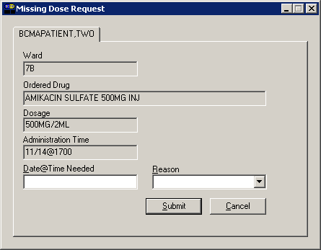  - In the Date@Time Needed field, enter the day and time when you need the medication for the patient using the VA FileMan Date/Time formatting guidelines listed below. You can use a date in the future or the past.  Date Formatting  - May 1, 2010, 01 MAY 10, 5/01/10, 050110  - N (for NOW )  - T (for Today)  Time Formatting  - 00:00 (For example, 14:00 for 2:00 p.m.)  Keyboard Shortcut: Press tab to move among the fields on the dialog box.  Note: If the year is omitted, the computer uses the current year. A two-digit year assumes no more than 20 years in the future, or 80 years in the past.
Administering a Patient’s IVP/IVPB Medications
Submitting a Missing Dose Request (cont.)  tip:  When you “refresh” the VDL, the Last Action column reflects the action taken on the Missing Dose. | To submit a Missing Dose Request (cont.)  - In the Reason field, click once on the drop-down arrow to display pre-defined reasons why you are sending this request to the Pharmacy.  Keyboard Shortcut: Use the arrow keys to locate and select a Reason in the drop-down list box.  Example: Missing Dose Request Dialog Box  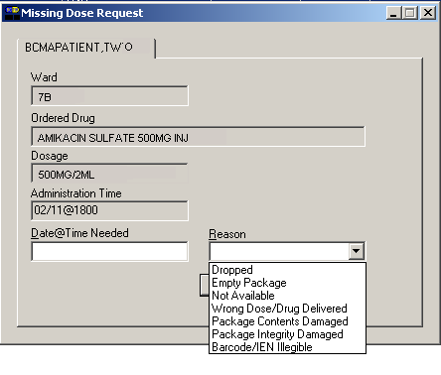  - Verify the information in the dialog box and click submit to send the request to the Pharmacy, where it prints  on a predefined printer. An Information message displays.  A MailMan message will also be sent to a mail group if predefined using the GUI BCMA Site Parameters application.  Keyboard Shortcut: Press tab to activate the submit button, and press enter to display the Information message.  - Read the Information message, and click ok. BCMA processes the request, and displays the letter “M” (for “Missing”) in the Status column.  Example: Missing Dose Submission Message

